## Autres_cereales - AB

### Covariate distribution before matching

|  |  | Autres_cereales - AB (N=46) / Mean | Autres_cereales - AB (N=46) / Std. Dev. | Autres_cereales - Conventionnel (N=182) / Mean | Autres_cereales - Conventionnel (N=182) / Std. Dev. | Diff. in Means | Std. Error |
| --- | --- | --- | --- | --- | --- | --- | --- |
| SAU_TOT |  | 110.5 | 66.4 | 147.5 | 92.9 | 37.0 | 12.0 |
| UGBAG.TOT |  | 77.2 | 70.1 | 74.9 | 77.9 | -2.3 | 11.8 |
| AGE |  | 47.3 | 10.3 | 47.6 | 10.4 | 0.3 | 1.7 |
|  |  | N | Pct. | N | Pct. |  |  |
| SIEGE_REG | 11 | 1 | 2.2 | 3 | 1.6 |  |  |
|  | 24 | 2 | 4.3 | 42 | 23.1 |  |  |
|  | 27 | 4 | 8.7 | 17 | 9.3 |  |  |
|  | 28 | 5 | 10.9 | 1 | 0.5 |  |  |
|  | 32 | 4 | 8.7 | 3 | 1.6 |  |  |
|  | 44 | 6 | 13.0 | 20 | 11.0 |  |  |
|  | 52 | 4 | 8.7 | 4 | 2.2 |  |  |
|  | 53 | 3 | 6.5 | 5 | 2.7 |  |  |
|  | 75 | 3 | 6.5 | 19 | 10.4 |  |  |
|  | 76 | 6 | 13.0 | 29 | 15.9 |  |  |
|  | 84 | 8 | 17.4 | 35 | 19.2 |  |  |
|  | 93 | 0 | 0.0 | 4 | 2.2 |  |  |
| MNT | FALSE | 35 | 76.1 | 135 | 74.2 |  |  |
|  | TRUE | 11 | 23.9 | 47 | 25.8 |  |  |
| OTEFDA_COEF17 | 1516 | 6 | 13.0 | 47 | 25.8 |  |  |
|  | 2829 | 1 | 2.2 | 0 | 0.0 |  |  |
|  | 3500 | 1 | 2.2 | 8 | 4.4 |  |  |
|  | 3900 | 0 | 0.0 | 2 | 1.1 |  |  |
|  | 4500 | 19 | 41.3 | 21 | 11.5 |  |  |
|  | 4600 | 2 | 4.3 | 25 | 13.7 |  |  |
|  | 4700 | 2 | 4.3 | 9 | 4.9 |  |  |
|  | 4800 | 6 | 13.0 | 26 | 14.3 |  |  |
|  | 5074 | 2 | 4.3 | 14 | 7.7 |  |  |
|  | 6184 | 7 | 15.2 | 30 | 16.5 |  |  |
| NivForm | 00 | 1 | 2.2 | 0 | 0.0 |  |  |
|  | 11 | 0 | 0.0 | 3 | 1.6 |  |  |
|  | 23 | 1 | 2.2 | 5 | 2.7 |  |  |
|  | 24 | 7 | 15.2 | 49 | 26.9 |  |  |
|  | 25 | 3 | 6.5 | 23 | 12.6 |  |  |
|  | 26 | 17 | 37.0 | 51 | 28.0 |  |  |
|  | 27 | 13 | 28.3 | 46 | 25.3 |  |  |
|  | 28 | 4 | 8.7 | 5 | 2.7 |  |  |

### Covariate distribution after matching

|  |  | Autres_cereales - AB (N=41) / Mean | Autres_cereales - AB (N=41) / Std. Dev. | Autres_cereales - Conventionnel (N=103) / Mean | Autres_cereales - Conventionnel (N=103) / Std. Dev. | Diff. in Means | Std. Error |
| --- | --- | --- | --- | --- | --- | --- | --- |
| SAU_TOT |  | 114.1 | 67.6 | 129.7 | 79.2 | 15.6 | 13.1 |
| UGBAG.TOT |  | 81.2 | 73.1 | 78.8 | 68.4 | -2.4 | 13.3 |
| AGE |  | 46.7 | 10.5 | 47.4 | 10.6 | 0.7 | 1.9 |
|  |  | N | Pct. | N | Pct. |  |  |
| SIEGE_REG | 11 | 1 | 2.4 | 3 | 2.9 |  |  |
|  | 24 | 2 | 4.9 | 6 | 5.8 |  |  |
|  | 27 | 4 | 9.8 | 12 | 11.7 |  |  |
|  | 28 | 1 | 2.4 | 1 | 1.0 |  |  |
|  | 32 | 3 | 7.3 | 3 | 2.9 |  |  |
|  | 44 | 6 | 14.6 | 18 | 17.5 |  |  |
|  | 52 | 4 | 9.8 | 4 | 3.9 |  |  |
|  | 53 | 3 | 7.3 | 5 | 4.9 |  |  |
|  | 75 | 3 | 7.3 | 9 | 8.7 |  |  |
|  | 76 | 6 | 14.6 | 18 | 17.5 |  |  |
|  | 84 | 8 | 19.5 | 24 | 23.3 |  |  |
| MNT | FALSE | 30 | 73.2 | 73 | 70.9 |  |  |
|  | TRUE | 11 | 26.8 | 30 | 29.1 |  |  |
| OTEFDA_COEF17 | 1516 | 4 | 9.8 | 22 | 21.4 |  |  |
|  | 2829 | 1 | 2.4 | 0 | 0.0 |  |  |
|  | 3500 | 1 | 2.4 | 1 | 1.0 |  |  |
|  | 4500 | 17 | 41.5 | 21 | 20.4 |  |  |
|  | 4600 | 2 | 4.9 | 14 | 13.6 |  |  |
|  | 4700 | 2 | 4.9 | 5 | 4.9 |  |  |
|  | 4800 | 6 | 14.6 | 15 | 14.6 |  |  |
|  | 5074 | 1 | 2.4 | 8 | 7.8 |  |  |
|  | 6184 | 7 | 17.1 | 17 | 16.5 |  |  |
| NivForm | 00 | 1 | 2.4 | 0 | 0.0 |  |  |
|  | 11 | 0 | 0.0 | 1 | 1.0 |  |  |
|  | 23 | 1 | 2.4 | 4 | 3.9 |  |  |
|  | 24 | 6 | 14.6 | 24 | 23.3 |  |  |
|  | 25 | 2 | 4.9 | 14 | 13.6 |  |  |
|  | 26 | 14 | 34.1 | 35 | 34.0 |  |  |
|  | 27 | 13 | 31.7 | 23 | 22.3 |  |  |
|  | 28 | 4 | 9.8 | 2 | 1.9 |  |  |

### Matching model coefficients

| . | Estimate | Std. Error | t value | Pr(&gt;|t|) |
| --- | --- | --- | --- | --- |
| (Intercept) | 39.0431205420844 | 6632.46895974955 | 0.00588666464615595 | 0.995309135466206 |
| SIEGE_REG24 | -3.12249397663781 | 1.79371385682632 | -1.74079826877323 | 0.0832882121798086 |
| SIEGE_REG27 | -0.714710730695926 | 1.69885826462966 | -0.420700623222226 | 0.674434614396599 |
| SIEGE_REG28 | 2.90355230935309 | 1.95583733477468 | 1.48455715499858 | 0.1392676245696 |
| SIEGE_REG32 | 1.86444538548868 | 1.7276620701638 | 1.07917249425515 | 0.281837080845179 |
| SIEGE_REG44 | -0.334629213422081 | 1.62215231771524 | -0.206287171536023 | 0.836780723464212 |
| SIEGE_REG52 | 2.39240041175337 | 1.86346230055212 | 1.28384696113494 | 0.200711145417747 |
| SIEGE_REG53 | -1.07955230909213 | 1.95191451434027 | -0.553073559913054 | 0.580843313316144 |
| SIEGE_REG75 | -0.39799678056765 | 1.59394350266062 | -0.249693154056784 | 0.803086149751578 |
| SIEGE_REG76 | -0.491833928879836 | 1.67870577809252 | -0.292983997135398 | 0.76984433693322 |
| SIEGE_REG84 | -1.08106574234878 | 1.65842980415711 | -0.65186101916338 | 0.515254491994732 |
| SIEGE_REG93 | -19.0033076011124 | 2636.49233800883 | -0.00720779928966696 | 0.994256388956226 |
| MNTTRUE | -0.429810462080951 | 0.869045984742471 | -0.49457735220803 | 0.621452393048814 |
| OTEFDA_COEF172829 | 20.8250190010722 | 6394.98965367491 | 0.00325645859162649 | 0.997405038579716 |
| OTEFDA_COEF173500 | -17.6648777881053 | 1758.90571076739 | -0.0100431067339012 | 0.991997109824189 |
| OTEFDA_COEF173900 | -16.219903554791 | 4085.57945397307 | -0.00397003747877619 | 0.996836414495872 |
| OTEFDA_COEF174500 | 3.40703769850251 | 1.03082524877832 | 3.30515545922101 | 0.00112872313787345 |
| OTEFDA_COEF174600 | 1.73786610443757 | 1.22084800124712 | 1.42349096911517 | 0.15618376351539 |
| OTEFDA_COEF174700 | 2.72532028974106 | 1.41220787237839 | 1.92982941325145 | 0.0550716177362053 |
| OTEFDA_COEF174800 | 1.19034213338146 | 0.993213841725691 | 1.19847517561098 | 0.232179175275321 |
| OTEFDA_COEF175074 | 0.287442289378712 | 1.13584874085725 | 0.253063879933321 | 0.800484074893434 |
| OTEFDA_COEF176184 | 2.10249433113556 | 0.905986505484596 | 2.32066848502448 | 0.0213335537492748 |
| SAU_TOT | -0.00649066948677694 | 0.00434200918249593 | -1.494853929131 | 0.136560835139758 |
| UGBAG.TOT | -0.00653152003813502 | 0.00533133887430749 | -1.22511815364268 | 0.222000935891804 |
| AGE | 0.00612316610494522 | 0.0245525347929076 | 0.249390385008802 | 0.80331998434603 |
| NivForm11 | -59.4466655943885 | 7453.59282656326 | -0.00797557191245157 | 0.993644593637918 |
| NivForm23 | -40.7208126775356 | 6632.46866149791 | -0.0061396162961046 | 0.995107570179506 |
| NivForm24 | -41.3449271066585 | 6632.46858629074 | -0.00623371623532724 | 0.995032586438161 |
| NivForm25 | -41.3344415319026 | 6632.46861673604 | -0.00623213526070841 | 0.995033846240863 |
| NivForm26 | -40.3961348492666 | 6632.46857367428 | -0.00609066358936214 | 0.995146578267662 |
| NivForm27 | -39.9539284087134 | 6632.46857504269 | -0.00602399060872388 | 0.995199706819666 |
| NivForm28 | -37.1347928326949 | 6632.46847185533 | -0.00559893997088343 | 0.995538410109226 |

### Propensity score distribution

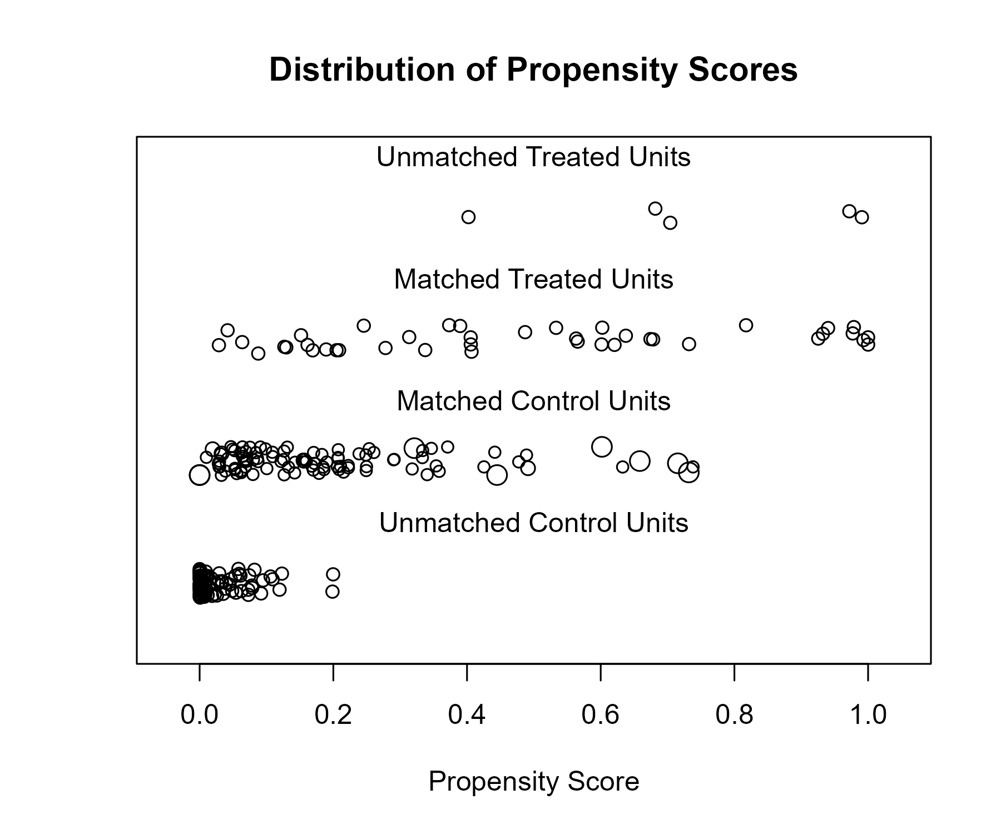

### Covariate balance

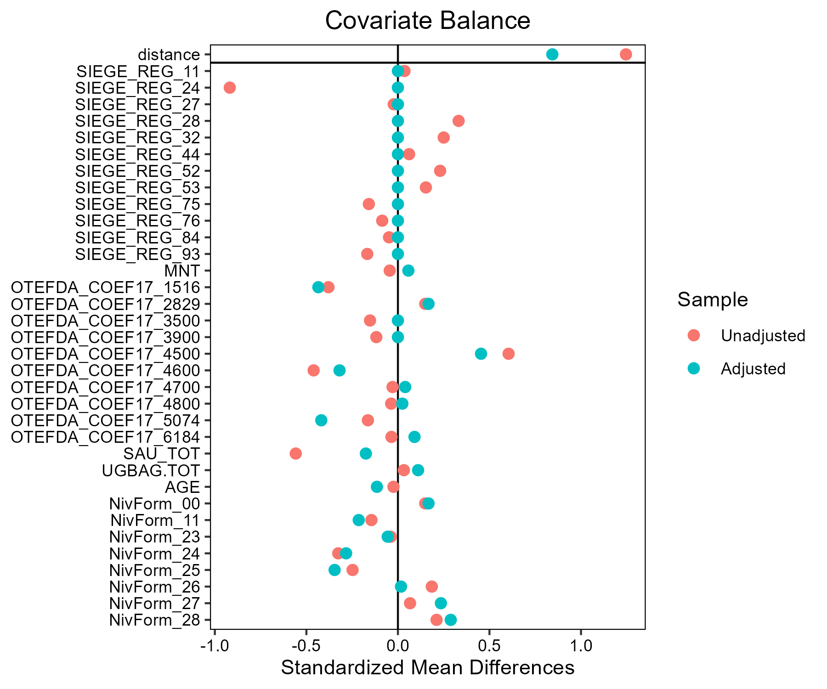

## Ble_tendre - LR

### Covariate distribution before matching

|  |  | Ble_tendre - Conventionnel (N=3136) / Mean | Ble_tendre - Conventionnel (N=3136) / Std. Dev. | Ble_tendre - LR (N=100) / Mean | Ble_tendre - LR (N=100) / Std. Dev. | Diff. in Means | Std. Error |
| --- | --- | --- | --- | --- | --- | --- | --- |
| SAU_TOT |  | 136.8 | 85.0 | 175.4 | 89.2 | 38.6 | 9.0 |
| UGBAG.TOT |  | 68.3 | 82.6 | 56.4 | 88.0 | -11.9 | 8.9 |
| AGE |  | 49.3 | 10.2 | 48.6 | 10.3 | -0.6 | 1.0 |
|  |  | N | Pct. | N | Pct. |  |  |
| SIEGE_REG | 11 | 114 | 3.6 | 15 | 15.0 |  |  |
|  | 24 | 237 | 7.6 | 9 | 9.0 |  |  |
|  | 27 | 239 | 7.6 | 12 | 12.0 |  |  |
|  | 28 | 226 | 7.2 | 2 | 2.0 |  |  |
|  | 32 | 470 | 15.0 | 9 | 9.0 |  |  |
|  | 44 | 504 | 16.1 | 0 | 0.0 |  |  |
|  | 52 | 209 | 6.7 | 20 | 20.0 |  |  |
|  | 53 | 249 | 7.9 | 0 | 0.0 |  |  |
|  | 75 | 336 | 10.7 | 13 | 13.0 |  |  |
|  | 76 | 225 | 7.2 | 5 | 5.0 |  |  |
|  | 84 | 310 | 9.9 | 15 | 15.0 |  |  |
|  | 93 | 17 | 0.5 | 0 | 0.0 |  |  |
| MNT | FALSE | 2926 | 93.3 | 97 | 97.0 |  |  |
|  | TRUE | 210 | 6.7 | 3 | 3.0 |  |  |
| OTEFDA_COEF17 | 1516 | 1014 | 32.3 | 53 | 53.0 |  |  |
|  | 2829 | 31 | 1.0 | 2 | 2.0 |  |  |
|  | 3500 | 112 | 3.6 | 0 | 0.0 |  |  |
|  | 3900 | 50 | 1.6 | 0 | 0.0 |  |  |
|  | 4500 | 476 | 15.2 | 9 | 9.0 |  |  |
|  | 4600 | 297 | 9.5 | 2 | 2.0 |  |  |
|  | 4700 | 151 | 4.8 | 0 | 0.0 |  |  |
|  | 4800 | 124 | 4.0 | 8 | 8.0 |  |  |
|  | 5074 | 344 | 11.0 | 7 | 7.0 |  |  |
|  | 6184 | 537 | 17.1 | 19 | 19.0 |  |  |
| NivForm | 00 | 15 | 0.5 | 0 | 0.0 |  |  |
|  | 10 | 21 | 0.7 | 0 | 0.0 |  |  |
|  | 11 | 72 | 2.3 | 6 | 6.0 |  |  |
|  | 23 | 114 | 3.6 | 2 | 2.0 |  |  |
|  | 24 | 886 | 28.3 | 26 | 26.0 |  |  |
|  | 25 | 351 | 11.2 | 16 | 16.0 |  |  |
|  | 26 | 764 | 24.4 | 19 | 19.0 |  |  |
|  | 27 | 767 | 24.5 | 26 | 26.0 |  |  |
|  | 28 | 146 | 4.7 | 5 | 5.0 |  |  |

### Covariate distribution after matching

|  |  | Ble_tendre - Conventionnel (N=300) / Mean | Ble_tendre - Conventionnel (N=300) / Std. Dev. | Ble_tendre - LR (N=100) / Mean | Ble_tendre - LR (N=100) / Std. Dev. | Diff. in Means | Std. Error |
| --- | --- | --- | --- | --- | --- | --- | --- |
| SAU_TOT |  | 170.5 | 95.3 | 175.4 | 89.2 | 4.9 | 10.5 |
| UGBAG.TOT |  | 48.7 | 74.2 | 56.4 | 88.0 | 7.7 | 9.8 |
| AGE |  | 48.6 | 10.6 | 48.6 | 10.3 | 0.0 | 1.2 |
|  |  | N | Pct. | N | Pct. |  |  |
| SIEGE_REG | 11 | 45 | 15.0 | 15 | 15.0 |  |  |
|  | 24 | 27 | 9.0 | 9 | 9.0 |  |  |
|  | 27 | 36 | 12.0 | 12 | 12.0 |  |  |
|  | 28 | 6 | 2.0 | 2 | 2.0 |  |  |
|  | 32 | 27 | 9.0 | 9 | 9.0 |  |  |
|  | 52 | 60 | 20.0 | 20 | 20.0 |  |  |
|  | 75 | 39 | 13.0 | 13 | 13.0 |  |  |
|  | 76 | 15 | 5.0 | 5 | 5.0 |  |  |
|  | 84 | 45 | 15.0 | 15 | 15.0 |  |  |
| MNT | FALSE | 288 | 96.0 | 97 | 97.0 |  |  |
|  | TRUE | 12 | 4.0 | 3 | 3.0 |  |  |
| OTEFDA_COEF17 | 1516 | 162 | 54.0 | 53 | 53.0 |  |  |
|  | 2829 | 6 | 2.0 | 2 | 2.0 |  |  |
|  | 4500 | 16 | 5.3 | 9 | 9.0 |  |  |
|  | 4600 | 3 | 1.0 | 2 | 2.0 |  |  |
|  | 4800 | 23 | 7.7 | 8 | 8.0 |  |  |
|  | 5074 | 29 | 9.7 | 7 | 7.0 |  |  |
|  | 6184 | 61 | 20.3 | 19 | 19.0 |  |  |
| NivForm | 11 | 10 | 3.3 | 6 | 6.0 |  |  |
|  | 23 | 6 | 2.0 | 2 | 2.0 |  |  |
|  | 24 | 83 | 27.7 | 26 | 26.0 |  |  |
|  | 25 | 51 | 17.0 | 16 | 16.0 |  |  |
|  | 26 | 59 | 19.7 | 19 | 19.0 |  |  |
|  | 27 | 79 | 26.3 | 26 | 26.0 |  |  |
|  | 28 | 12 | 4.0 | 5 | 5.0 |  |  |

### Matching model coefficients

| . | Estimate | Std. Error | t value | Pr(&gt;|t|) |
| --- | --- | --- | --- | --- |
| (Intercept) | -19.5484987274159 | 3233.05080042847 | -0.00604645578870123 | 0.995176032218037 |
| SIEGE_REG24 | -1.05466654522058 | 0.358472139411681 | -2.94211579999349 | 0.00328316568411068 |
| SIEGE_REG27 | -0.540307305184697 | 0.346078743297814 | -1.56122650017757 | 0.118569110064293 |
| SIEGE_REG28 | -2.15190115600441 | 0.624127002560205 | -3.4478578032631 | 0.000572336082298808 |
| SIEGE_REG32 | -1.50883165675888 | 0.361314350836525 | -4.17595274935963 | 3.04652881127674e-05 |
| SIEGE_REG44 | -18.0958028978805 | 595.171797601531 | -0.0304043353042002 | 0.975746481654383 |
| SIEGE_REG52 | 0.876670858044839 | 0.348423553867976 | 2.51610675659725 | 0.0119144335545674 |
| SIEGE_REG53 | -17.3231297829851 | 857.110218721944 | -0.0202110876811339 | 0.983876241883045 |
| SIEGE_REG75 | -0.454156719715008 | 0.351863254750629 | -1.29071937345909 | 0.196894161038941 |
| SIEGE_REG76 | -1.36381563933466 | 0.443104575339606 | -3.07786404211556 | 0.00210254313935535 |
| SIEGE_REG84 | -0.0707849360823493 | 0.339138086556234 | -0.208720102189443 | 0.83468001825173 |
| SIEGE_REG93 | -17.2897204808871 | 3033.09469167118 | -0.00570035631540433 | 0.995452153325745 |
| MNTTRUE | -0.717218933284457 | 0.531855311214547 | -1.34852264922694 | 0.177585681913707 |
| OTEFDA_COEF172829 | 0.300418917348078 | 0.633862051664219 | 0.473949996784507 | 0.635567869522012 |
| OTEFDA_COEF173500 | -17.5509483670476 | 1239.75515995719 | -0.0141567858992849 | 0.988705778072369 |
| OTEFDA_COEF173900 | -17.6303377304508 | 1884.69778664403 | -0.00935446407131622 | 0.992536908960366 |
| OTEFDA_COEF174500 | -1.07066023351192 | 0.396533201369945 | -2.70005192456267 | 0.00696931663746679 |
| OTEFDA_COEF174600 | -2.6807155419025 | 0.661428851243834 | -4.05291595137005 | 5.17856373819412e-05 |
| OTEFDA_COEF174700 | -18.0523377467991 | 1002.56905063264 | -0.0180060792175938 | 0.985635125174561 |
| OTEFDA_COEF174800 | -0.0145855789702758 | 0.44208376697227 | -0.0329927947143797 | 0.973682389207699 |
| OTEFDA_COEF175074 | -1.46858203775594 | 0.395166667968999 | -3.71636111239815 | 0.000205567405674957 |
| OTEFDA_COEF176184 | -0.316261312901039 | 0.273056433175419 | -1.15822692482717 | 0.246857795269321 |
| SAU_TOT | 0.0038613228717151 | 0.00103728158712107 | 3.72254064822651 | 0.000200620648396922 |
| UGBAG.TOT | 0.000286578687970738 | 0.00172116414092542 | 0.166502822802625 | 0.867771771441669 |
| AGE | -0.0108788486551958 | 0.00900109325798069 | -1.20861414757037 | 0.226900334825024 |
| NivForm10 | 0.50908796104183 | 4255.4874416026 | 0.000119630939587525 | 0.999904555770424 |
| NivForm11 | 18.6669962481858 | 3233.05078099513 | 0.00577380236583852 | 0.995393557394463 |
| NivForm23 | 17.2345430415808 | 3233.05081146499 | 0.00533073683236403 | 0.995747039498465 |
| NivForm24 | 17.5441699053497 | 3233.05076360034 | 0.00542650616652009 | 0.995670633694851 |
| NivForm25 | 17.8603576039095 | 3233.05076742742 | 0.00552430471672466 | 0.99559260900187 |
| NivForm26 | 17.1584568090029 | 3233.05076471008 | 0.00530720302826472 | 0.995765815026192 |
| NivForm27 | 17.3679177828956 | 3233.05076444341 | 0.00537199043513492 | 0.995714126926173 |
| NivForm28 | 17.2711947854583 | 3233.05078241059 | 0.00534207346182814 | 0.995737995011643 |

### Propensity score distribution

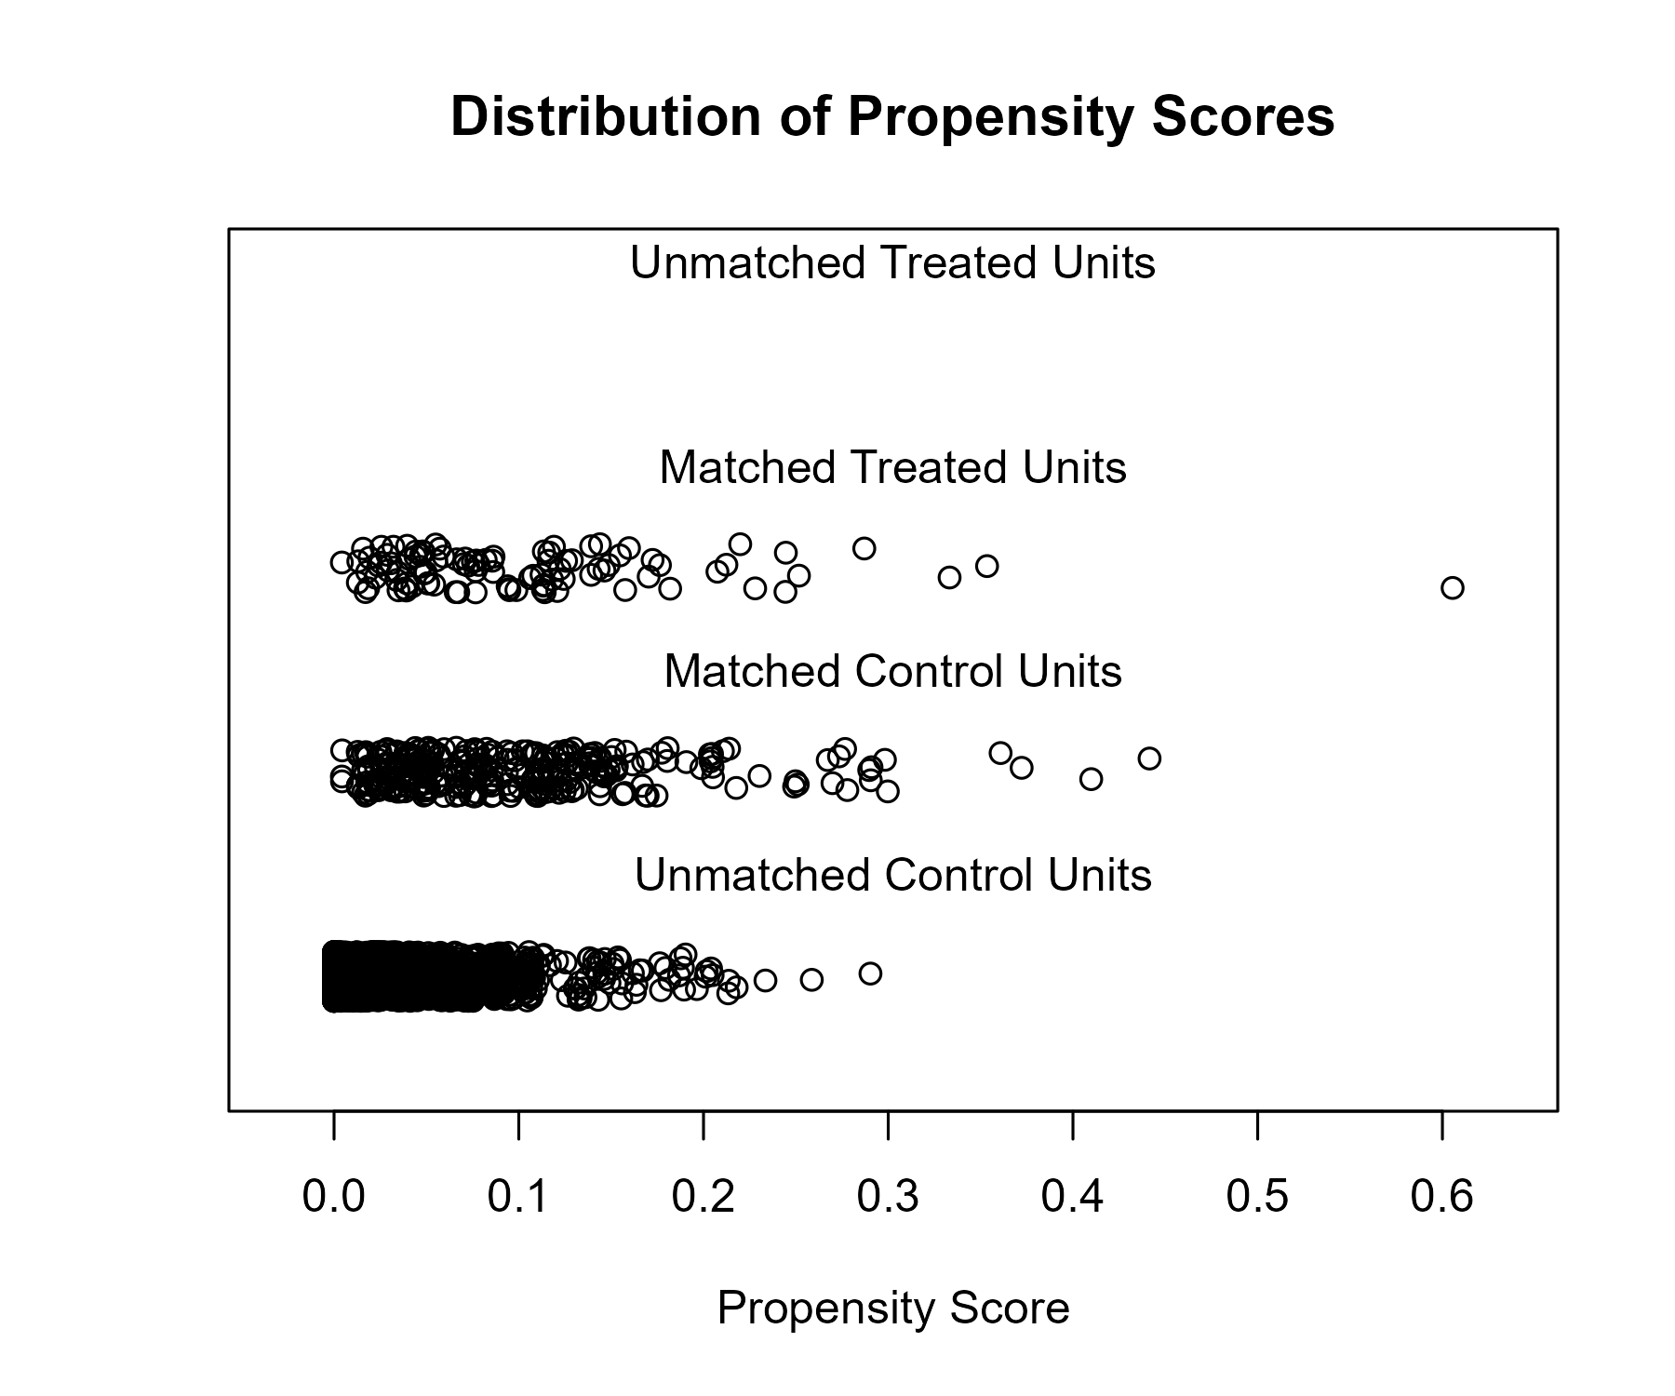

### Covariate balance

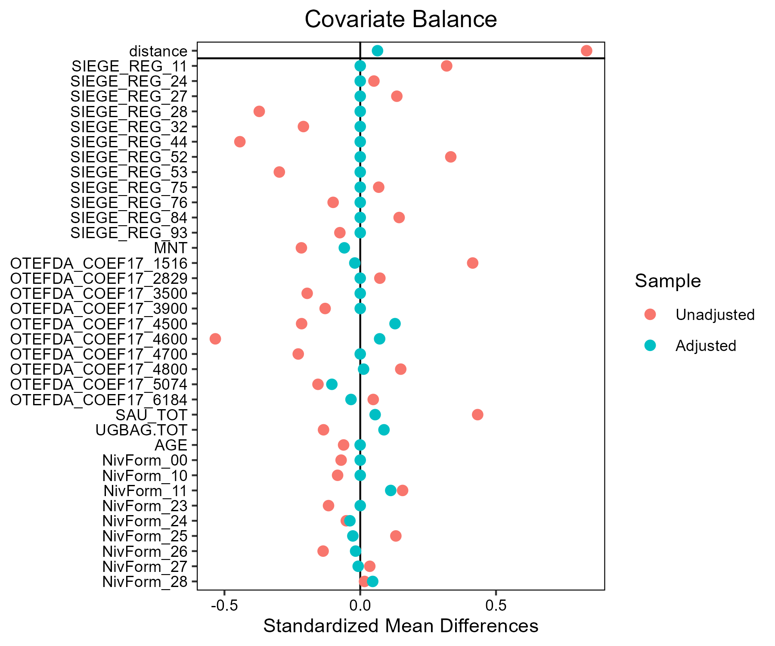

## Ble_tendre - AB

### Covariate distribution before matching

|  |  | Ble_tendre - AB (N=93) / Mean | Ble_tendre - AB (N=93) / Std. Dev. | Ble_tendre - Conventionnel (N=3136) / Mean | Ble_tendre - Conventionnel (N=3136) / Std. Dev. | Diff. in Means | Std. Error |
| --- | --- | --- | --- | --- | --- | --- | --- |
| SAU_TOT |  | 124.4 | 95.2 | 136.8 | 85.0 | 12.5 | 10.0 |
| UGBAG.TOT |  | 51.1 | 71.8 | 68.3 | 82.6 | 17.2 | 7.6 |
| AGE |  | 48.5 | 9.5 | 49.3 | 10.2 | 0.8 | 1.0 |
|  |  | N | Pct. | N | Pct. |  |  |
| SIEGE_REG | 11 | 10 | 10.8 | 114 | 3.6 |  |  |
|  | 24 | 2 | 2.2 | 237 | 7.6 |  |  |
|  | 27 | 7 | 7.5 | 239 | 7.6 |  |  |
|  | 28 | 6 | 6.5 | 226 | 7.2 |  |  |
|  | 32 | 9 | 9.7 | 470 | 15.0 |  |  |
|  | 44 | 17 | 18.3 | 504 | 16.1 |  |  |
|  | 52 | 7 | 7.5 | 209 | 6.7 |  |  |
|  | 53 | 5 | 5.4 | 249 | 7.9 |  |  |
|  | 75 | 8 | 8.6 | 336 | 10.7 |  |  |
|  | 76 | 12 | 12.9 | 225 | 7.2 |  |  |
|  | 84 | 9 | 9.7 | 310 | 9.9 |  |  |
|  | 93 | 1 | 1.1 | 17 | 0.5 |  |  |
| MNT | FALSE | 84 | 90.3 | 2926 | 93.3 |  |  |
|  | TRUE | 9 | 9.7 | 210 | 6.7 |  |  |
| OTEFDA_COEF17 | 1516 | 29 | 31.2 | 1014 | 32.3 |  |  |
|  | 2829 | 6 | 6.5 | 31 | 1.0 |  |  |
|  | 3500 | 2 | 2.2 | 112 | 3.6 |  |  |
|  | 3900 | 1 | 1.1 | 50 | 1.6 |  |  |
|  | 4500 | 17 | 18.3 | 476 | 15.2 |  |  |
|  | 4600 | 8 | 8.6 | 297 | 9.5 |  |  |
|  | 4700 | 2 | 2.2 | 151 | 4.8 |  |  |
|  | 4800 | 5 | 5.4 | 124 | 4.0 |  |  |
|  | 5074 | 6 | 6.5 | 344 | 11.0 |  |  |
|  | 6184 | 17 | 18.3 | 537 | 17.1 |  |  |
| NivForm | 00 | 0 | 0.0 | 15 | 0.5 |  |  |
|  | 10 | 0 | 0.0 | 21 | 0.7 |  |  |
|  | 11 | 0 | 0.0 | 72 | 2.3 |  |  |
|  | 23 | 2 | 2.2 | 114 | 3.6 |  |  |
|  | 24 | 15 | 16.1 | 886 | 28.3 |  |  |
|  | 25 | 5 | 5.4 | 351 | 11.2 |  |  |
|  | 26 | 27 | 29.0 | 764 | 24.4 |  |  |
|  | 27 | 27 | 29.0 | 767 | 24.5 |  |  |
|  | 28 | 17 | 18.3 | 146 | 4.7 |  |  |

### Covariate distribution after matching

|  |  | Ble_tendre - AB (N=93) / Mean | Ble_tendre - AB (N=93) / Std. Dev. | Ble_tendre - Conventionnel (N=279) / Mean | Ble_tendre - Conventionnel (N=279) / Std. Dev. | Diff. in Means | Std. Error |
| --- | --- | --- | --- | --- | --- | --- | --- |
| SAU_TOT |  | 124.4 | 95.2 | 124.3 | 72.7 | -0.1 | 10.8 |
| UGBAG.TOT |  | 51.1 | 71.8 | 46.6 | 57.6 | -4.6 | 8.2 |
| AGE |  | 48.5 | 9.5 | 48.7 | 10.2 | 0.1 | 1.2 |
|  |  | N | Pct. | N | Pct. |  |  |
| SIEGE_REG | 11 | 10 | 10.8 | 30 | 10.8 |  |  |
|  | 24 | 2 | 2.2 | 6 | 2.2 |  |  |
|  | 27 | 7 | 7.5 | 21 | 7.5 |  |  |
|  | 28 | 6 | 6.5 | 18 | 6.5 |  |  |
|  | 32 | 9 | 9.7 | 27 | 9.7 |  |  |
|  | 44 | 17 | 18.3 | 51 | 18.3 |  |  |
|  | 52 | 7 | 7.5 | 21 | 7.5 |  |  |
|  | 53 | 5 | 5.4 | 15 | 5.4 |  |  |
|  | 75 | 8 | 8.6 | 24 | 8.6 |  |  |
|  | 76 | 12 | 12.9 | 36 | 12.9 |  |  |
|  | 84 | 9 | 9.7 | 27 | 9.7 |  |  |
|  | 93 | 1 | 1.1 | 3 | 1.1 |  |  |
| MNT | FALSE | 84 | 90.3 | 255 | 91.4 |  |  |
|  | TRUE | 9 | 9.7 | 24 | 8.6 |  |  |
| OTEFDA_COEF17 | 1516 | 29 | 31.2 | 98 | 35.1 |  |  |
|  | 2829 | 6 | 6.5 | 9 | 3.2 |  |  |
|  | 3500 | 2 | 2.2 | 9 | 3.2 |  |  |
|  | 3900 | 1 | 1.1 | 1 | 0.4 |  |  |
|  | 4500 | 17 | 18.3 | 46 | 16.5 |  |  |
|  | 4600 | 8 | 8.6 | 24 | 8.6 |  |  |
|  | 4700 | 2 | 2.2 | 4 | 1.4 |  |  |
|  | 4800 | 5 | 5.4 | 14 | 5.0 |  |  |
|  | 5074 | 6 | 6.5 | 19 | 6.8 |  |  |
|  | 6184 | 17 | 18.3 | 55 | 19.7 |  |  |
| NivForm | 23 | 2 | 2.2 | 6 | 2.2 |  |  |
|  | 24 | 15 | 16.1 | 47 | 16.8 |  |  |
|  | 25 | 5 | 5.4 | 15 | 5.4 |  |  |
|  | 26 | 27 | 29.0 | 92 | 33.0 |  |  |
|  | 27 | 27 | 29.0 | 74 | 26.5 |  |  |
|  | 28 | 17 | 18.3 | 45 | 16.1 |  |  |

### Matching model coefficients

| . | Estimate | Std. Error | t value | Pr(&gt;|t|) |
| --- | --- | --- | --- | --- |
| (Intercept) | -18.3494283823843 | 1683.25721784673 | -0.0109011434425081 | 0.991302998601307 |
| SIEGE_REG24 | -2.15234598988661 | 0.832478594673588 | -2.58546706624996 | 0.00976859835454682 |
| SIEGE_REG27 | -0.621997853343665 | 0.577852527900906 | -1.07639548727617 | 0.281831664367469 |
| SIEGE_REG28 | -0.812668909896034 | 0.596921848347431 | -1.36143267690049 | 0.17347296441292 |
| SIEGE_REG32 | -1.42224622676027 | 0.527484312825602 | -2.69628156170493 | 0.00704859928808599 |
| SIEGE_REG44 | -0.530951381691244 | 0.469722318610025 | -1.1303516155298 | 0.258412913294997 |
| SIEGE_REG52 | -0.481736445774428 | 0.596039723414691 | -0.808228758671614 | 0.419019059242813 |
| SIEGE_REG53 | -1.33253045961253 | 0.658379419864313 | -2.02395521398156 | 0.0430578003541141 |
| SIEGE_REG75 | -0.935282501965183 | 0.573662954164714 | -1.63036935743394 | 0.103121994240556 |
| SIEGE_REG76 | -0.256505717635487 | 0.525036695427397 | -0.488548171717184 | 0.625195132534167 |
| SIEGE_REG84 | -0.832683549813331 | 0.590668082349519 | -1.40973175070022 | 0.15871620655412 |
| SIEGE_REG93 | 0.168450255209481 | 1.23956639568552 | 0.135894499718446 | 0.891913242174358 |
| MNTTRUE | 0.102538367644134 | 0.499165086442801 | 0.205419750757916 | 0.837257272749737 |
| OTEFDA_COEF172829 | 2.25454675862581 | 0.576165150454648 | 3.91302173837963 | 9.30473097714463e-05 |
| OTEFDA_COEF173500 | -0.548277682041647 | 0.788355257011963 | -0.695470318952065 | 0.486811169166515 |
| OTEFDA_COEF173900 | -0.663321292219418 | 1.13017903424932 | -0.586917003517062 | 0.557300904504628 |
| OTEFDA_COEF174500 | 1.23015494792209 | 0.500870945879136 | 2.45603175437319 | 0.0141009234729879 |
| OTEFDA_COEF174600 | 1.02601134273772 | 0.58953008816773 | 1.74038842686823 | 0.0818870826768866 |
| OTEFDA_COEF174700 | 0.644825446454387 | 0.905496852332562 | 0.712123343988789 | 0.476440379231461 |
| OTEFDA_COEF174800 | 0.883677240132763 | 0.651984531409228 | 1.35536534620345 | 0.175396960239827 |
| OTEFDA_COEF175074 | -0.255183959638716 | 0.528254620545049 | -0.483070000174195 | 0.629079122845744 |
| OTEFDA_COEF176184 | 0.71996516533015 | 0.375757487549563 | 1.91603677687243 | 0.0554495304658622 |
| SAU_TOT | -0.00150562730410264 | 0.0017726047730577 | -0.849386917482719 | 0.395729648790368 |
| UGBAG.TOT | -0.00601556424253793 | 0.00301895880242733 | -1.99259567162733 | 0.0463906536066592 |
| AGE | 0.0134524164024931 | 0.0121710595929475 | 1.105278985758 | 0.269121917594715 |
| NivForm10 | -0.771391261618628 | 2204.38939308078 | -0.000349934210371317 | 0.999720814741448 |
| NivForm11 | -0.430496568201986 | 1850.96038577841 | -0.000232580108958379 | 0.999814442438981 |
| NivForm23 | 14.134118309865 | 1683.25719239703 | 0.00839688573659818 | 0.993300857312381 |
| NivForm24 | 14.2816929751975 | 1683.25704836902 | 0.00848455854620398 | 0.993230912495364 |
| NivForm25 | 14.340073532456 | 1683.25709459302 | 0.00851924140318157 | 0.993203242744174 |
| NivForm26 | 15.1334331004648 | 1683.2570409891 | 0.00899056574958522 | 0.992827224159411 |
| NivForm27 | 15.3326041350347 | 1683.25704389161 | 0.00910889052309351 | 0.992732825900991 |
| NivForm28 | 16.4336812258903 | 1683.25705538005 | 0.00976302530464063 | 0.992210965932457 |

### Propensity score distribution

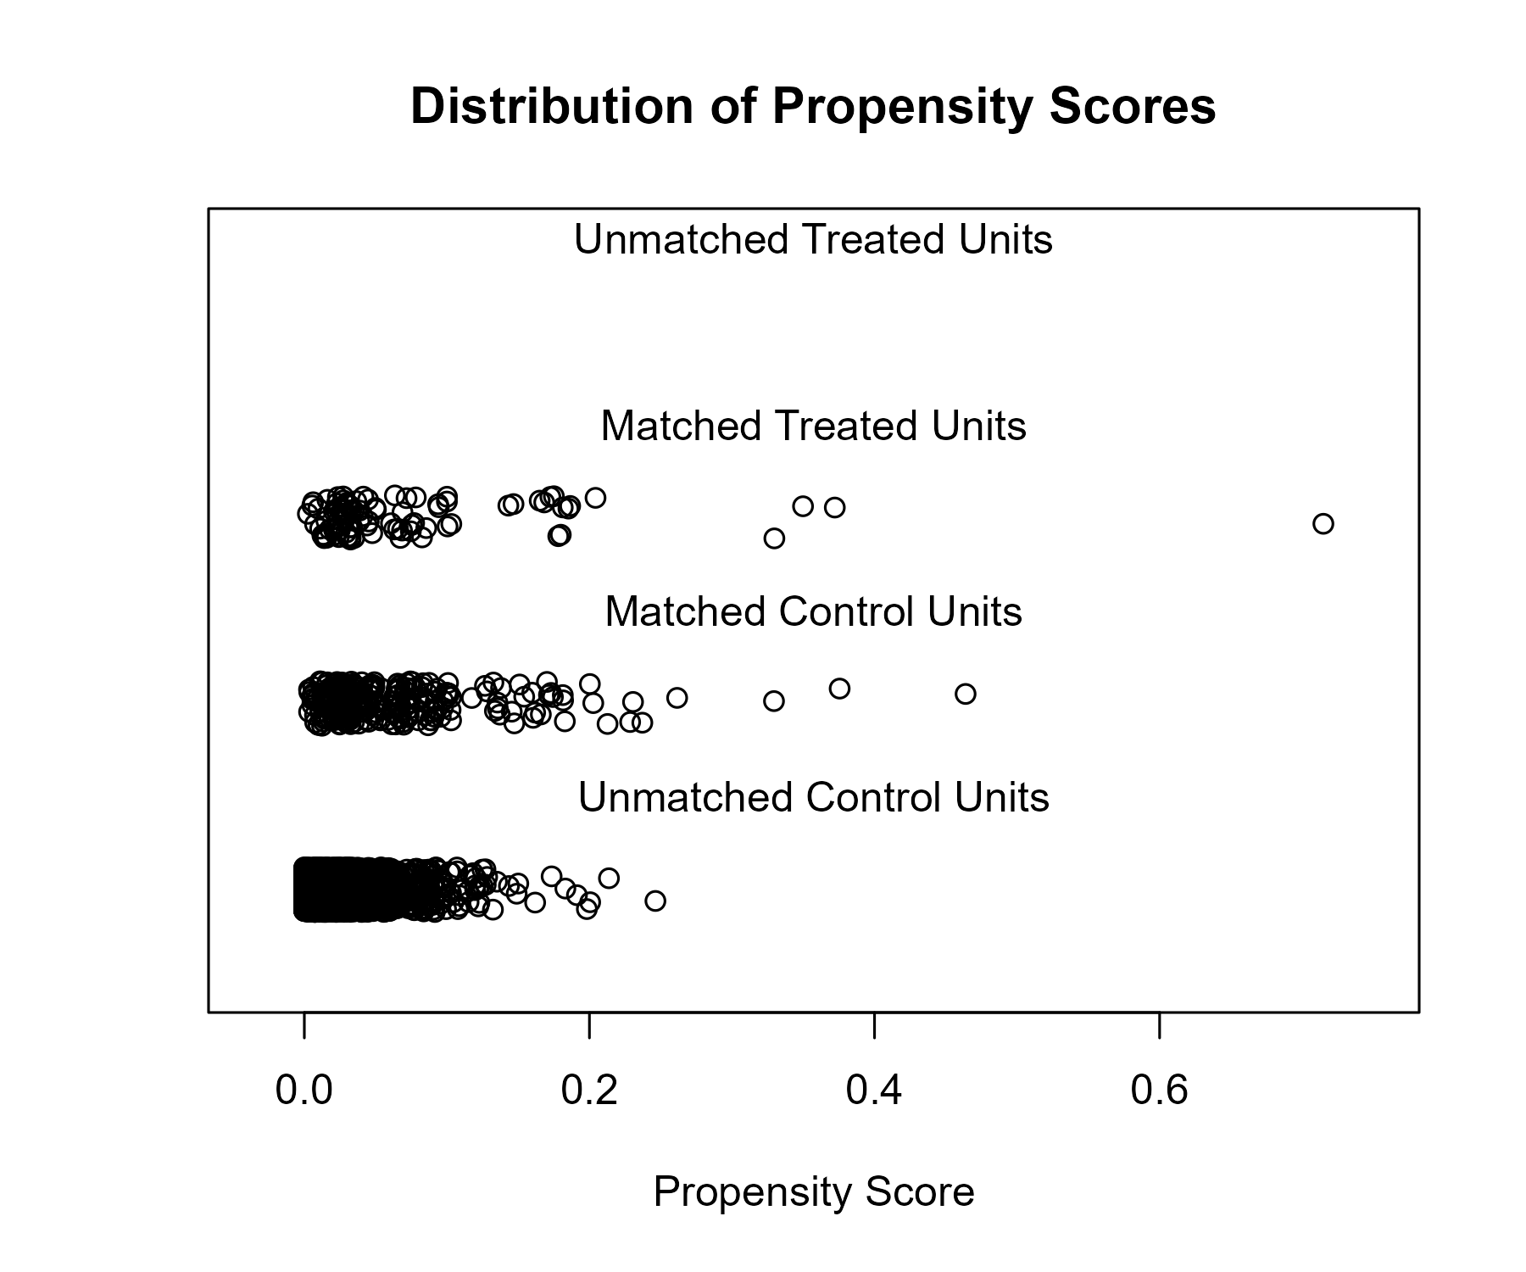

### Covariate balance

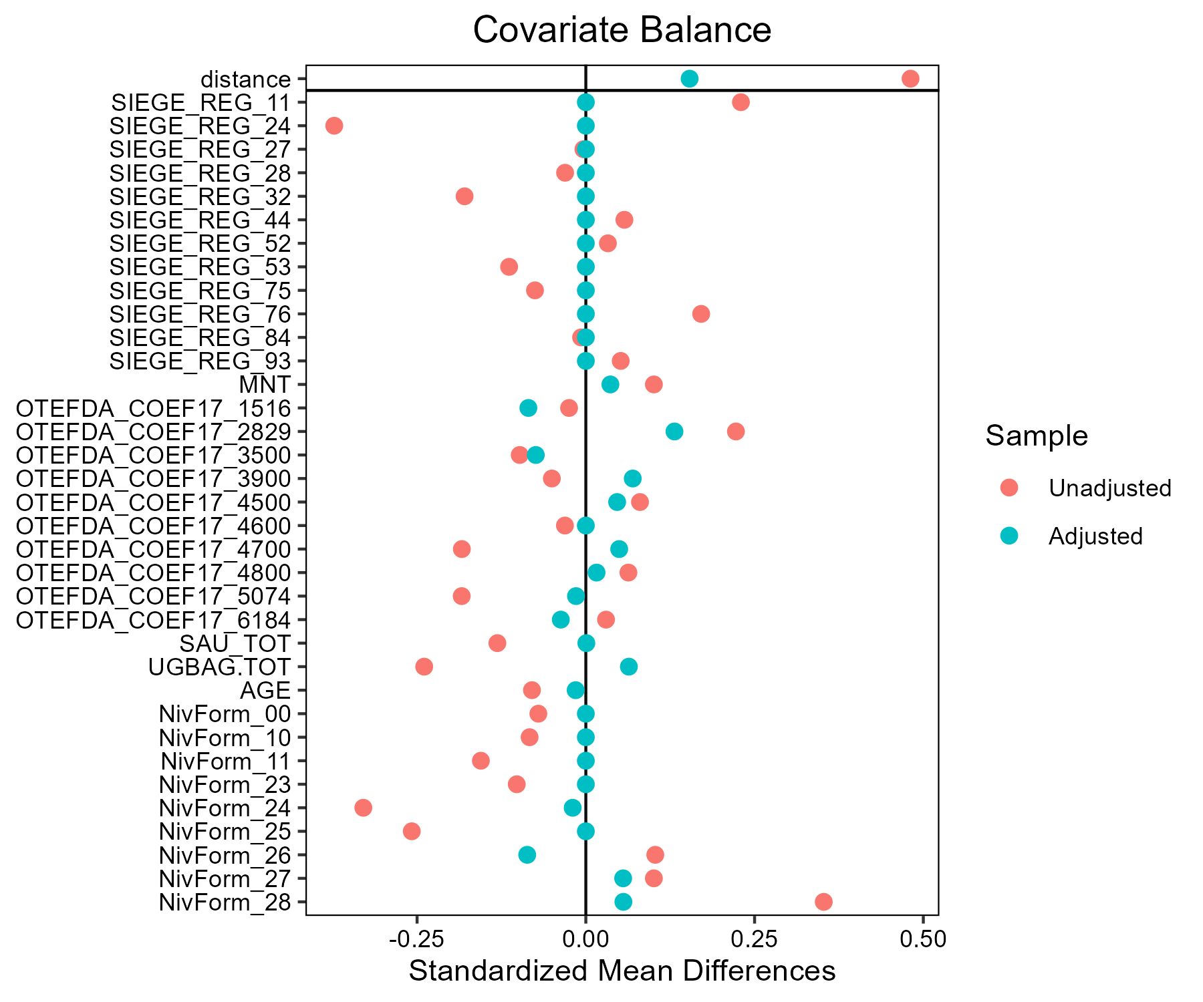

## Lait - AB

### Covariate distribution before matching

|  |  | Lait - AB (N=88) / Mean | Lait - AB (N=88) / Std. Dev. | Lait - Conventionnel (N=883) / Mean | Lait - Conventionnel (N=883) / Std. Dev. | Diff. in Means | Std. Error |
| --- | --- | --- | --- | --- | --- | --- | --- |
| SAU_TOT |  | 113.9 | 62.3 | 133.2 | 80.5 | 19.3 | 7.2 |
| UGBAG.TOT |  | 103.0 | 56.3 | 131.8 | 77.5 | 28.8 | 6.5 |
| AGE |  | 46.9 | 9.5 | 48.4 | 9.4 | 1.5 | 1.1 |
|  |  | N | Pct. | N | Pct. |  |  |
| SIEGE_REG | 11 | 0 | 0.0 | 2 | 0.2 |  |  |
|  | 24 | 0 | 0.0 | 27 | 3.1 |  |  |
|  | 27 | 8 | 9.1 | 71 | 8.0 |  |  |
|  | 28 | 14 | 15.9 | 106 | 12.0 |  |  |
|  | 32 | 8 | 9.1 | 155 | 17.6 |  |  |
|  | 44 | 13 | 14.8 | 125 | 14.2 |  |  |
|  | 52 | 11 | 12.5 | 87 | 9.9 |  |  |
|  | 53 | 9 | 10.2 | 116 | 13.1 |  |  |
|  | 75 | 1 | 1.1 | 44 | 5.0 |  |  |
|  | 76 | 4 | 4.5 | 39 | 4.4 |  |  |
|  | 84 | 19 | 21.6 | 106 | 12.0 |  |  |
|  | 93 | 1 | 1.1 | 5 | 0.6 |  |  |
| MNT | FALSE | 64 | 72.7 | 745 | 84.4 |  |  |
|  | TRUE | 24 | 27.3 | 138 | 15.6 |  |  |
| OTEFDA_COEF17 | 1516 | 0 | 0.0 | 4 | 0.5 |  |  |
|  | 2829 | 0 | 0.0 | 1 | 0.1 |  |  |
|  | 3900 | 0 | 0.0 | 2 | 0.2 |  |  |
|  | 4500 | 77 | 87.5 | 529 | 59.9 |  |  |
|  | 4600 | 0 | 0.0 | 2 | 0.2 |  |  |
|  | 4700 | 6 | 6.8 | 170 | 19.3 |  |  |
|  | 4800 | 1 | 1.1 | 3 | 0.3 |  |  |
|  | 5074 | 0 | 0.0 | 8 | 0.9 |  |  |
|  | 6184 | 4 | 4.5 | 164 | 18.6 |  |  |
| NivForm | 00 | 1 | 1.1 | 3 | 0.3 |  |  |
|  | 10 | 0 | 0.0 | 2 | 0.2 |  |  |
|  | 11 | 0 | 0.0 | 18 | 2.0 |  |  |
|  | 23 | 2 | 2.3 | 37 | 4.2 |  |  |
|  | 24 | 18 | 20.5 | 256 | 29.0 |  |  |
|  | 25 | 9 | 10.2 | 107 | 12.1 |  |  |
|  | 26 | 28 | 31.8 | 240 | 27.2 |  |  |
|  | 27 | 25 | 28.4 | 201 | 22.8 |  |  |
|  | 28 | 5 | 5.7 | 19 | 2.2 |  |  |

### Covariate distribution after matching

|  |  | Lait - AB (N=88) / Mean | Lait - AB (N=88) / Std. Dev. | Lait - Conventionnel (N=264) / Mean | Lait - Conventionnel (N=264) / Std. Dev. | Diff. in Means | Std. Error |
| --- | --- | --- | --- | --- | --- | --- | --- |
| SAU_TOT |  | 113.9 | 62.3 | 120.5 | 72.1 | 6.6 | 8.0 |
| UGBAG.TOT |  | 103.0 | 56.3 | 110.9 | 60.0 | 7.9 | 7.1 |
| AGE |  | 46.9 | 9.5 | 46.7 | 9.6 | -0.1 | 1.2 |
|  |  | N | Pct. | N | Pct. |  |  |
| SIEGE_REG | 27 | 8 | 9.1 | 24 | 9.1 |  |  |
|  | 28 | 14 | 15.9 | 42 | 15.9 |  |  |
|  | 32 | 8 | 9.1 | 24 | 9.1 |  |  |
|  | 44 | 13 | 14.8 | 39 | 14.8 |  |  |
|  | 52 | 11 | 12.5 | 33 | 12.5 |  |  |
|  | 53 | 9 | 10.2 | 27 | 10.2 |  |  |
|  | 75 | 1 | 1.1 | 3 | 1.1 |  |  |
|  | 76 | 4 | 4.5 | 12 | 4.5 |  |  |
|  | 84 | 19 | 21.6 | 57 | 21.6 |  |  |
|  | 93 | 1 | 1.1 | 3 | 1.1 |  |  |
| MNT | FALSE | 64 | 72.7 | 197 | 74.6 |  |  |
|  | TRUE | 24 | 27.3 | 67 | 25.4 |  |  |
| OTEFDA_COEF17 | 1516 | 0 | 0.0 | 1 | 0.4 |  |  |
|  | 4500 | 77 | 87.5 | 231 | 87.5 |  |  |
|  | 4700 | 6 | 6.8 | 21 | 8.0 |  |  |
|  | 4800 | 1 | 1.1 | 1 | 0.4 |  |  |
|  | 6184 | 4 | 4.5 | 10 | 3.8 |  |  |
| NivForm | 00 | 1 | 1.1 | 1 | 0.4 |  |  |
|  | 11 | 0 | 0.0 | 1 | 0.4 |  |  |
|  | 23 | 2 | 2.3 | 7 | 2.7 |  |  |
|  | 24 | 18 | 20.5 | 59 | 22.3 |  |  |
|  | 25 | 9 | 10.2 | 36 | 13.6 |  |  |
|  | 26 | 28 | 31.8 | 75 | 28.4 |  |  |
|  | 27 | 25 | 28.4 | 76 | 28.8 |  |  |
|  | 28 | 5 | 5.7 | 9 | 3.4 |  |  |

### Matching model coefficients

| . | Estimate | Std. Error | t value | Pr(&gt;|t|) |
| --- | --- | --- | --- | --- |
| (Intercept) | -33.2764063816255 | 7278.41919761165 | -0.0045719277054755 | 0.99635311327116 |
| SIEGE_REG24 | -0.36613058719803 | 6247.76972761464 | -5.86018056298975e-05 | 0.999953254971162 |
| SIEGE_REG27 | 15.9917337736572 | 6043.07174633214 | 0.0026462922243747 | 0.997889128832262 |
| SIEGE_REG28 | 16.6807026958223 | 6043.07173445702 | 0.0027603019505313 | 0.997798186780459 |
| SIEGE_REG32 | 15.6855764804199 | 6043.07173536778 | 0.00259562970080568 | 0.997929540777902 |
| SIEGE_REG44 | 16.2370449007567 | 6043.07173662866 | 0.00268688600903737 | 0.997856748415625 |
| SIEGE_REG52 | 16.501600277939 | 6043.07173845868 | 0.00273066430320879 | 0.997821827817415 |
| SIEGE_REG53 | 15.9245905043008 | 6043.07174020312 | 0.00263518144230496 | 0.997897991562857 |
| SIEGE_REG75 | 14.462866210472 | 6043.07187783857 | 0.00239329706858377 | 0.998090935382704 |
| SIEGE_REG76 | 15.6965948616259 | 6043.07178319515 | 0.00259745298827588 | 0.997928086397155 |
| SIEGE_REG84 | 15.9684739135984 | 6043.07176327666 | 0.0026424432042389 | 0.997892199077721 |
| SIEGE_REG93 | 15.802855696354 | 6043.07194266211 | 0.00261503682999221 | 0.997914060303843 |
| MNTTRUE | 0.387450364752762 | 0.688736668772028 | 0.562552253016469 | 0.573874086548028 |
| OTEFDA_COEF172829 | 1.83812293109873 | 9468.81290410332 | 0.000194123904412788 | 0.999845152766874 |
| OTEFDA_COEF173900 | 0.984395115438543 | 7199.65125697949 | 0.000136728166448931 | 0.999890935748505 |
| OTEFDA_COEF174500 | 18.3695201705678 | 4056.68166060224 | 0.0045282133791688 | 0.996387982610898 |
| OTEFDA_COEF174600 | 1.8955018895991 | 7088.86985255394 | 0.000267391266735727 | 0.999786709433298 |
| OTEFDA_COEF174700 | 17.2820709150663 | 4056.68171350918 | 0.00426014958420701 | 0.996601807569982 |
| OTEFDA_COEF174800 | 19.5559957370414 | 4056.68200105653 | 0.00482068738243426 | 0.996154686793405 |
| OTEFDA_COEF175074 | 0.909628214277706 | 5015.93169175962 | 0.000181347807381843 | 0.999855343903606 |
| OTEFDA_COEF176184 | 16.3378423545338 | 4056.68167364084 | 0.00402739077623282 | 0.996787471194926 |
| SAU_TOT | 0.00597641115983729 | 0.00387959388895153 | 1.54047339255203 | 0.123781909259101 |
| UGBAG.TOT | -0.0136361393523672 | 0.00473932284932336 | -2.87723368630902 | 0.00410266113968727 |
| AGE | -0.0112586732085426 | 0.0200493935876594 | -0.561546819823637 | 0.574558816604869 |
| NivForm10 | -18.5139030051341 | 6039.42894975241 | -0.0030655055567618 | 0.997554735395593 |
| NivForm11 | -18.3277253968093 | 1915.47231854886 | -0.00956825385536986 | 0.992367786862703 |
| NivForm23 | -2.55296079163881 | 2.11217968633303 | -1.20868542016471 | 0.227087999947727 |
| NivForm24 | -2.15037484492096 | 1.89834712805204 | -1.13276166047014 | 0.257603511564563 |
| NivForm25 | -1.95003174541047 | 1.94972138454032 | -1.00015918216449 | 0.317491141327803 |
| NivForm26 | -1.60101399845437 | 1.89996233390793 | -0.842655651578801 | 0.39963563582677 |
| NivForm27 | -1.49456320687623 | 1.91298405673603 | -0.781273216372899 | 0.434838747812662 |
| NivForm28 | -0.763664714199208 | 2.02057805126952 | -0.377943684837812 | 0.705557846428403 |

### Propensity score distribution

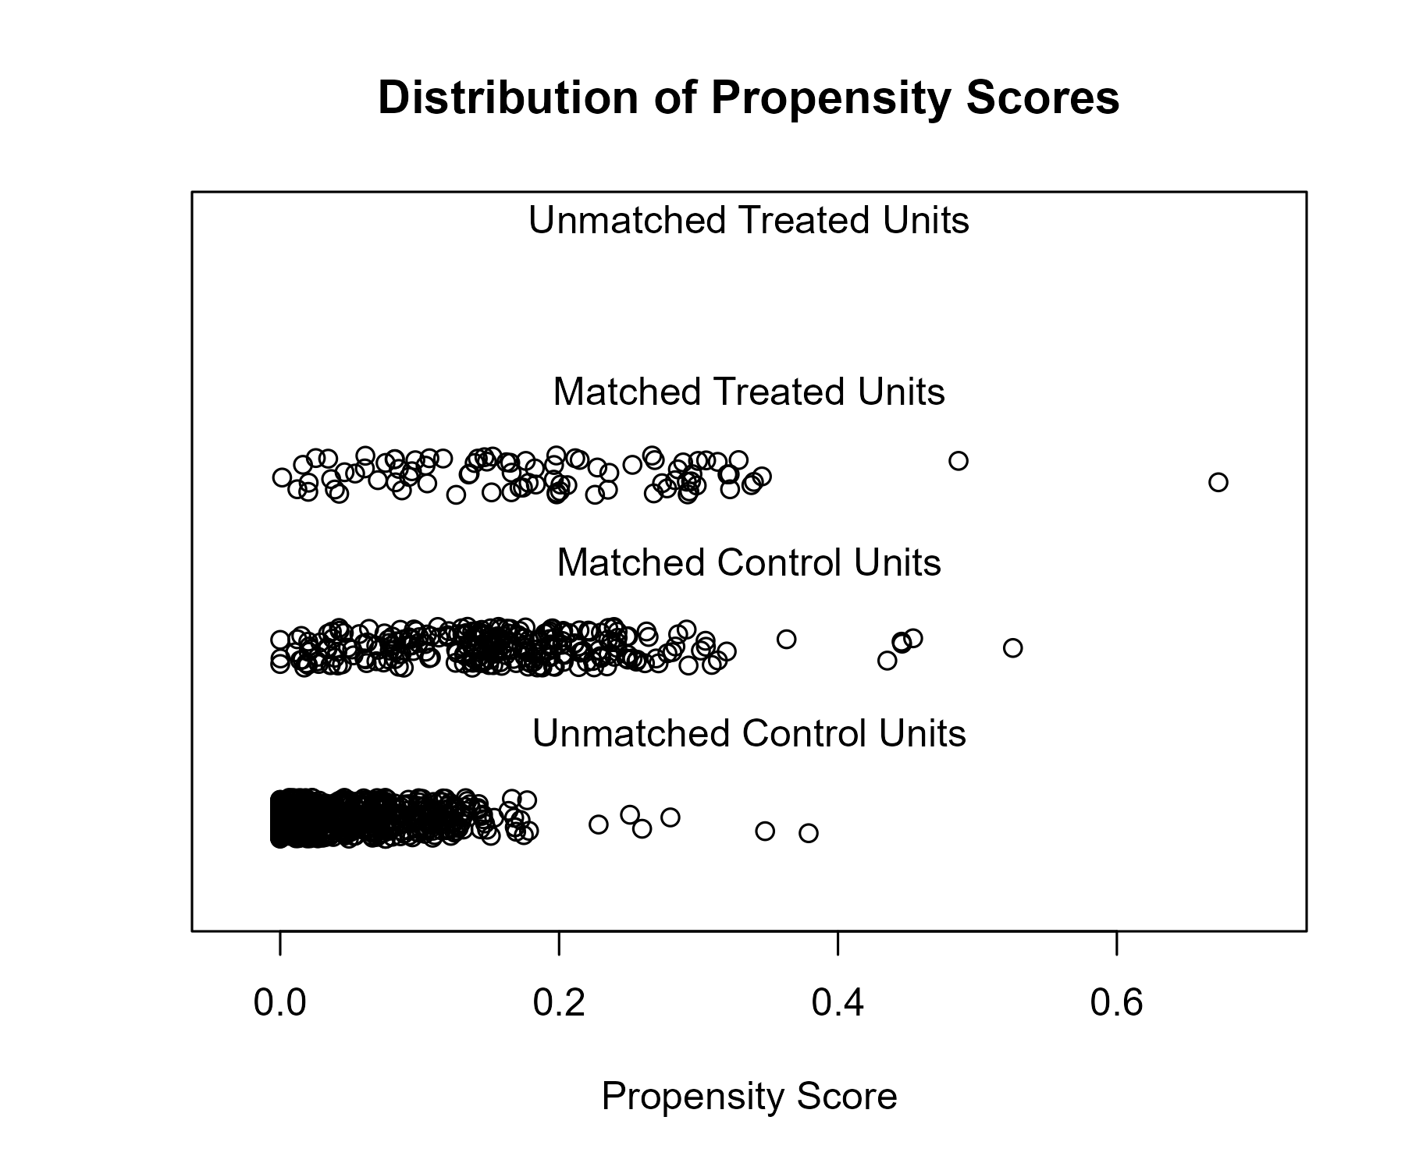

### Covariate balance

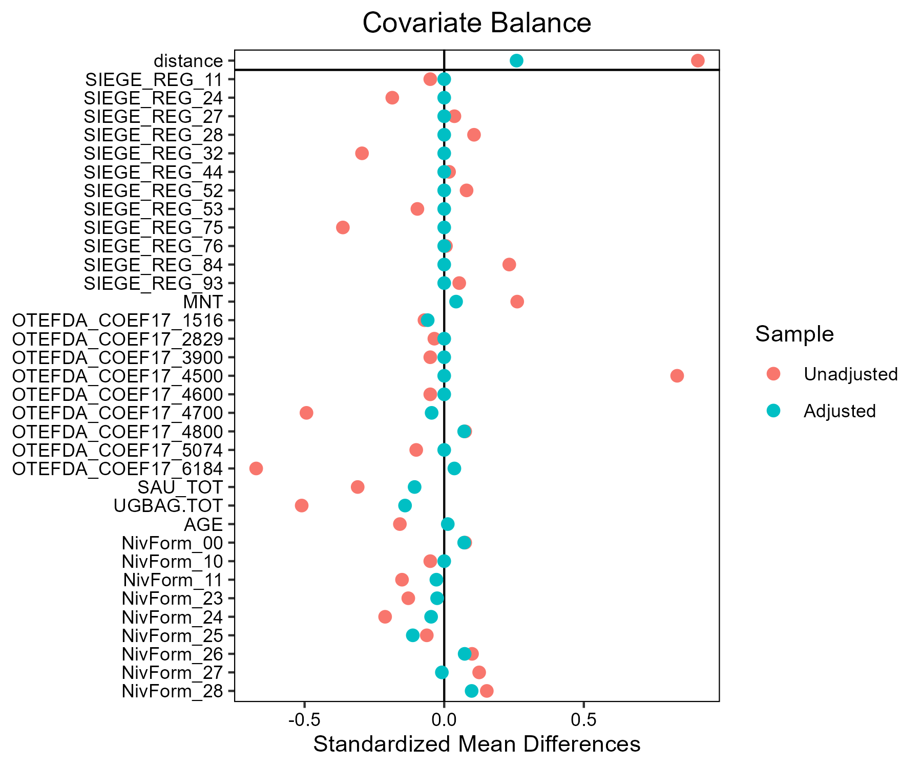

## Lait - Bleu d'Auvergne - Cantal

### Covariate distribution before matching

|  |  | Lait - Bleu d'Auvergne - Cantal (N=54) / Mean | Lait - Bleu d'Auvergne - Cantal (N=54) / Std. Dev. | Lait - Conventionnel (N=883) / Mean | Lait - Conventionnel (N=883) / Std. Dev. | Diff. in Means | Std. Error |
| --- | --- | --- | --- | --- | --- | --- | --- |
| SAU_TOT |  | 101.4 | 50.7 | 133.2 | 80.5 | 31.8 | 7.4 |
| UGBAG.TOT |  | 105.3 | 55.1 | 131.8 | 77.5 | 26.5 | 7.9 |
| AGE |  | 46.3 | 10.7 | 48.4 | 9.4 | 2.1 | 1.5 |
|  |  | N | Pct. | N | Pct. |  |  |
| SIEGE_REG | 11 | 0 | 0.0 | 2 | 0.2 |  |  |
|  | 24 | 0 | 0.0 | 27 | 3.1 |  |  |
|  | 27 | 0 | 0.0 | 71 | 8.0 |  |  |
|  | 28 | 0 | 0.0 | 106 | 12.0 |  |  |
|  | 32 | 0 | 0.0 | 155 | 17.6 |  |  |
|  | 44 | 0 | 0.0 | 125 | 14.2 |  |  |
|  | 52 | 0 | 0.0 | 87 | 9.9 |  |  |
|  | 53 | 0 | 0.0 | 116 | 13.1 |  |  |
|  | 75 | 0 | 0.0 | 44 | 5.0 |  |  |
|  | 76 | 2 | 3.7 | 39 | 4.4 |  |  |
|  | 84 | 52 | 96.3 | 106 | 12.0 |  |  |
|  | 93 | 0 | 0.0 | 5 | 0.6 |  |  |
| MNT | FALSE | 0 | 0.0 | 745 | 84.4 |  |  |
|  | TRUE | 54 | 100.0 | 138 | 15.6 |  |  |
| OTEFDA_COEF17 | 1516 | 0 | 0.0 | 4 | 0.5 |  |  |
|  | 2829 | 0 | 0.0 | 1 | 0.1 |  |  |
|  | 3900 | 0 | 0.0 | 2 | 0.2 |  |  |
|  | 4500 | 33 | 61.1 | 529 | 59.9 |  |  |
|  | 4600 | 1 | 1.9 | 2 | 0.2 |  |  |
|  | 4700 | 20 | 37.0 | 170 | 19.3 |  |  |
|  | 4800 | 0 | 0.0 | 3 | 0.3 |  |  |
|  | 5074 | 0 | 0.0 | 8 | 0.9 |  |  |
|  | 6184 | 0 | 0.0 | 164 | 18.6 |  |  |
| NivForm | 00 | 0 | 0.0 | 3 | 0.3 |  |  |
|  | 10 | 0 | 0.0 | 2 | 0.2 |  |  |
|  | 11 | 1 | 1.9 | 18 | 2.0 |  |  |
|  | 23 | 0 | 0.0 | 37 | 4.2 |  |  |
|  | 24 | 25 | 46.3 | 256 | 29.0 |  |  |
|  | 25 | 9 | 16.7 | 107 | 12.1 |  |  |
|  | 26 | 16 | 29.6 | 240 | 27.2 |  |  |
|  | 27 | 3 | 5.6 | 201 | 22.8 |  |  |
|  | 28 | 0 | 0.0 | 19 | 2.2 |  |  |

### Covariate distribution after matching

|  |  | Lait - Bleu d'Auvergne - Cantal (N=54) / Mean | Lait - Bleu d'Auvergne - Cantal (N=54) / Std. Dev. | Lait - Conventionnel (N=112) / Mean | Lait - Conventionnel (N=112) / Std. Dev. | Diff. in Means | Std. Error |
| --- | --- | --- | --- | --- | --- | --- | --- |
| SAU_TOT |  | 101.4 | 50.7 | 111.8 | 62.2 | 10.4 | 9.1 |
| UGBAG.TOT |  | 105.3 | 55.1 | 96.8 | 60.3 | -8.5 | 9.4 |
| AGE |  | 46.3 | 10.7 | 48.1 | 10.0 | 1.8 | 1.7 |
|  |  | N | Pct. | N | Pct. |  |  |
| SIEGE_REG | 76 | 2 | 3.7 | 6 | 5.4 |  |  |
|  | 84 | 52 | 96.3 | 106 | 94.6 |  |  |
| MNT | FALSE | 0 | 0.0 | 20 | 17.9 |  |  |
|  | TRUE | 54 | 100.0 | 92 | 82.1 |  |  |
| OTEFDA_COEF17 | 1516 | 0 | 0.0 | 1 | 0.9 |  |  |
|  | 3900 | 0 | 0.0 | 2 | 1.8 |  |  |
|  | 4500 | 33 | 61.1 | 79 | 70.5 |  |  |
|  | 4600 | 1 | 1.9 | 1 | 0.9 |  |  |
|  | 4700 | 20 | 37.0 | 24 | 21.4 |  |  |
|  | 4800 | 0 | 0.0 | 1 | 0.9 |  |  |
|  | 6184 | 0 | 0.0 | 4 | 3.6 |  |  |
| NivForm | 11 | 1 | 1.9 | 2 | 1.8 |  |  |
|  | 23 | 0 | 0.0 | 6 | 5.4 |  |  |
|  | 24 | 25 | 46.3 | 39 | 34.8 |  |  |
|  | 25 | 9 | 16.7 | 9 | 8.0 |  |  |
|  | 26 | 16 | 29.6 | 28 | 25.0 |  |  |
|  | 27 | 3 | 5.6 | 25 | 22.3 |  |  |
|  | 28 | 0 | 0.0 | 3 | 2.7 |  |  |

### Matching model coefficients

| . | Estimate | Std. Error | t value | Pr(&gt;|t|) |
| --- | --- | --- | --- | --- |
| (Intercept) | -19.6285203897953 | 20771.7554145844 | -0.000944962040907414 | 0.999246237739688 |
| SIEGE_REG24 | 0.28969268900778 | 14394.9869481535 | 2.01245537805048e-05 | 0.999983947364288 |
| SIEGE_REG27 | -16.9596813157369 | 14087.9917409814 | -0.00120383952713444 | 0.999039740561501 |
| SIEGE_REG28 | -1.15213821598599 | 14024.9357328767 | -8.21492688401559e-05 | 0.999934472470809 |
| SIEGE_REG32 | -0.356364120373343 | 13983.0860699346 | -2.54853698669258e-05 | 0.999979671233315 |
| SIEGE_REG44 | -15.8607602614094 | 14014.4010848223 | -0.00113174727663437 | 0.9990972459282 |
| SIEGE_REG52 | -1.47883069591521 | 14060.3484752055 | -0.000105177385789764 | 0.999916103766839 |
| SIEGE_REG53 | -0.954679225736418 | 14020.732735038 | -6.80905373333781e-05 | 0.999945686617333 |
| SIEGE_REG75 | -17.9272162483447 | 14208.6972828766 | -0.00126170724109587 | 0.998993581593947 |
| SIEGE_REG76 | 0.624190149164304 | 13942.0274881768 | 4.47704001224809e-05 | 0.999964288255457 |
| SIEGE_REG84 | 2.67274512824942 | 13942.0274846981 | 0.000191704193036692 | 0.999847084432769 |
| SIEGE_REG93 | -19.4313650749537 | 16807.4899431907 | -0.00115611344350832 | 0.999077809922383 |
| MNTTRUE | 18.9119148724384 | 1039.33780702294 | 0.018196119437442 | 0.985486409082774 |
| OTEFDA_COEF172829 | 1.36511241598544 | 23450.6708315039 | 5.82120838160217e-05 | 0.999953566305854 |
| OTEFDA_COEF173900 | -20.1459646672735 | 16907.753458245 | -0.00119152226326375 | 0.999049565594647 |
| OTEFDA_COEF174500 | -1.51063352680665 | 9786.20837656676 | -0.000154363515334895 | 0.999876869753425 |
| OTEFDA_COEF174600 | -0.98201480010256 | 9786.20839752858 | -0.000100346810553366 | 0.99991995694366 |
| OTEFDA_COEF174700 | -1.10362378237319 | 9786.20837911974 | -0.000112773378577134 | 0.999910044715508 |
| OTEFDA_COEF174800 | -22.9887705989207 | 14002.8460337937 | -0.00164172130033001 | 0.998690458312139 |
| OTEFDA_COEF175074 | 0.178796922504131 | 12081.4312820792 | 1.47993162672163e-05 | 0.999988195115508 |
| OTEFDA_COEF176184 | -16.6201410995823 | 9863.27421802218 | -0.00168505313065452 | 0.998655894111057 |
| SAU_TOT | -0.0162413206372436 | 0.00335964855531915 | -4.83423202451626 | 1.56987798148919e-06 |
| UGBAG.TOT | 0.0151606996906323 | 0.00323037143190715 | 4.69317538561866 | 3.1056765314337e-06 |
| AGE | -0.0365475012654912 | 0.0103149917147081 | -3.54314402534886 | 0.000415600486579659 |
| NivForm10 | 18.0416491497386 | 19178.381614228 | 0.000940728446885939 | 0.999249614724494 |
| NivForm11 | 1.25877604642974 | 11824.2578646383 | 0.000106457086849759 | 0.999915082995147 |
| NivForm23 | -18.8518926498546 | 12126.3032320808 | -0.00155462817390059 | 0.998759929290679 |
| NivForm24 | 1.30702921431041 | 11824.2578502505 | 0.000110537949261883 | 0.999911827837392 |
| NivForm25 | 1.71049653389745 | 11824.2578515999 | 0.000144659948672044 | 0.999884609940895 |
| NivForm26 | 0.68453041651524 | 11824.257850633 | 5.78920406813182e-05 | 0.999953821592798 |
| NivForm27 | -0.499760726003576 | 11824.2578546895 | -4.22657161358646e-05 | 0.999966286152156 |
| NivForm28 | -19.0282495459498 | 12419.4274838357 | -0.0015321358066397 | 0.998777870625001 |

### Propensity score distribution

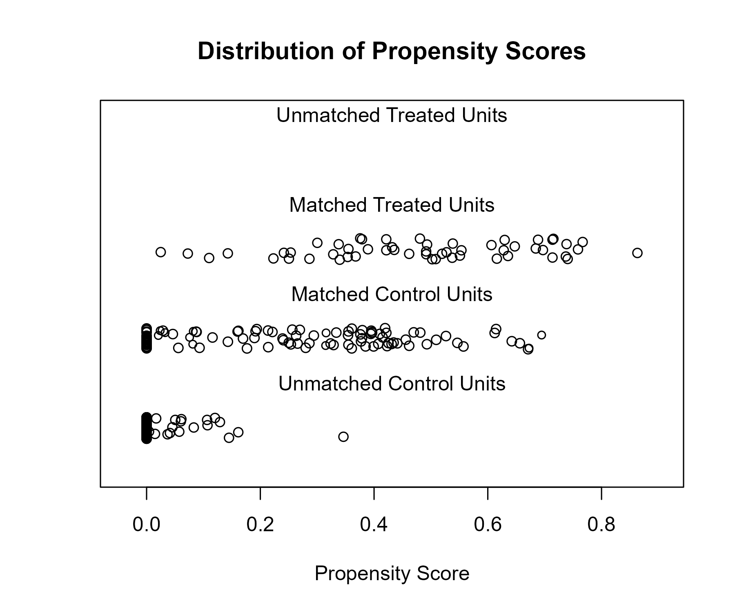

### Covariate balance

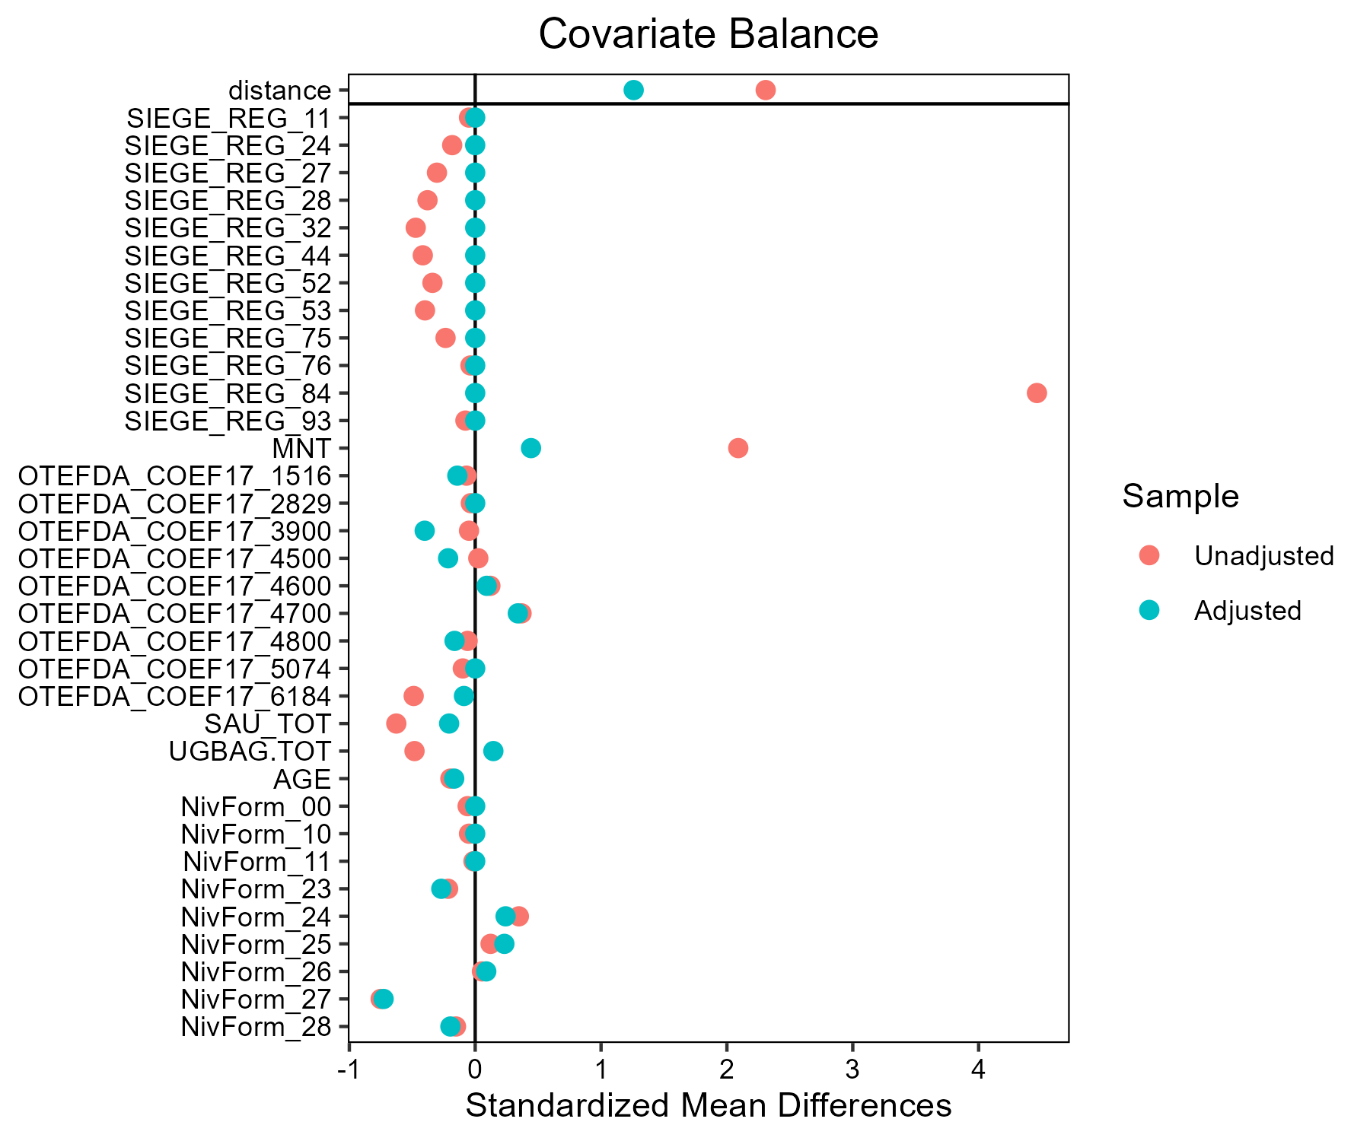

## Lait - Beurre de Charentes-Poitou

### Covariate distribution before matching

|  |  | Lait - Beurre de Charentes-Poitou (N=59) / Mean | Lait - Beurre de Charentes-Poitou (N=59) / Std. Dev. | Lait - Conventionnel (N=883) / Mean | Lait - Conventionnel (N=883) / Std. Dev. | Diff. in Means | Std. Error |
| --- | --- | --- | --- | --- | --- | --- | --- |
| SAU_TOT |  | 145.6 | 71.0 | 133.2 | 80.5 | -12.3 | 9.6 |
| UGBAG.TOT |  | 139.7 | 87.1 | 131.8 | 77.5 | -7.8 | 11.6 |
| AGE |  | 47.3 | 10.6 | 48.4 | 9.4 | 1.1 | 1.4 |
|  |  | N | Pct. | N | Pct. |  |  |
| SIEGE_REG | 11 | 0 | 0.0 | 2 | 0.2 |  |  |
|  | 24 | 3 | 5.1 | 27 | 3.1 |  |  |
|  | 27 | 0 | 0.0 | 71 | 8.0 |  |  |
|  | 28 | 0 | 0.0 | 106 | 12.0 |  |  |
|  | 32 | 0 | 0.0 | 155 | 17.6 |  |  |
|  | 44 | 0 | 0.0 | 125 | 14.2 |  |  |
|  | 52 | 17 | 28.8 | 87 | 9.9 |  |  |
|  | 53 | 0 | 0.0 | 116 | 13.1 |  |  |
|  | 75 | 39 | 66.1 | 44 | 5.0 |  |  |
|  | 76 | 0 | 0.0 | 39 | 4.4 |  |  |
|  | 84 | 0 | 0.0 | 106 | 12.0 |  |  |
|  | 93 | 0 | 0.0 | 5 | 0.6 |  |  |
| MNT | FALSE | 59 | 100.0 | 745 | 84.4 |  |  |
|  | TRUE | 0 | 0.0 | 138 | 15.6 |  |  |
| OTEFDA_COEF17 | 1516 | 0 | 0.0 | 4 | 0.5 |  |  |
|  | 2829 | 0 | 0.0 | 1 | 0.1 |  |  |
|  | 3900 | 0 | 0.0 | 2 | 0.2 |  |  |
|  | 4500 | 38 | 64.4 | 529 | 59.9 |  |  |
|  | 4600 | 0 | 0.0 | 2 | 0.2 |  |  |
|  | 4700 | 12 | 20.3 | 170 | 19.3 |  |  |
|  | 4800 | 0 | 0.0 | 3 | 0.3 |  |  |
|  | 5074 | 1 | 1.7 | 8 | 0.9 |  |  |
|  | 6184 | 8 | 13.6 | 164 | 18.6 |  |  |
| NivForm | 00 | 1 | 1.7 | 3 | 0.3 |  |  |
|  | 10 | 1 | 1.7 | 2 | 0.2 |  |  |
|  | 11 | 1 | 1.7 | 18 | 2.0 |  |  |
|  | 23 | 1 | 1.7 | 37 | 4.2 |  |  |
|  | 24 | 17 | 28.8 | 256 | 29.0 |  |  |
|  | 25 | 10 | 16.9 | 107 | 12.1 |  |  |
|  | 26 | 17 | 28.8 | 240 | 27.2 |  |  |
|  | 27 | 9 | 15.3 | 201 | 22.8 |  |  |
|  | 28 | 2 | 3.4 | 19 | 2.2 |  |  |

### Covariate distribution after matching

|  |  | Lait - Beurre de Charentes-Poitou (N=59) / Mean | Lait - Beurre de Charentes-Poitou (N=59) / Std. Dev. | Lait - Conventionnel (N=104) / Mean | Lait - Conventionnel (N=104) / Std. Dev. | Diff. in Means | Std. Error |
| --- | --- | --- | --- | --- | --- | --- | --- |
| SAU_TOT |  | 145.6 | 71.0 | 131.4 | 87.7 | -14.2 | 12.6 |
| UGBAG.TOT |  | 139.7 | 87.1 | 136.1 | 86.2 | -3.5 | 14.1 |
| AGE |  | 47.3 | 10.6 | 48.3 | 8.7 | 1.1 | 1.6 |
|  |  | N | Pct. | N | Pct. |  |  |
| SIEGE_REG | 24 | 3 | 5.1 | 9 | 8.7 |  |  |
|  | 52 | 17 | 28.8 | 51 | 49.0 |  |  |
|  | 75 | 39 | 66.1 | 44 | 42.3 |  |  |
| MNT | FALSE | 59 | 100.0 | 92 | 88.5 |  |  |
|  | TRUE | 0 | 0.0 | 12 | 11.5 |  |  |
| OTEFDA_COEF17 | 4500 | 38 | 64.4 | 62 | 59.6 |  |  |
|  | 4600 | 0 | 0.0 | 1 | 1.0 |  |  |
|  | 4700 | 12 | 20.3 | 27 | 26.0 |  |  |
|  | 4800 | 0 | 0.0 | 1 | 1.0 |  |  |
|  | 5074 | 1 | 1.7 | 2 | 1.9 |  |  |
|  | 6184 | 8 | 13.6 | 11 | 10.6 |  |  |
| NivForm | 00 | 1 | 1.7 | 0 | 0.0 |  |  |
|  | 10 | 1 | 1.7 | 0 | 0.0 |  |  |
|  | 11 | 1 | 1.7 | 2 | 1.9 |  |  |
|  | 23 | 1 | 1.7 | 4 | 3.8 |  |  |
|  | 24 | 17 | 28.8 | 33 | 31.7 |  |  |
|  | 25 | 10 | 16.9 | 16 | 15.4 |  |  |
|  | 26 | 17 | 28.8 | 29 | 27.9 |  |  |
|  | 27 | 9 | 15.3 | 20 | 19.2 |  |  |
|  | 28 | 2 | 3.4 | 0 | 0.0 |  |  |

### Matching model coefficients

| . | Estimate | Std. Error | t value | Pr(&gt;|t|) |
| --- | --- | --- | --- | --- |
| (Intercept) | -2.05457343006521 | 19666.3037780216 | -0.000104471763136362 | 0.999916666490267 |
| SIEGE_REG24 | 20.7160131052854 | 16381.5664022984 | 0.00126459293308965 | 0.998991278251587 |
| SIEGE_REG27 | -14.5629504281715 | 16589.5384605865 | -0.000877839396362363 | 0.999299777983907 |
| SIEGE_REG28 | -12.785492151298 | 16499.1742811213 | -0.000774917091816371 | 0.999381875516199 |
| SIEGE_REG32 | -15.0188618814338 | 16471.6809559803 | -0.000911798979203821 | 0.99927268961081 |
| SIEGE_REG44 | -15.1677681356717 | 16485.4197331317 | -0.000920071698580297 | 0.999266090751637 |
| SIEGE_REG52 | 21.1364290118004 | 16381.5664004127 | 0.00129025689577939 | 0.998970807013452 |
| SIEGE_REG53 | -13.7847230028765 | 16500.6785902826 | -0.000835403400378603 | 0.999333627696839 |
| SIEGE_REG75 | 23.2304736587594 | 16381.5664001867 | 0.00141808622516676 | 0.998868842074993 |
| SIEGE_REG76 | -13.3467918801323 | 16621.5401795031 | -0.000802981657294972 | 0.999359489390553 |
| SIEGE_REG84 | 2.23873240473262 | 16496.0970831196 | 0.000135712853376906 | 0.999891746553958 |
| SIEGE_REG93 | 20.3646646389719 | 19478.8392692358 | 0.00104547629134838 | 0.999166059896427 |
| MNTTRUE | -20.0993147353916 | 1674.71819595854 | -0.0120016100523035 | 0.990426961081889 |
| OTEFDA_COEF172829 | 13.7033495028703 | 25761.9889123106 | 0.000531921256138806 | 0.999575704842793 |
| OTEFDA_COEF173900 | 19.1170228102302 | 19148.6018574809 | 0.000998350843185018 | 0.999203650215851 |
| OTEFDA_COEF174500 | 0.246720082786729 | 10705.5793229756 | 2.30459347732107e-05 | 0.999981617055409 |
| OTEFDA_COEF174600 | -1.64629541371457 | 17608.2248316268 | -9.34958196784038e-05 | 0.999925421620464 |
| OTEFDA_COEF174700 | -0.0151962834085355 | 10705.579329606 | -1.41947324293889e-06 | 0.999998867735319 |
| OTEFDA_COEF174800 | -1.02448318221976 | 15822.6375890664 | -6.47479395551404e-05 | 0.999948352809456 |
| OTEFDA_COEF175074 | 0.783648219638096 | 10705.5793342208 | 7.31999824739176e-05 | 0.999941610907345 |
| OTEFDA_COEF176184 | -0.029772681049985 | 10705.5793216251 | -2.78104343123632e-06 | 0.999997781657902 |
| SAU_TOT | -0.00106287796461769 | 0.00167297572786312 | -0.635321808269924 | 0.525378271024185 |
| UGBAG.TOT | 0.00251388282709206 | 0.00180849179606354 | 1.39004381029757 | 0.164855489749718 |
| AGE | -0.0544909481856471 | 0.0130041540146111 | -4.19027244097715 | 3.05771877652195e-05 |
| NivForm10 | 0.136761726992625 | 3238.30127368244 | 4.22325520185791e-05 | 0.999966312554853 |
| NivForm11 | -18.767573676982 | 1942.23617469729 | -0.00966286897622375 | 0.992292383907889 |
| NivForm23 | -19.7821153515886 | 1942.2361604192 | -0.0101852265727145 | 0.991875737875817 |
| NivForm24 | -18.368793876701 | 1942.23607637494 | -0.00945754952249944 | 0.99245615263769 |
| NivForm25 | -19.4227249450666 | 1942.23610604932 | -0.0100001873534182 | 0.992023329731476 |
| NivForm26 | -18.4996543715118 | 1942.23608434327 | -0.00952492568778893 | 0.992402411425726 |
| NivForm27 | -18.4652601883676 | 1942.23609575181 | -0.00950721708280271 | 0.9924165363268 |
| NivForm28 | -0.126386333654707 | 1960.875193674 | -6.44540427980543e-05 | 0.999948587240728 |

### Propensity score distribution

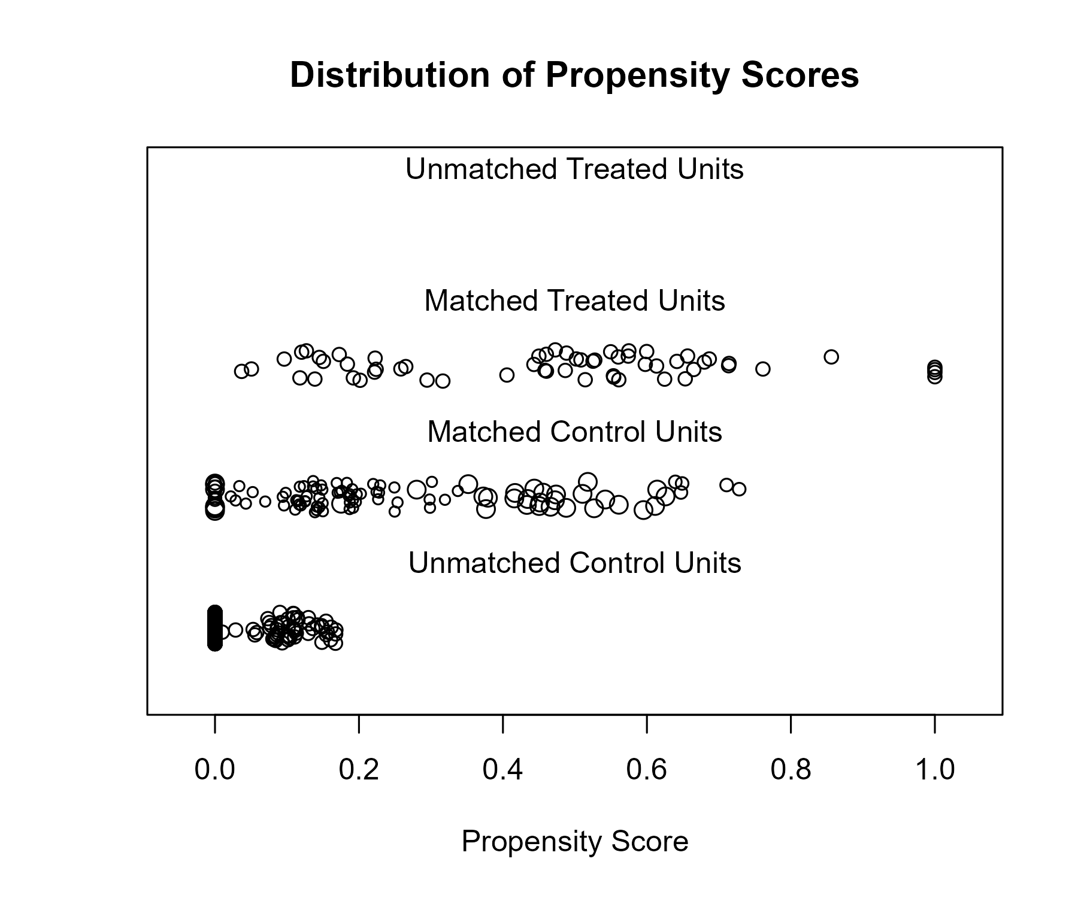

### Covariate balance

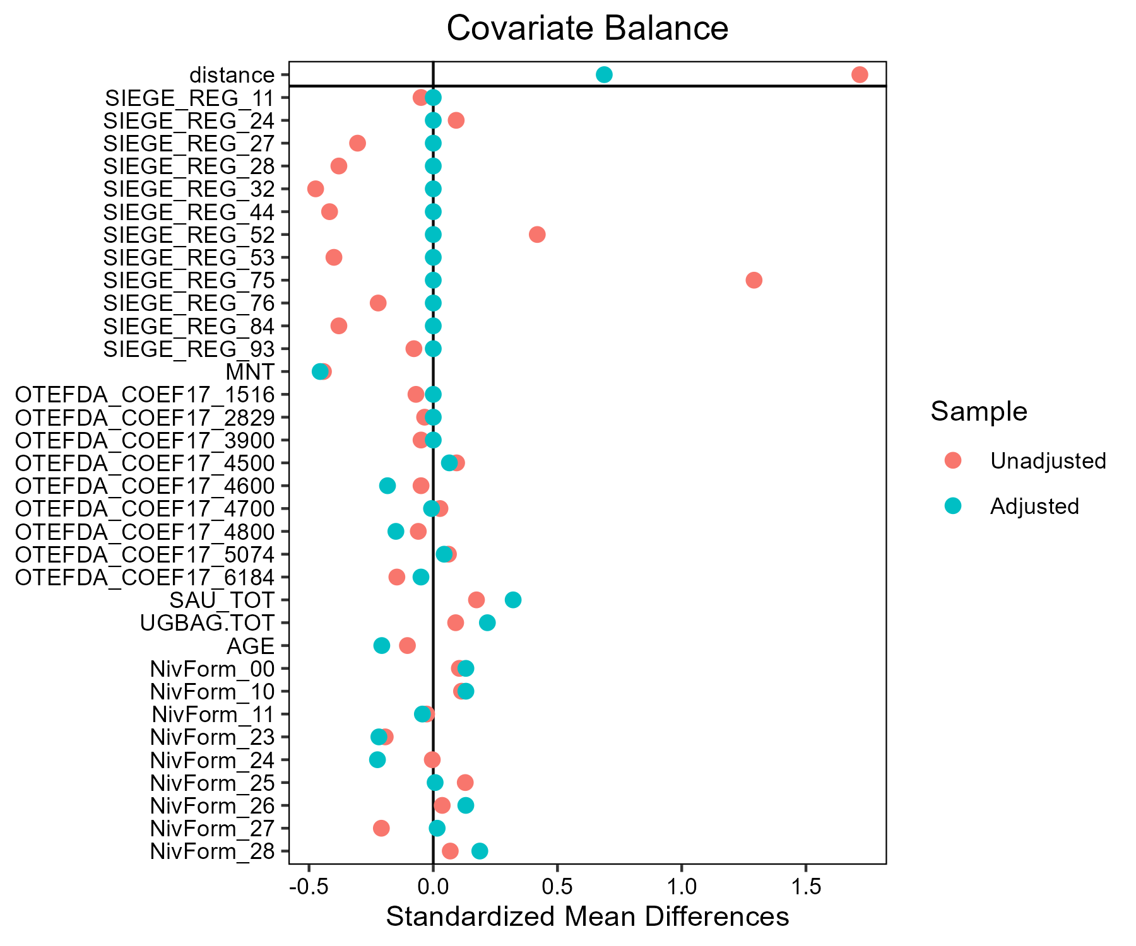

## Lait - Munster

### Covariate distribution before matching

|  |  | Lait - Conventionnel (N=883) / Mean | Lait - Conventionnel (N=883) / Std. Dev. | Lait - Munster (N=38) / Mean | Lait - Munster (N=38) / Std. Dev. | Diff. in Means | Std. Error |
| --- | --- | --- | --- | --- | --- | --- | --- |
| SAU_TOT |  | 133.2 | 80.5 | 161.5 | 80.1 | 28.3 | 13.3 |
| UGBAG.TOT |  | 131.8 | 77.5 | 158.5 | 82.1 | 26.7 | 13.6 |
| AGE |  | 48.4 | 9.4 | 45.1 | 10.3 | -3.2 | 1.7 |
|  |  | N | Pct. | N | Pct. |  |  |
| SIEGE_REG | 11 | 2 | 0.2 | 0 | 0.0 |  |  |
|  | 24 | 27 | 3.1 | 0 | 0.0 |  |  |
|  | 27 | 71 | 8.0 | 4 | 10.5 |  |  |
|  | 28 | 106 | 12.0 | 0 | 0.0 |  |  |
|  | 32 | 155 | 17.6 | 0 | 0.0 |  |  |
|  | 44 | 125 | 14.2 | 34 | 89.5 |  |  |
|  | 52 | 87 | 9.9 | 0 | 0.0 |  |  |
|  | 53 | 116 | 13.1 | 0 | 0.0 |  |  |
|  | 75 | 44 | 5.0 | 0 | 0.0 |  |  |
|  | 76 | 39 | 4.4 | 0 | 0.0 |  |  |
|  | 84 | 106 | 12.0 | 0 | 0.0 |  |  |
|  | 93 | 5 | 0.6 | 0 | 0.0 |  |  |
| MNT | FALSE | 745 | 84.4 | 34 | 89.5 |  |  |
|  | TRUE | 138 | 15.6 | 4 | 10.5 |  |  |
| OTEFDA_COEF17 | 1516 | 4 | 0.5 | 0 | 0.0 |  |  |
|  | 2829 | 1 | 0.1 | 0 | 0.0 |  |  |
|  | 3900 | 2 | 0.2 | 0 | 0.0 |  |  |
|  | 4500 | 529 | 59.9 | 23 | 60.5 |  |  |
|  | 4600 | 2 | 0.2 | 1 | 2.6 |  |  |
|  | 4700 | 170 | 19.3 | 10 | 26.3 |  |  |
|  | 4800 | 3 | 0.3 | 0 | 0.0 |  |  |
|  | 5074 | 8 | 0.9 | 0 | 0.0 |  |  |
|  | 6184 | 164 | 18.6 | 4 | 10.5 |  |  |
| NivForm | 00 | 3 | 0.3 | 0 | 0.0 |  |  |
|  | 10 | 2 | 0.2 | 0 | 0.0 |  |  |
|  | 11 | 18 | 2.0 | 2 | 5.3 |  |  |
|  | 23 | 37 | 4.2 | 1 | 2.6 |  |  |
|  | 24 | 256 | 29.0 | 15 | 39.5 |  |  |
|  | 25 | 107 | 12.1 | 8 | 21.1 |  |  |
|  | 26 | 240 | 27.2 | 4 | 10.5 |  |  |
|  | 27 | 201 | 22.8 | 8 | 21.1 |  |  |
|  | 28 | 19 | 2.2 | 0 | 0.0 |  |  |

### Covariate distribution after matching

|  |  | Lait - Conventionnel (N=114) / Mean | Lait - Conventionnel (N=114) / Std. Dev. | Lait - Munster (N=38) / Mean | Lait - Munster (N=38) / Std. Dev. | Diff. in Means | Std. Error |
| --- | --- | --- | --- | --- | --- | --- | --- |
| SAU_TOT |  | 160.9 | 69.5 | 161.5 | 80.1 | 0.5 | 14.5 |
| UGBAG.TOT |  | 149.6 | 67.1 | 158.5 | 82.1 | 8.9 | 14.7 |
| AGE |  | 47.1 | 10.9 | 45.1 | 10.3 | -2.0 | 2.0 |
|  |  | N | Pct. | N | Pct. |  |  |
| SIEGE_REG | 27 | 12 | 10.5 | 4 | 10.5 |  |  |
|  | 44 | 102 | 89.5 | 34 | 89.5 |  |  |
| MNT | FALSE | 109 | 95.6 | 34 | 89.5 |  |  |
|  | TRUE | 5 | 4.4 | 4 | 10.5 |  |  |
| OTEFDA_COEF17 | 4500 | 67 | 58.8 | 23 | 60.5 |  |  |
|  | 4600 | 0 | 0.0 | 1 | 2.6 |  |  |
|  | 4700 | 31 | 27.2 | 10 | 26.3 |  |  |
|  | 6184 | 16 | 14.0 | 4 | 10.5 |  |  |
| NivForm | 11 | 6 | 5.3 | 2 | 5.3 |  |  |
|  | 23 | 4 | 3.5 | 1 | 2.6 |  |  |
|  | 24 | 44 | 38.6 | 15 | 39.5 |  |  |
|  | 25 | 17 | 14.9 | 8 | 21.1 |  |  |
|  | 26 | 18 | 15.8 | 4 | 10.5 |  |  |
|  | 27 | 25 | 21.9 | 8 | 21.1 |  |  |

### Matching model coefficients

| . | Estimate | Std. Error | t value | Pr(&gt;|t|) |
| --- | --- | --- | --- | --- |
| (Intercept) | -38.0205568865831 | 14389.2614248606 | -0.00264228689464868 | 0.99789235532168 |
| SIEGE_REG24 | 0.539567514953777 | 10613.5397598083 | 5.08376589869696e-05 | 0.999959448821999 |
| SIEGE_REG27 | 18.8243066761505 | 10257.0311142348 | 0.00183525880603267 | 0.998536087888155 |
| SIEGE_REG28 | 0.0908930145642562 | 10352.9785023568 | 8.77940725401533e-06 | 0.999992997016119 |
| SIEGE_REG32 | 0.251675950407499 | 10320.9364865939 | 2.43849916850478e-05 | 0.999980549062282 |
| SIEGE_REG44 | 20.4743602047413 | 10257.0311108283 | 0.00199612928765777 | 0.998407768140992 |
| SIEGE_REG52 | 0.317832691241131 | 10368.0066246031 | 3.06551396762152e-05 | 0.999975547614686 |
| SIEGE_REG53 | 0.204516102963395 | 10342.0803384542 | 1.97751415837448e-05 | 0.999984226156306 |
| SIEGE_REG75 | -13.4850668304021 | 10464.5931850898 | -0.00128863746462844 | 0.998972105447183 |
| SIEGE_REG76 | -0.420314777918935 | 10499.1864459414 | -4.00330806661133e-05 | 0.999968067204261 |
| SIEGE_REG84 | -11.8841982826137 | 10369.2280353903 | -0.00114610251043306 | 0.999085799825012 |
| SIEGE_REG93 | -0.483607243324302 | 12079.2963978656 | -4.00360441035087e-05 | 0.999968064840445 |
| MNTTRUE | 0.967225639137936 | 0.359715089046874 | 2.68886590690639 | 0.00730372608613901 |
| OTEFDA_COEF172829 | -0.255995717682375 | 16174.6840002423 | -1.58269378046916e-05 | 0.999987375481382 |
| OTEFDA_COEF173900 | 10.9609945881458 | 12530.8767634866 | 0.000874718887993917 | 0.999302271632455 |
| OTEFDA_COEF174500 | -0.629601494757187 | 7024.12162365909 | -8.96341960589811e-05 | 0.999928502367959 |
| OTEFDA_COEF174600 | 15.7288196709714 | 7093.56948372499 | 0.00221733496895442 | 0.998231321561963 |
| OTEFDA_COEF174700 | -0.855715194241765 | 7024.12163052708 | -0.00012182522445551 | 0.999902824865459 |
| OTEFDA_COEF174800 | 1.68526274066613 | 9760.3645873875 | 0.000172663912866929 | 0.999862272866754 |
| OTEFDA_COEF175074 | -18.1316105450059 | 8112.762806875 | -0.00223494892882122 | 0.998217271641795 |
| OTEFDA_COEF176184 | -0.603601616189722 | 7024.121621836 | -8.59326829298194e-05 | 0.999931454917708 |
| SAU_TOT | -0.00554607744624903 | 0.00206151522429346 | -2.69029177223265 | 0.00727284545848136 |
| UGBAG.TOT | 0.00493180804985115 | 0.00244553513480506 | 2.01665802288474 | 0.0440314656457899 |
| AGE | -0.0284079547862138 | 0.0121864383614064 | -2.33111217106549 | 0.0199701879102089 |
| NivForm10 | 0.0697728465511655 | 12558.3972623988 | 5.55587190732316e-06 | 0.999995568302018 |
| NivForm11 | 19.1574013044993 | 7246.0935800372 | 0.00264382471643444 | 0.997891128666713 |
| NivForm23 | 18.236713225889 | 7246.09358640449 | 0.00251676479311635 | 0.997992478974677 |
| NivForm24 | 18.7942450629806 | 7246.09356859115 | 0.0025937072003108 | 0.997931105278183 |
| NivForm25 | 18.5768757600049 | 7246.09357550785 | 0.00256370906149979 | 0.9979550335204 |
| NivForm26 | 17.4520484908644 | 7246.09357546814 | 0.00240847683087461 | 0.998078855711712 |
| NivForm27 | 18.1649244700396 | 7246.09357637308 | 0.00250685756105454 | 0.99800038155458 |
| NivForm28 | -0.232080650591852 | 7740.85817847999 | -2.99812559849047e-05 | 0.999976085144896 |

### Propensity score distribution

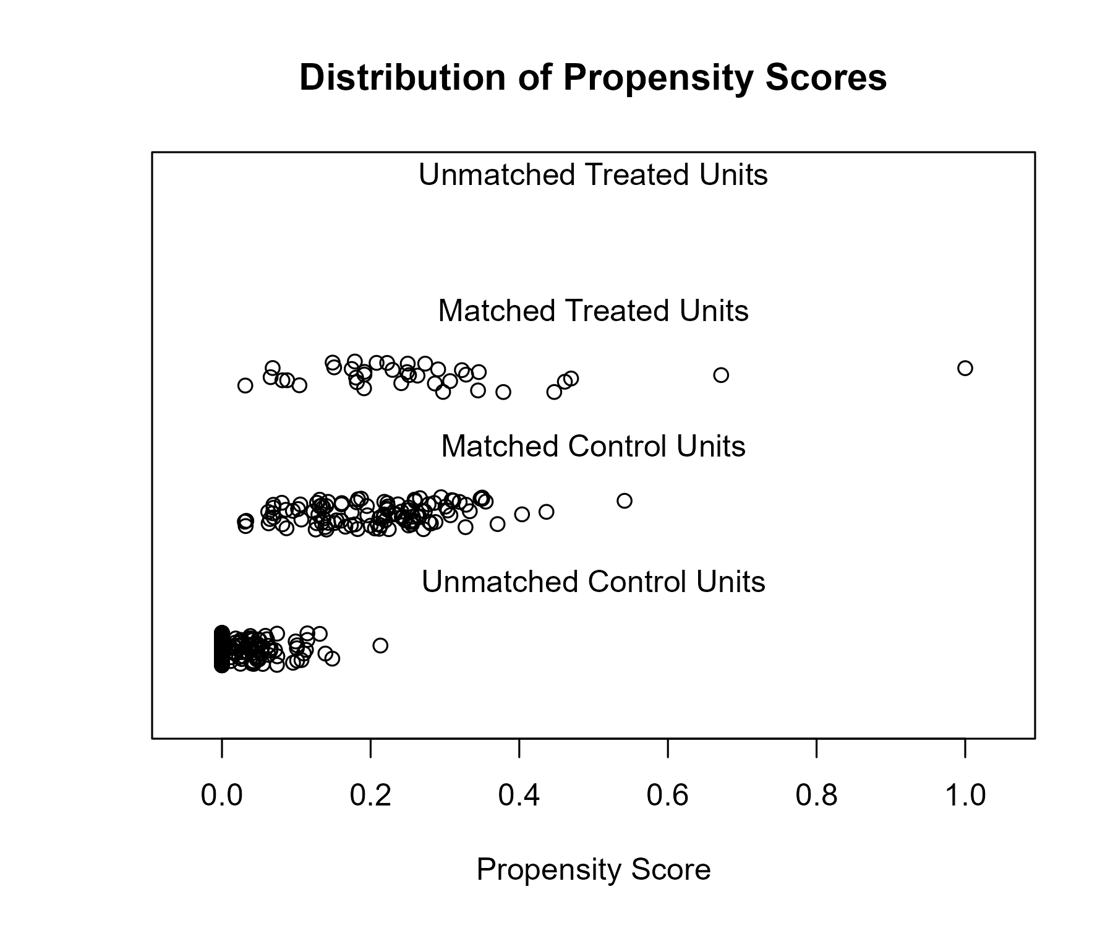

### Covariate balance

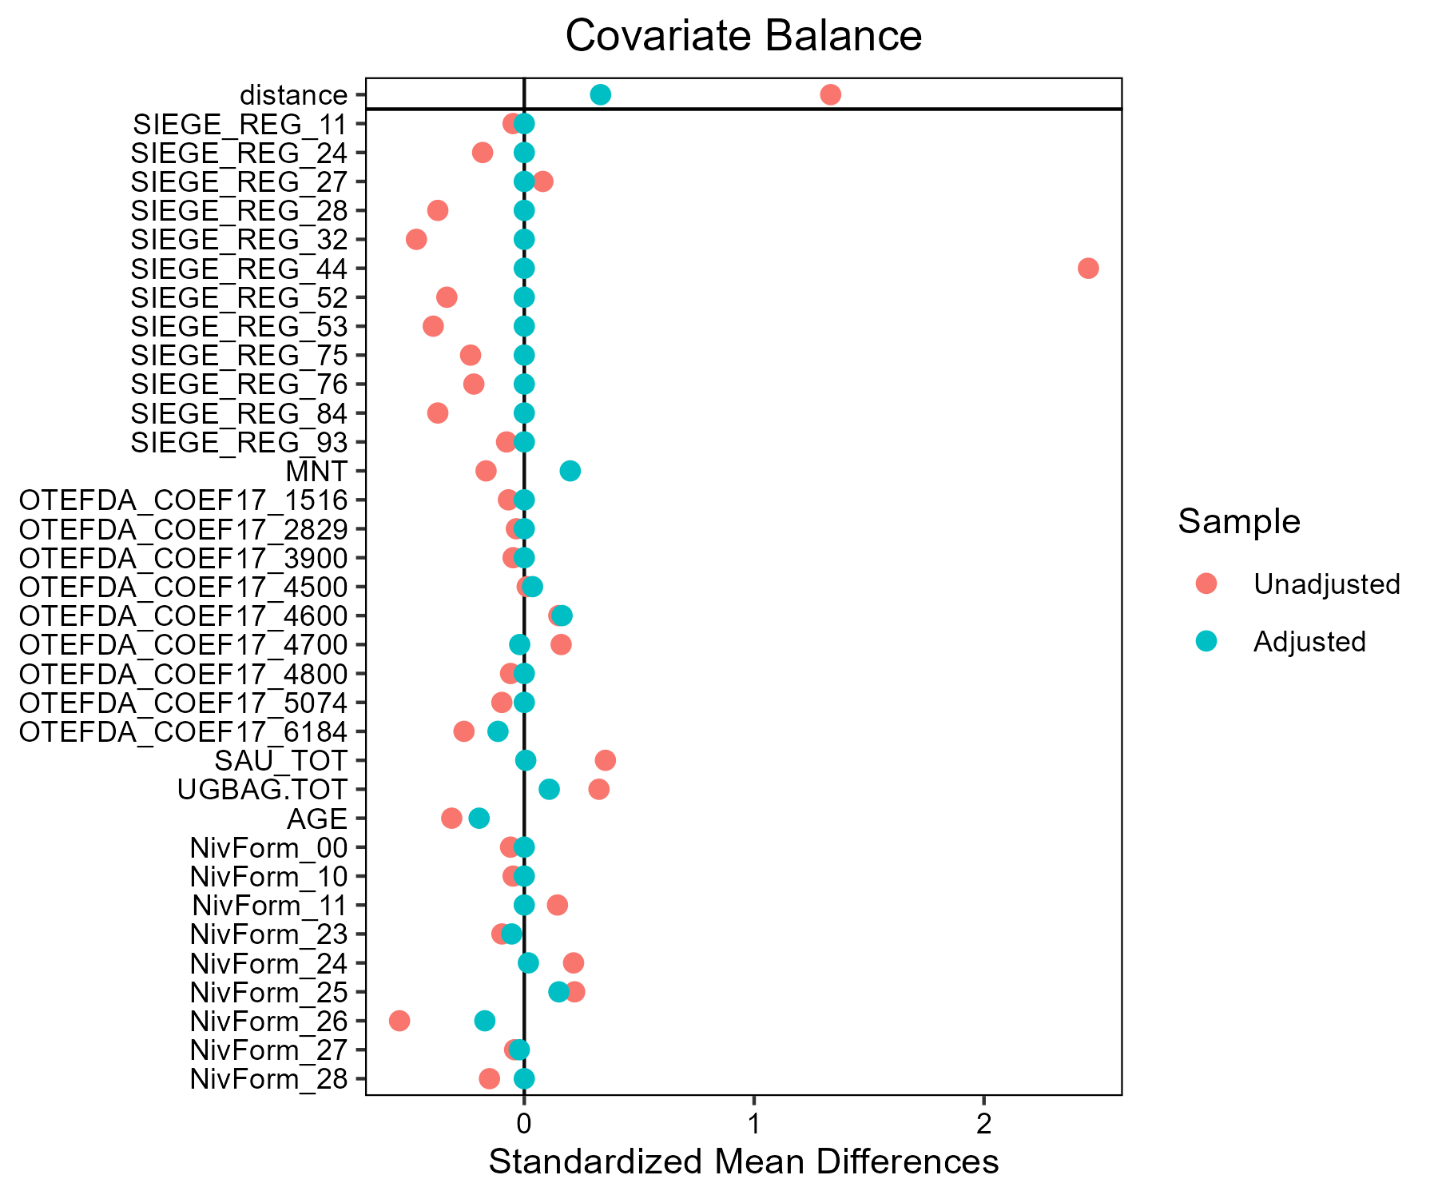

## Lait - Comte - Morbier

### Covariate distribution before matching

|  |  | Lait - Comte - Morbier (N=64) / Mean | Lait - Comte - Morbier (N=64) / Std. Dev. | Lait - Conventionnel (N=883) / Mean | Lait - Conventionnel (N=883) / Std. Dev. | Diff. in Means | Std. Error |
| --- | --- | --- | --- | --- | --- | --- | --- |
| SAU_TOT |  | 150.6 | 103.2 | 133.2 | 80.5 | -17.4 | 13.2 |
| UGBAG.TOT |  | 110.5 | 72.9 | 131.8 | 77.5 | 21.3 | 9.5 |
| AGE |  | 46.0 | 9.7 | 48.4 | 9.4 | 2.3 | 1.2 |
|  |  | N | Pct. | N | Pct. |  |  |
| SIEGE_REG | 11 | 0 | 0.0 | 2 | 0.2 |  |  |
|  | 24 | 0 | 0.0 | 27 | 3.1 |  |  |
|  | 27 | 63 | 98.4 | 71 | 8.0 |  |  |
|  | 28 | 0 | 0.0 | 106 | 12.0 |  |  |
|  | 32 | 0 | 0.0 | 155 | 17.6 |  |  |
|  | 44 | 0 | 0.0 | 125 | 14.2 |  |  |
|  | 52 | 0 | 0.0 | 87 | 9.9 |  |  |
|  | 53 | 0 | 0.0 | 116 | 13.1 |  |  |
|  | 75 | 0 | 0.0 | 44 | 5.0 |  |  |
|  | 76 | 0 | 0.0 | 39 | 4.4 |  |  |
|  | 84 | 1 | 1.6 | 106 | 12.0 |  |  |
|  | 93 | 0 | 0.0 | 5 | 0.6 |  |  |
| MNT | FALSE | 36 | 56.2 | 745 | 84.4 |  |  |
|  | TRUE | 28 | 43.8 | 138 | 15.6 |  |  |
| OTEFDA_COEF17 | 1516 | 0 | 0.0 | 4 | 0.5 |  |  |
|  | 2829 | 0 | 0.0 | 1 | 0.1 |  |  |
|  | 3900 | 0 | 0.0 | 2 | 0.2 |  |  |
|  | 4500 | 59 | 92.2 | 529 | 59.9 |  |  |
|  | 4600 | 0 | 0.0 | 2 | 0.2 |  |  |
|  | 4700 | 2 | 3.1 | 170 | 19.3 |  |  |
|  | 4800 | 0 | 0.0 | 3 | 0.3 |  |  |
|  | 5074 | 1 | 1.6 | 8 | 0.9 |  |  |
|  | 6184 | 2 | 3.1 | 164 | 18.6 |  |  |
| NivForm | 00 | 0 | 0.0 | 3 | 0.3 |  |  |
|  | 10 | 0 | 0.0 | 2 | 0.2 |  |  |
|  | 11 | 0 | 0.0 | 18 | 2.0 |  |  |
|  | 23 | 3 | 4.7 | 37 | 4.2 |  |  |
|  | 24 | 14 | 21.9 | 256 | 29.0 |  |  |
|  | 25 | 9 | 14.1 | 107 | 12.1 |  |  |
|  | 26 | 21 | 32.8 | 240 | 27.2 |  |  |
|  | 27 | 14 | 21.9 | 201 | 22.8 |  |  |
|  | 28 | 3 | 4.7 | 19 | 2.2 |  |  |

### Covariate distribution after matching

|  |  | Lait - Comte - Morbier (N=64) / Mean | Lait - Comte - Morbier (N=64) / Std. Dev. | Lait - Conventionnel (N=74) / Mean | Lait - Conventionnel (N=74) / Std. Dev. | Diff. in Means | Std. Error |
| --- | --- | --- | --- | --- | --- | --- | --- |
| SAU_TOT |  | 150.6 | 103.2 | 163.3 | 80.3 | 12.6 | 15.9 |
| UGBAG.TOT |  | 110.5 | 72.9 | 132.3 | 66.3 | 21.8 | 11.9 |
| AGE |  | 46.0 | 9.7 | 45.2 | 10.3 | -0.8 | 1.7 |
|  |  | N | Pct. | N | Pct. |  |  |
| SIEGE_REG | 27 | 63 | 98.4 | 71 | 95.9 |  |  |
|  | 84 | 1 | 1.6 | 3 | 4.1 |  |  |
| MNT | FALSE | 36 | 56.2 | 64 | 86.5 |  |  |
|  | TRUE | 28 | 43.8 | 10 | 13.5 |  |  |
| OTEFDA_COEF17 | 4500 | 59 | 92.2 | 53 | 71.6 |  |  |
|  | 4700 | 2 | 3.1 | 14 | 18.9 |  |  |
|  | 5074 | 1 | 1.6 | 0 | 0.0 |  |  |
|  | 6184 | 2 | 3.1 | 7 | 9.5 |  |  |
| NivForm | 10 | 0 | 0.0 | 2 | 2.7 |  |  |
|  | 11 | 0 | 0.0 | 2 | 2.7 |  |  |
|  | 23 | 3 | 4.7 | 5 | 6.8 |  |  |
|  | 24 | 14 | 21.9 | 14 | 18.9 |  |  |
|  | 25 | 9 | 14.1 | 14 | 18.9 |  |  |
|  | 26 | 21 | 32.8 | 22 | 29.7 |  |  |
|  | 27 | 14 | 21.9 | 13 | 17.6 |  |  |
|  | 28 | 3 | 4.7 | 2 | 2.7 |  |  |

### Matching model coefficients

| . | Estimate | Std. Error | t value | Pr(&gt;|t|) |
| --- | --- | --- | --- | --- |
| (Intercept) | -38.3750267242765 | 19658.8926572375 | -0.00195204416613713 | 0.99844292057763 |
| SIEGE_REG24 | -1.68662287871289 | 14979.3608709206 | -0.000112596451427186 | 0.999910185572804 |
| SIEGE_REG27 | 20.8620794906714 | 14509.4721291998 | 0.00143782484330957 | 0.998853095556718 |
| SIEGE_REG28 | 0.0423982540007293 | 14620.8834540316 | 2.89984214251009e-06 | 0.999997686892808 |
| SIEGE_REG32 | 0.111340850007118 | 14592.1324395771 | 7.63019733189491e-06 | 0.999993913646518 |
| SIEGE_REG44 | -9.90608388270246 | 14584.5733545716 | -0.00067921656958154 | 0.999458211677195 |
| SIEGE_REG52 | -14.3290794556592 | 14625.8336247768 | -0.000979710273155653 | 0.999218517972984 |
| SIEGE_REG53 | -14.1469296345646 | 14604.6450350125 | -0.000968659601150829 | 0.999227332720645 |
| SIEGE_REG75 | -1.6757744241627 | 14761.5758058774 | -0.00011352273268112 | 0.9999094467092 |
| SIEGE_REG76 | -2.66152267421219 | 14817.5338024851 | -0.000179619814585192 | 0.999856723275886 |
| SIEGE_REG84 | 14.520762105993 | 14509.4721388403 | 0.00100077811012314 | 0.999201712871574 |
| SIEGE_REG93 | -3.52495772007632 | 17073.0685013679 | -0.000206463045573436 | 0.999835311327776 |
| MNTTRUE | 2.39863448969531 | 0.263161938468828 | 9.11467100315281 | 4.88019166347895e-19 |
| OTEFDA_COEF172829 | 32.2049085622772 | 22090.3062058959 | 0.00145787515402035 | 0.99883710211054 |
| OTEFDA_COEF173900 | 0.846056219388604 | 16429.1170114033 | 5.14973640276203e-05 | 0.999958922273292 |
| OTEFDA_COEF174500 | 20.2939594693795 | 7675.3954640408 | 0.00264402786337937 | 0.997890949772035 |
| OTEFDA_COEF174600 | 2.46683980733521 | 14873.1600086918 | 0.000165858486420747 | 0.999867700227424 |
| OTEFDA_COEF174700 | 18.4179357593654 | 7675.3954745385 | 0.00239960739749019 | 0.998085915190323 |
| OTEFDA_COEF174800 | 6.05136882477001 | 11742.5068534923 | 0.000515338751790491 | 0.999588931513699 |
| OTEFDA_COEF175074 | 35.0916652865955 | 7721.94170112424 | 0.00454440950797213 | 0.996375088857412 |
| OTEFDA_COEF176184 | 17.2249709775779 | 7675.39545769584 | 0.00224418026048509 | 0.998209893889908 |
| SAU_TOT | 0.0226050016708535 | 0.00269151744768355 | 8.39860863257954 | 1.70866890680748e-16 |
| UGBAG.TOT | -0.0267134340461581 | 0.00358007086166096 | -7.46170539031301 | 1.98515821427083e-13 |
| AGE | 0.0148231453983174 | 0.0103426943975513 | 1.43319959273156 | 0.152142392595551 |
| NivForm10 | -26.4669548467392 | 18046.6209917008 | -0.00146658783707547 | 0.998830152301801 |
| NivForm11 | -23.6547425689806 | 11477.0026007792 | -0.00206105578187937 | 0.998355965829183 |
| NivForm23 | -3.4852712003536 | 10818.2985283752 | -0.000322164450464379 | 0.999743020186029 |
| NivForm24 | -4.31148921247777 | 10818.2985252003 | -0.000398536720209239 | 0.999682100582073 |
| NivForm25 | -5.23056155744214 | 10818.2985297872 | -0.000483492070683783 | 0.999614334544028 |
| NivForm26 | -3.67447280853985 | 10818.2985245676 | -0.000339653486192433 | 0.999729069767313 |
| NivForm27 | -3.64469777929625 | 10818.298525237 | -0.000336901202235628 | 0.999731265172144 |
| NivForm28 | -2.99876037915076 | 10818.2985350344 | -0.000277193346942631 | 0.99977889213118 |

### Propensity score distribution

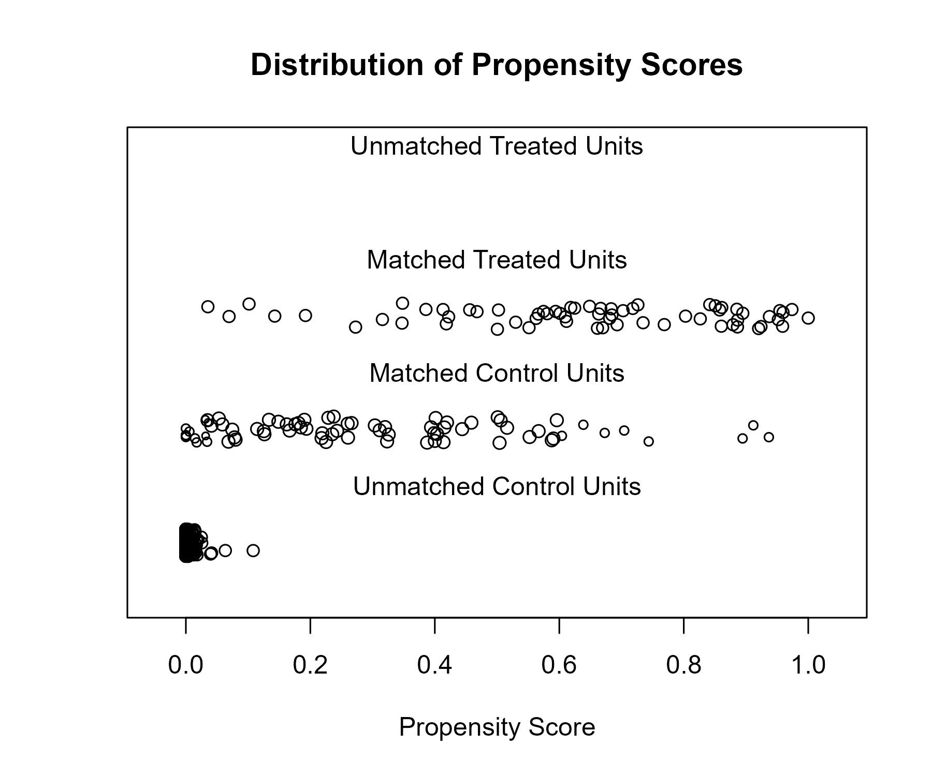

### Covariate balance

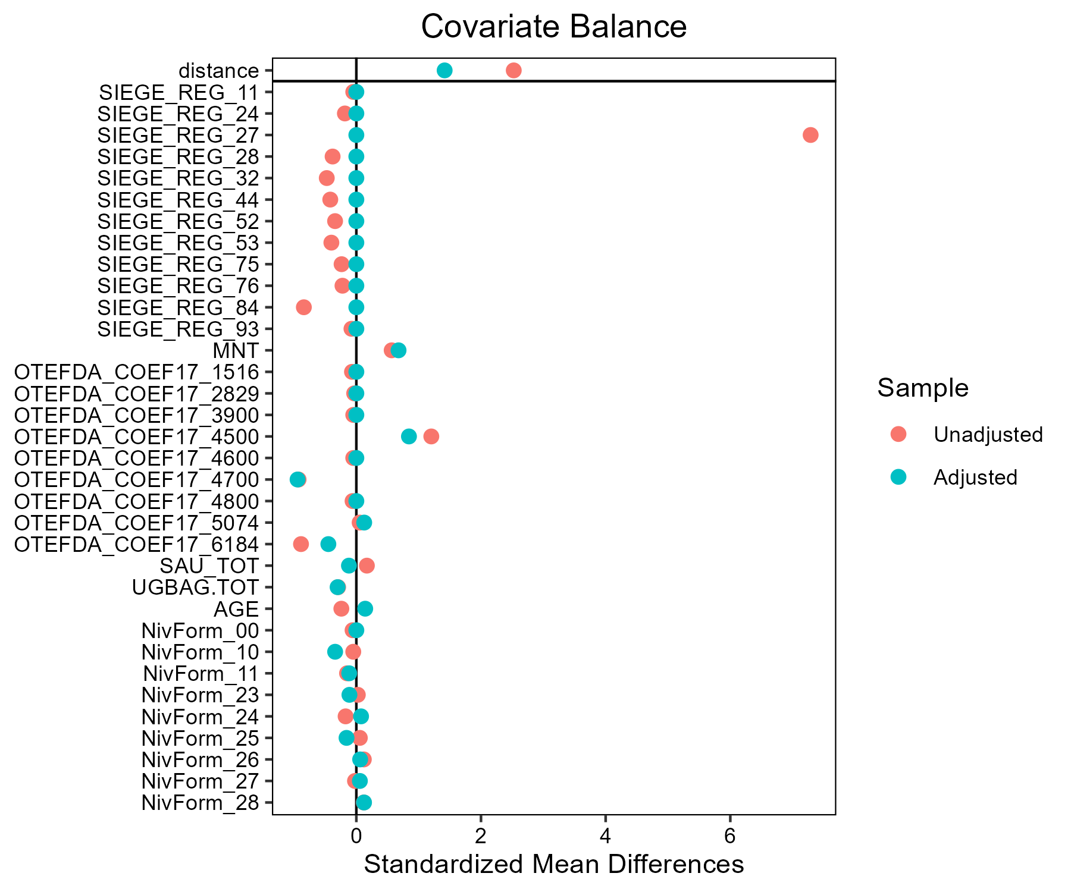

## Lait - Fromages de Savoie

### Covariate distribution before matching

|  |  | Lait - Conventionnel (N=883) / Mean | Lait - Conventionnel (N=883) / Std. Dev. | Lait - Fromages de Savoie (N=33) / Mean | Lait - Fromages de Savoie (N=33) / Std. Dev. | Diff. in Means | Std. Error |
| --- | --- | --- | --- | --- | --- | --- | --- |
| SAU_TOT |  | 133.2 | 80.5 | 115.0 | 72.3 | -18.3 | 12.9 |
| UGBAG.TOT |  | 131.8 | 77.5 | 99.6 | 59.6 | -32.2 | 10.7 |
| AGE |  | 48.4 | 9.4 | 46.3 | 9.2 | -2.0 | 1.6 |
|  |  | N | Pct. | N | Pct. |  |  |
| SIEGE_REG | 11 | 2 | 0.2 | 0 | 0.0 |  |  |
|  | 24 | 27 | 3.1 | 0 | 0.0 |  |  |
|  | 27 | 71 | 8.0 | 0 | 0.0 |  |  |
|  | 28 | 106 | 12.0 | 0 | 0.0 |  |  |
|  | 32 | 155 | 17.6 | 0 | 0.0 |  |  |
|  | 44 | 125 | 14.2 | 0 | 0.0 |  |  |
|  | 52 | 87 | 9.9 | 0 | 0.0 |  |  |
|  | 53 | 116 | 13.1 | 0 | 0.0 |  |  |
|  | 75 | 44 | 5.0 | 0 | 0.0 |  |  |
|  | 76 | 39 | 4.4 | 0 | 0.0 |  |  |
|  | 84 | 106 | 12.0 | 33 | 100.0 |  |  |
|  | 93 | 5 | 0.6 | 0 | 0.0 |  |  |
| MNT | FALSE | 745 | 84.4 | 5 | 15.2 |  |  |
|  | TRUE | 138 | 15.6 | 28 | 84.8 |  |  |
| OTEFDA_COEF17 | 1516 | 4 | 0.5 | 0 | 0.0 |  |  |
|  | 2829 | 1 | 0.1 | 0 | 0.0 |  |  |
|  | 3900 | 2 | 0.2 | 0 | 0.0 |  |  |
|  | 4500 | 529 | 59.9 | 32 | 97.0 |  |  |
|  | 4600 | 2 | 0.2 | 0 | 0.0 |  |  |
|  | 4700 | 170 | 19.3 | 0 | 0.0 |  |  |
|  | 4800 | 3 | 0.3 | 0 | 0.0 |  |  |
|  | 5074 | 8 | 0.9 | 0 | 0.0 |  |  |
|  | 6184 | 164 | 18.6 | 1 | 3.0 |  |  |
| NivForm | 00 | 3 | 0.3 | 0 | 0.0 |  |  |
|  | 10 | 2 | 0.2 | 0 | 0.0 |  |  |
|  | 11 | 18 | 2.0 | 1 | 3.0 |  |  |
|  | 23 | 37 | 4.2 | 3 | 9.1 |  |  |
|  | 24 | 256 | 29.0 | 9 | 27.3 |  |  |
|  | 25 | 107 | 12.1 | 6 | 18.2 |  |  |
|  | 26 | 240 | 27.2 | 8 | 24.2 |  |  |
|  | 27 | 201 | 22.8 | 6 | 18.2 |  |  |
|  | 28 | 19 | 2.2 | 0 | 0.0 |  |  |

### Covariate distribution after matching

|  |  | Lait - Conventionnel (N=99) / Mean | Lait - Conventionnel (N=99) / Std. Dev. | Lait - Fromages de Savoie (N=33) / Mean | Lait - Fromages de Savoie (N=33) / Std. Dev. | Diff. in Means | Std. Error |
| --- | --- | --- | --- | --- | --- | --- | --- |
| SAU_TOT |  | 114.9 | 64.0 | 115.0 | 72.3 | 0.0 | 14.1 |
| UGBAG.TOT |  | 99.7 | 61.0 | 99.6 | 59.6 | -0.1 | 12.0 |
| AGE |  | 47.3 | 10.1 | 46.3 | 9.2 | -0.9 | 1.9 |
|  |  | N | Pct. | N | Pct. |  |  |
|  | 84 | 99 | 100.0 | 33 | 100.0 |  |  |
| MNT | FALSE | 20 | 20.2 | 5 | 15.2 |  |  |
|  | TRUE | 79 | 79.8 | 28 | 84.8 |  |  |
| OTEFDA_COEF17 | 1516 | 1 | 1.0 | 0 | 0.0 |  |  |
|  | 4500 | 75 | 75.8 | 32 | 97.0 |  |  |
|  | 4700 | 19 | 19.2 | 0 | 0.0 |  |  |
|  | 6184 | 4 | 4.0 | 1 | 3.0 |  |  |
| NivForm | 11 | 2 | 2.0 | 1 | 3.0 |  |  |
|  | 23 | 5 | 5.1 | 3 | 9.1 |  |  |
|  | 24 | 32 | 32.3 | 9 | 27.3 |  |  |
|  | 25 | 9 | 9.1 | 6 | 18.2 |  |  |
|  | 26 | 26 | 26.3 | 8 | 24.2 |  |  |
|  | 27 | 22 | 22.2 | 6 | 18.2 |  |  |
|  | 28 | 3 | 3.0 | 0 | 0.0 |  |  |

### Matching model coefficients

| . | Estimate | Std. Error | t value | Pr(&gt;|t|) |
| --- | --- | --- | --- | --- |
| (Intercept) | -21.3034893174345 | 17080.0142714188 | -0.00124727584994371 | 0.999005099517581 |
| SIEGE_REG24 | -0.634070657078541 | 12412.2025448113 | -5.10844594091484e-05 | 0.999959252023934 |
| SIEGE_REG27 | -0.669028779873534 | 12157.4419173091 | -5.50303908029375e-05 | 0.99995610451646 |
| SIEGE_REG28 | -0.159764447787542 | 12106.1517262942 | -1.31969639402865e-05 | 0.999989473323645 |
| SIEGE_REG32 | 0.116654691720965 | 12076.9569046396 | 9.65927862805821e-06 | 0.999992295189984 |
| SIEGE_REG44 | -0.0475268818140997 | 12087.9520779902 | -3.93175630640005e-06 | 0.999996863799406 |
| SIEGE_REG52 | 0.0749196325987702 | 12127.6644964832 | 6.17758123342671e-06 | 0.99999507239706 |
| SIEGE_REG53 | -0.0749862748810304 | 12102.4387414508 | -6.19596401047689e-06 | 0.999995057733874 |
| SIEGE_REG75 | -0.274522553104668 | 12244.698206065 | -2.24197075734126e-05 | 0.999982116719674 |
| SIEGE_REG76 | -0.0118996381944953 | 12266.1306025198 | -9.70121595807138e-07 | 0.99999922617383 |
| SIEGE_REG84 | 20.8348057807441 | 12005.5214945534 | 0.00173543529868288 | 0.998615715203277 |
| SIEGE_REG93 | -0.482289998881537 | 14062.4642399378 | -3.42962649115095e-05 | 0.999972643277461 |
| MNTTRUE | 0.50503040768223 | 0.224970016865118 | 2.24487873859664 | 0.0250224721541447 |
| OTEFDA_COEF172829 | 19.5164560043338 | 18460.3824648726 | 0.00105720756552421 | 0.999156709084141 |
| OTEFDA_COEF173900 | -1.75545185587595 | 13820.3605741548 | -0.000127019251520745 | 0.999898681957898 |
| OTEFDA_COEF174500 | 20.1696628256892 | 7078.50158901848 | 0.00284942548532873 | 0.997727133347894 |
| OTEFDA_COEF174600 | -0.0411089465730676 | 12818.2172568536 | -3.20707207167108e-06 | 0.999997441850269 |
| OTEFDA_COEF174700 | 0.510455457713993 | 7154.92739398338 | 7.1343205822499e-05 | 0.99994309245364 |
| OTEFDA_COEF174800 | 0.199894358969818 | 10897.8517216353 | 1.83425471437615e-05 | 0.999985368903167 |
| OTEFDA_COEF175074 | 19.3505399660261 | 9211.88880588437 | 0.0021006050304977 | 0.99832443483765 |
| OTEFDA_COEF176184 | 19.54419636617 | 7078.50158949184 | 0.00276106406406459 | 0.997797615348443 |
| SAU_TOT | 0.00497697401480443 | 0.00248910446465421 | 1.99950387196619 | 0.0458595111994794 |
| UGBAG.TOT | -0.00235752145726804 | 0.00258705983319516 | -0.911274423195839 | 0.362399220935175 |
| AGE | -0.034326528991567 | 0.0101429021375068 | -3.38429066219945 | 0.000745020583218904 |
| NivForm10 | -19.0948808904676 | 15661.5370302324 | -0.00121922138635611 | 0.999027477394418 |
| NivForm11 | -18.7117387072969 | 9873.65970851822 | -0.00189511683202469 | 0.998488344009821 |
| NivForm23 | -18.5858906831554 | 9873.65970118365 | -0.00188237099977502 | 0.998498510818792 |
| NivForm24 | -19.6975438216161 | 9873.65969880291 | -0.00199495875111072 | 0.998408704360658 |
| NivForm25 | -19.2052149529257 | 9873.65970084573 | -0.00194509589501861 | 0.998448477836654 |
| NivForm26 | -19.5801973256282 | 9873.65969843567 | -0.00198307394863228 | 0.998418184360911 |
| NivForm27 | -20.2152112001652 | 9873.65970185475 | -0.00204738787952838 | 0.998366883882832 |
| NivForm28 | -39.3462448253211 | 10355.8862822546 | -0.00379940873749678 | 0.996969374928169 |

### Propensity score distribution

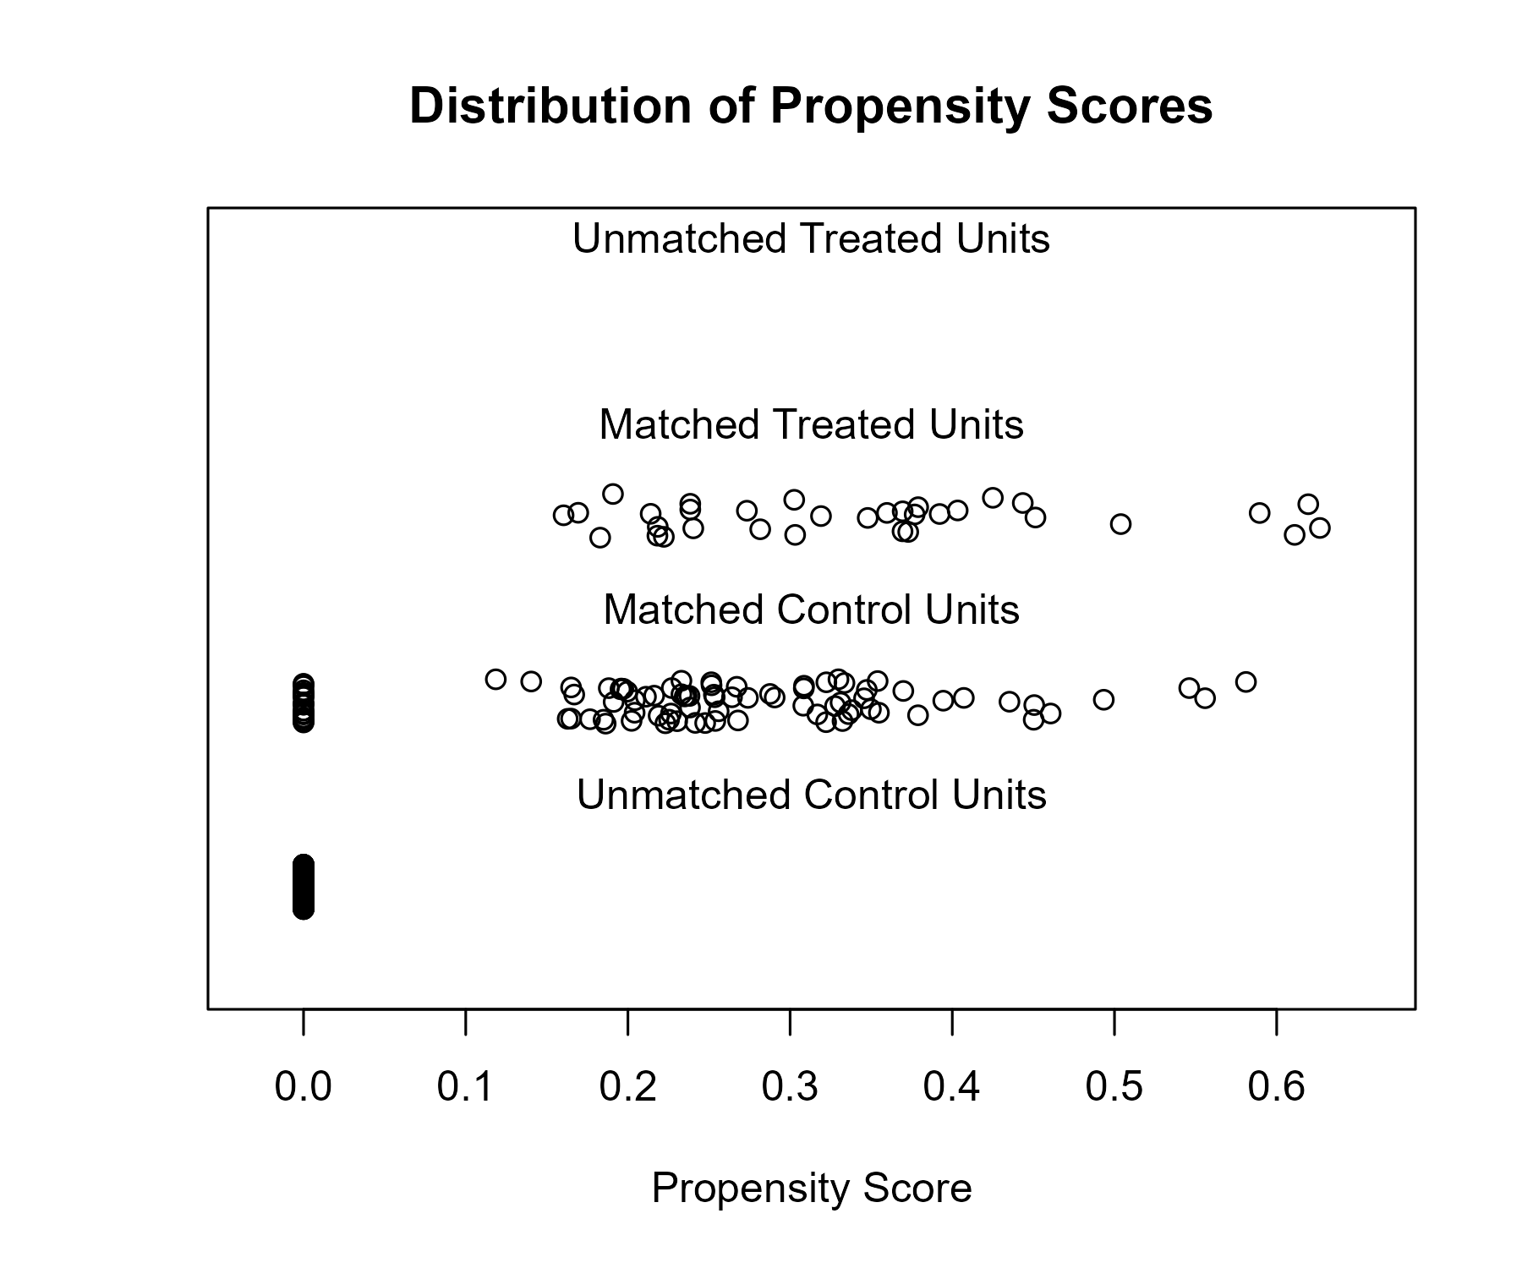

### Covariate balance

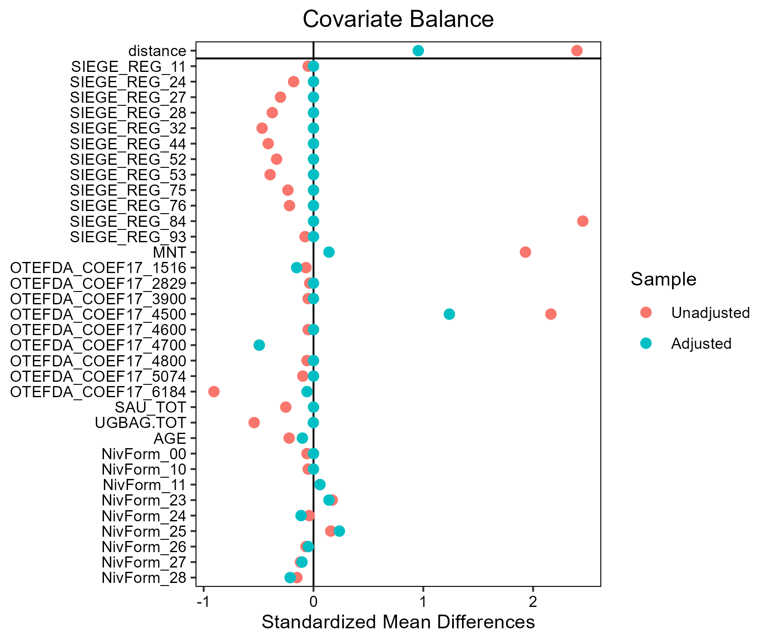

## Mais_fourrage - AB

### Covariate distribution before matching

|  |  | Mais_fourrage - AB (N=44) / Mean | Mais_fourrage - AB (N=44) / Std. Dev. | Mais_fourrage - Conventionnel (N=1806) / Mean | Mais_fourrage - Conventionnel (N=1806) / Std. Dev. | Diff. in Means | Std. Error |
| --- | --- | --- | --- | --- | --- | --- | --- |
| SAU_TOT |  | 128.1 | 79.0 | 137.6 | 84.6 | 9.5 | 12.1 |
| UGBAG.TOT |  | 114.8 | 66.5 | 124.0 | 81.3 | 9.2 | 10.2 |
| AGE |  | 48.0 | 9.1 | 48.4 | 9.7 | 0.4 | 1.4 |
|  |  | N | Pct. | N | Pct. |  |  |
| SIEGE_REG | 11 | 0 | 0.0 | 5 | 0.3 |  |  |
|  | 24 | 0 | 0.0 | 57 | 3.2 |  |  |
|  | 27 | 1 | 2.3 | 137 | 7.6 |  |  |
|  | 28 | 4 | 9.1 | 188 | 10.4 |  |  |
|  | 32 | 4 | 9.1 | 247 | 13.7 |  |  |
|  | 44 | 4 | 9.1 | 239 | 13.2 |  |  |
|  | 52 | 8 | 18.2 | 209 | 11.6 |  |  |
|  | 53 | 10 | 22.7 | 193 | 10.7 |  |  |
|  | 75 | 3 | 6.8 | 246 | 13.6 |  |  |
|  | 76 | 3 | 6.8 | 63 | 3.5 |  |  |
|  | 84 | 7 | 15.9 | 219 | 12.1 |  |  |
|  | 93 | 0 | 0.0 | 3 | 0.2 |  |  |
| MNT | FALSE | 36 | 81.8 | 1565 | 86.7 |  |  |
|  | TRUE | 8 | 18.2 | 241 | 13.3 |  |  |
| OTEFDA_COEF17 | 1516 | 1 | 2.3 | 122 | 6.8 |  |  |
|  | 2829 | 0 | 0.0 | 7 | 0.4 |  |  |
|  | 3500 | 0 | 0.0 | 4 | 0.2 |  |  |
|  | 3900 | 0 | 0.0 | 5 | 0.3 |  |  |
|  | 4500 | 29 | 65.9 | 625 | 34.6 |  |  |
|  | 4600 | 2 | 4.5 | 281 | 15.6 |  |  |
|  | 4700 | 1 | 2.3 | 184 | 10.2 |  |  |
|  | 4800 | 5 | 11.4 | 68 | 3.8 |  |  |
|  | 5074 | 3 | 6.8 | 146 | 8.1 |  |  |
|  | 6184 | 3 | 6.8 | 364 | 20.2 |  |  |
| NivForm | 00 | 0 | 0.0 | 8 | 0.4 |  |  |
|  | 10 | 0 | 0.0 | 8 | 0.4 |  |  |
|  | 11 | 0 | 0.0 | 38 | 2.1 |  |  |
|  | 23 | 0 | 0.0 | 68 | 3.8 |  |  |
|  | 24 | 10 | 22.7 | 546 | 30.2 |  |  |
|  | 25 | 4 | 9.1 | 225 | 12.5 |  |  |
|  | 26 | 15 | 34.1 | 470 | 26.0 |  |  |
|  | 27 | 12 | 27.3 | 397 | 22.0 |  |  |
|  | 28 | 3 | 6.8 | 46 | 2.5 |  |  |

### Covariate distribution after matching

|  |  | Mais_fourrage - AB (N=44) / Mean | Mais_fourrage - AB (N=44) / Std. Dev. | Mais_fourrage - Conventionnel (N=132) / Mean | Mais_fourrage - Conventionnel (N=132) / Std. Dev. | Diff. in Means | Std. Error |
| --- | --- | --- | --- | --- | --- | --- | --- |
| SAU_TOT |  | 128.1 | 79.0 | 131.5 | 94.7 | 3.4 | 14.5 |
| UGBAG.TOT |  | 114.8 | 66.5 | 115.9 | 69.5 | 1.1 | 11.7 |
| AGE |  | 48.0 | 9.1 | 47.2 | 8.6 | -0.8 | 1.6 |
|  |  | N | Pct. | N | Pct. |  |  |
| SIEGE_REG | 27 | 1 | 2.3 | 3 | 2.3 |  |  |
|  | 28 | 4 | 9.1 | 12 | 9.1 |  |  |
|  | 32 | 4 | 9.1 | 12 | 9.1 |  |  |
|  | 44 | 4 | 9.1 | 12 | 9.1 |  |  |
|  | 52 | 8 | 18.2 | 24 | 18.2 |  |  |
|  | 53 | 10 | 22.7 | 30 | 22.7 |  |  |
|  | 75 | 3 | 6.8 | 9 | 6.8 |  |  |
|  | 76 | 3 | 6.8 | 9 | 6.8 |  |  |
|  | 84 | 7 | 15.9 | 21 | 15.9 |  |  |
| MNT | FALSE | 36 | 81.8 | 110 | 83.3 |  |  |
|  | TRUE | 8 | 18.2 | 22 | 16.7 |  |  |
| OTEFDA_COEF17 | 1516 | 1 | 2.3 | 4 | 3.0 |  |  |
|  | 4500 | 29 | 65.9 | 86 | 65.2 |  |  |
|  | 4600 | 2 | 4.5 | 2 | 1.5 |  |  |
|  | 4700 | 1 | 2.3 | 4 | 3.0 |  |  |
|  | 4800 | 5 | 11.4 | 13 | 9.8 |  |  |
|  | 5074 | 3 | 6.8 | 9 | 6.8 |  |  |
|  | 6184 | 3 | 6.8 | 14 | 10.6 |  |  |
| NivForm | 24 | 10 | 22.7 | 30 | 22.7 |  |  |
|  | 25 | 4 | 9.1 | 15 | 11.4 |  |  |
|  | 26 | 15 | 34.1 | 40 | 30.3 |  |  |
|  | 27 | 12 | 27.3 | 35 | 26.5 |  |  |
|  | 28 | 3 | 6.8 | 12 | 9.1 |  |  |

### Matching model coefficients

| . | Estimate | Std. Error | t value | Pr(&gt;|t|) |
| --- | --- | --- | --- | --- |
| (Intercept) | -36.1998096557159 | 6780.72633146945 | -0.00533863304403129 | 0.995740993397887 |
| SIEGE_REG24 | -1.16971979147253 | 5493.09904491634 | -0.000212943510012816 | 0.999830119037755 |
| SIEGE_REG27 | 13.502856758394 | 5275.35517546897 | 0.00255961092841367 | 0.997958009165488 |
| SIEGE_REG28 | 15.0642916888741 | 5275.3550739372 | 0.00285559767593634 | 0.997721879267658 |
| SIEGE_REG32 | 14.8678379333506 | 5275.35506860628 | 0.00281835776739074 | 0.997751588208175 |
| SIEGE_REG44 | 14.5004091839418 | 5275.3550770319 | 0.00274870771203144 | 0.997807153050925 |
| SIEGE_REG52 | 15.5797709789874 | 5275.35506339008 | 0.00295331229685523 | 0.997643925335699 |
| SIEGE_REG53 | 15.7726692829305 | 5275.35505863613 | 0.00298987823712634 | 0.997614754079325 |
| SIEGE_REG75 | 14.080549931323 | 5275.35509507972 | 0.00266911888916365 | 0.997870646774095 |
| SIEGE_REG76 | 15.1958795038395 | 5275.3551134439 | 0.00288054153266645 | 0.997701979769537 |
| SIEGE_REG84 | 15.1685637768998 | 5275.35509403208 | 0.00287536355496897 | 0.997706110612479 |
| SIEGE_REG93 | -0.550342908300366 | 8626.04128478113 | -6.38001709163312e-05 | 0.999949101832215 |
| MNTTRUE | -0.152540678759758 | 0.758107702796372 | -0.201212411108729 | 0.840555008624222 |
| OTEFDA_COEF172829 | -13.8467888008257 | 4276.05609796172 | -0.00323821495406154 | 0.997416638269283 |
| OTEFDA_COEF173500 | -13.6158668127084 | 5806.16904956394 | -0.00234506895966644 | 0.998129164823821 |
| OTEFDA_COEF173900 | -13.9891176270225 | 5308.56317981733 | -0.00263519848086349 | 0.997897707525406 |
| OTEFDA_COEF174500 | 2.88645953342001 | 1.35605772537218 | 2.1285668592226 | 0.0334243112203193 |
| OTEFDA_COEF174600 | 1.25877238169068 | 1.59437388224263 | 0.789508907358736 | 0.429917636996127 |
| OTEFDA_COEF174700 | 1.10460529953959 | 1.82429532060338 | 0.605496975771582 | 0.544924453045501 |
| OTEFDA_COEF174800 | 3.88822010617202 | 1.53205113864906 | 2.53791796375714 | 0.0112343246445977 |
| OTEFDA_COEF175074 | 1.20073711996683 | 1.44190719883859 | 0.832742301955345 | 0.405099521446581 |
| OTEFDA_COEF176184 | 0.782331090379478 | 1.39330862825308 | 0.561491599575005 | 0.574531699727671 |
| SAU_TOT | 0.00680127822816943 | 0.00355389750373563 | 1.91375193601402 | 0.0558088245736325 |
| UGBAG.TOT | -0.00848755346806737 | 0.00436589032021331 | -1.94406016769855 | 0.0520423691558026 |
| AGE | 0.00522957995787726 | 0.0234104999937743 | 0.223386085699493 | 0.823260143671014 |
| NivForm10 | 0.189983946000235 | 6017.38039121346 | 3.15725338350968e-05 | 0.999974812228521 |
| NivForm11 | -0.758409276460745 | 4668.29097978876 | -0.000162459726641775 | 0.99987039372661 |
| NivForm23 | -0.506365344678356 | 4473.68732722891 | -0.00011318746877914 | 0.999909701891297 |
| NivForm24 | 15.0135460157971 | 4260.14975778117 | 0.00352418268591963 | 0.997188501728246 |
| NivForm25 | 14.9610301037756 | 4260.14979980457 | 0.00351185540575637 | 0.997198336060672 |
| NivForm26 | 15.4028220862045 | 4260.14976313543 | 0.00361555882835165 | 0.997115604610382 |
| NivForm27 | 15.4073192876196 | 4260.14977425459 | 0.00361661446288363 | 0.997114762457277 |
| NivForm28 | 16.4912813221942 | 4260.14981818983 | 0.00387105665903588 | 0.996911776312108 |

### Propensity score distribution

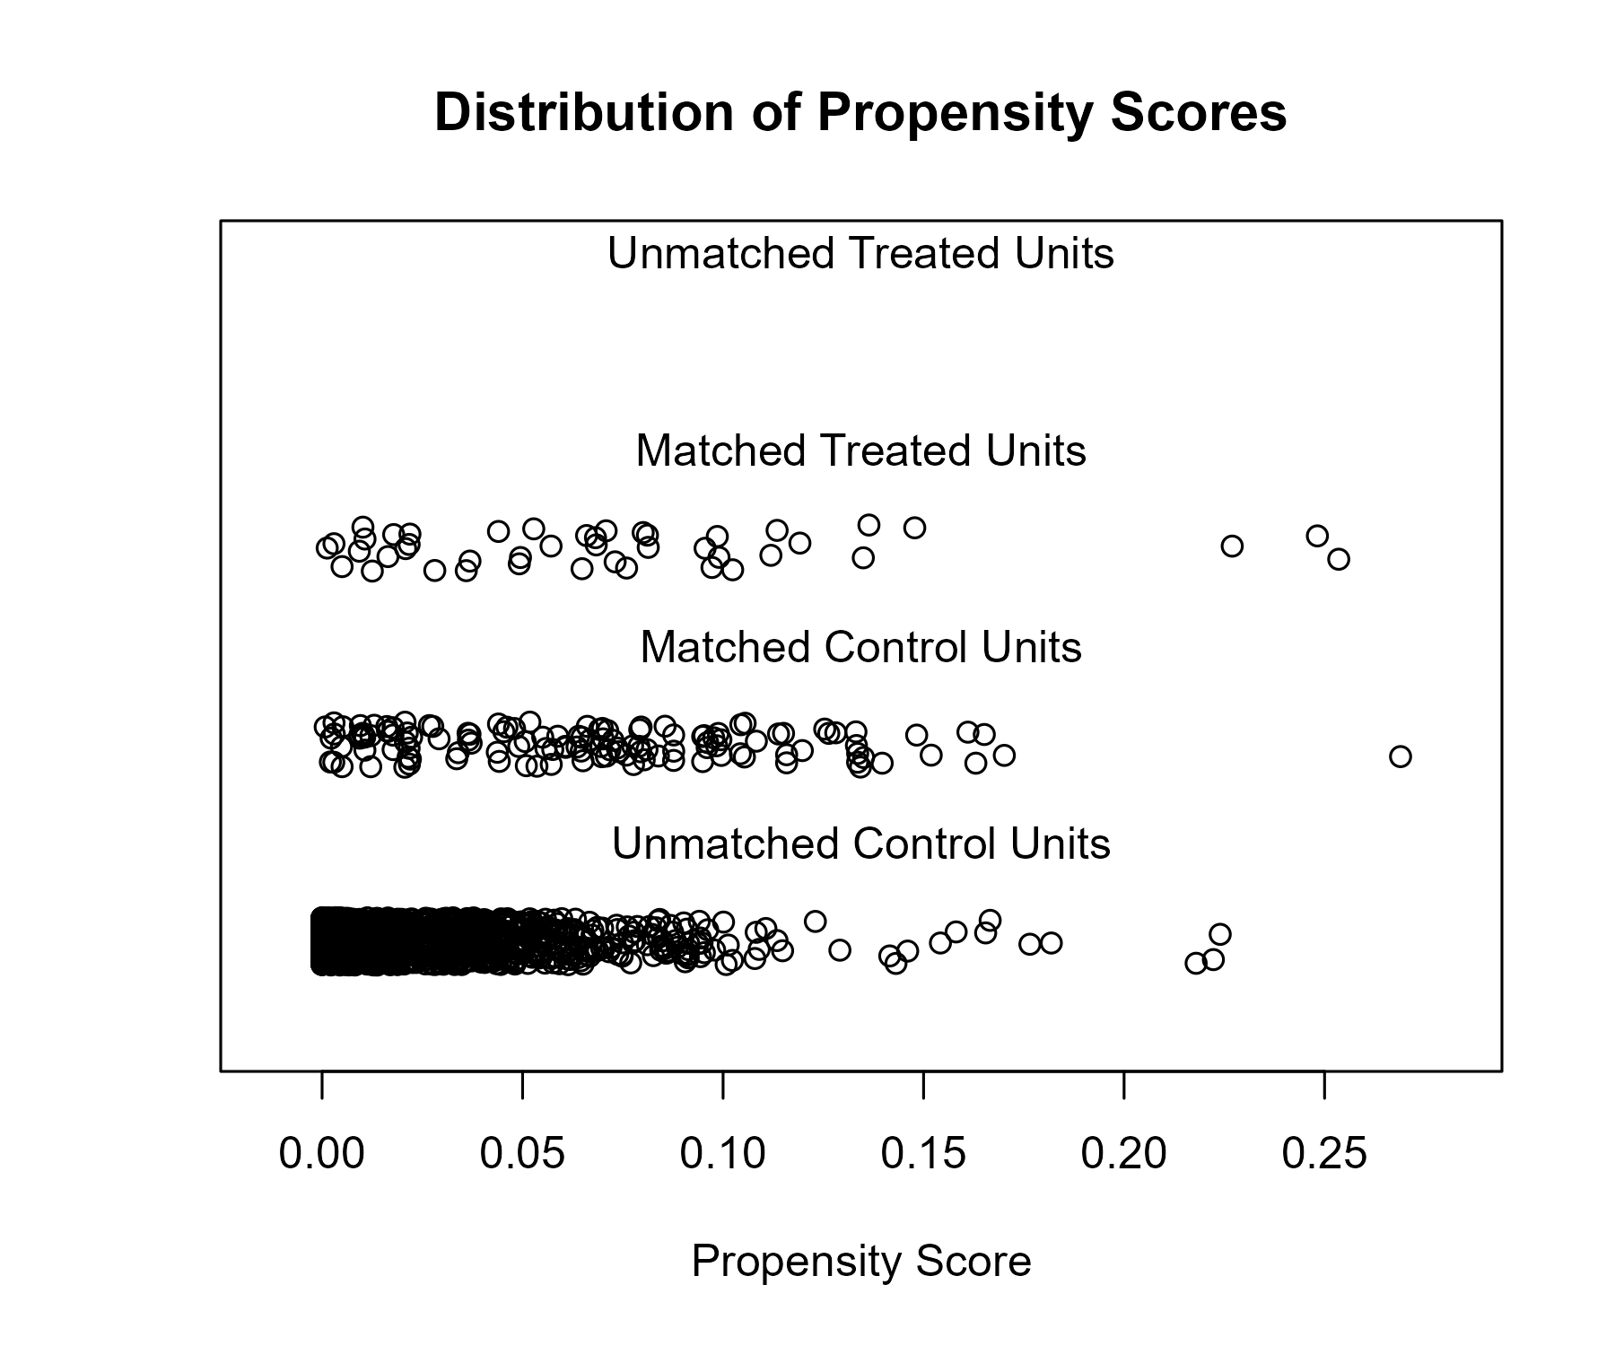

### Covariate balance

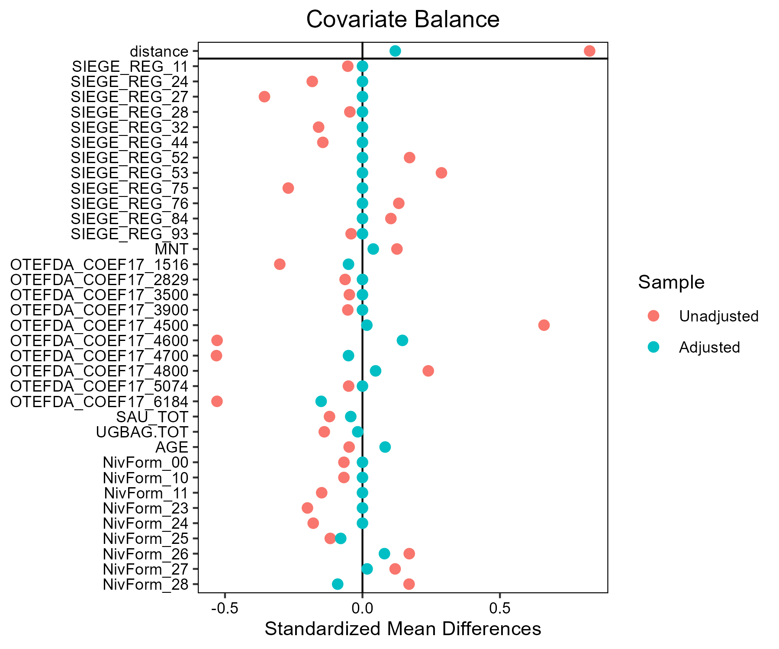

## Mais_grain - AB

### Covariate distribution before matching

|  |  | Mais_grain - AB (N=37) / Mean | Mais_grain - AB (N=37) / Std. Dev. | Mais_grain - Conventionnel (N=1656) / Mean | Mais_grain - Conventionnel (N=1656) / Std. Dev. | Diff. in Means | Std. Error |
| --- | --- | --- | --- | --- | --- | --- | --- |
| SAU_TOT |  | 113.5 | 66.7 | 124.4 | 84.5 | 11.0 | 11.2 |
| UGBAG.TOT |  | 41.4 | 54.8 | 44.2 | 69.7 | 2.8 | 9.2 |
| AGE |  | 48.8 | 9.6 | 49.7 | 10.4 | 0.9 | 1.6 |
|  |  | N | Pct. | N | Pct. |  |  |
| SIEGE_REG | 11 | 5 | 13.5 | 61 | 3.7 |  |  |
|  | 24 | 1 | 2.7 | 106 | 6.4 |  |  |
|  | 27 | 1 | 2.7 | 100 | 6.0 |  |  |
|  | 28 | 2 | 5.4 | 71 | 4.3 |  |  |
|  | 32 | 0 | 0.0 | 138 | 8.3 |  |  |
|  | 44 | 5 | 13.5 | 173 | 10.4 |  |  |
|  | 52 | 4 | 10.8 | 121 | 7.3 |  |  |
|  | 53 | 3 | 8.1 | 195 | 11.8 |  |  |
|  | 75 | 9 | 24.3 | 394 | 23.8 |  |  |
|  | 76 | 5 | 13.5 | 120 | 7.2 |  |  |
|  | 84 | 2 | 5.4 | 173 | 10.4 |  |  |
|  | 93 | 0 | 0.0 | 3 | 0.2 |  |  |
|  | 94 | 0 | 0.0 | 1 | 0.1 |  |  |
| MNT | FALSE | 35 | 94.6 | 1600 | 96.6 |  |  |
|  | TRUE | 2 | 5.4 | 56 | 3.4 |  |  |
| OTEFDA_COEF17 | 1516 | 11 | 29.7 | 561 | 33.9 |  |  |
|  | 2829 | 2 | 5.4 | 29 | 1.8 |  |  |
|  | 3500 | 0 | 0.0 | 97 | 5.9 |  |  |
|  | 3900 | 0 | 0.0 | 34 | 2.1 |  |  |
|  | 4500 | 7 | 18.9 | 161 | 9.7 |  |  |
|  | 4600 | 2 | 5.4 | 88 | 5.3 |  |  |
|  | 4700 | 1 | 2.7 | 19 | 1.1 |  |  |
|  | 4800 | 1 | 2.7 | 56 | 3.4 |  |  |
|  | 5074 | 7 | 18.9 | 304 | 18.4 |  |  |
|  | 6184 | 6 | 16.2 | 307 | 18.5 |  |  |
| NivForm | 00 | 0 | 0.0 | 8 | 0.5 |  |  |
|  | 10 | 0 | 0.0 | 10 | 0.6 |  |  |
|  | 11 | 0 | 0.0 | 45 | 2.7 |  |  |
|  | 23 | 1 | 2.7 | 65 | 3.9 |  |  |
|  | 24 | 5 | 13.5 | 468 | 28.3 |  |  |
|  | 25 | 2 | 5.4 | 187 | 11.3 |  |  |
|  | 26 | 14 | 37.8 | 391 | 23.6 |  |  |
|  | 27 | 12 | 32.4 | 399 | 24.1 |  |  |
|  | 28 | 3 | 8.1 | 83 | 5.0 |  |  |

### Covariate distribution after matching

|  |  | Mais_grain - AB (N=37) / Mean | Mais_grain - AB (N=37) / Std. Dev. | Mais_grain - Conventionnel (N=111) / Mean | Mais_grain - Conventionnel (N=111) / Std. Dev. | Diff. in Means | Std. Error |
| --- | --- | --- | --- | --- | --- | --- | --- |
| SAU_TOT |  | 113.5 | 66.7 | 111.9 | 65.6 | -1.6 | 12.6 |
| UGBAG.TOT |  | 41.4 | 54.8 | 51.7 | 65.8 | 10.3 | 11.0 |
| AGE |  | 48.8 | 9.6 | 47.1 | 10.3 | -1.6 | 1.9 |
|  |  | N | Pct. | N | Pct. |  |  |
| SIEGE_REG | 11 | 5 | 13.5 | 15 | 13.5 |  |  |
|  | 24 | 1 | 2.7 | 3 | 2.7 |  |  |
|  | 27 | 1 | 2.7 | 3 | 2.7 |  |  |
|  | 28 | 2 | 5.4 | 6 | 5.4 |  |  |
|  | 44 | 5 | 13.5 | 15 | 13.5 |  |  |
|  | 52 | 4 | 10.8 | 12 | 10.8 |  |  |
|  | 53 | 3 | 8.1 | 9 | 8.1 |  |  |
|  | 75 | 9 | 24.3 | 27 | 24.3 |  |  |
|  | 76 | 5 | 13.5 | 15 | 13.5 |  |  |
|  | 84 | 2 | 5.4 | 6 | 5.4 |  |  |
| MNT | FALSE | 35 | 94.6 | 106 | 95.5 |  |  |
|  | TRUE | 2 | 5.4 | 5 | 4.5 |  |  |
| OTEFDA_COEF17 | 1516 | 11 | 29.7 | 27 | 24.3 |  |  |
|  | 2829 | 2 | 5.4 | 5 | 4.5 |  |  |
|  | 4500 | 7 | 18.9 | 26 | 23.4 |  |  |
|  | 4600 | 2 | 5.4 | 9 | 8.1 |  |  |
|  | 4700 | 1 | 2.7 | 4 | 3.6 |  |  |
|  | 4800 | 1 | 2.7 | 4 | 3.6 |  |  |
|  | 5074 | 7 | 18.9 | 18 | 16.2 |  |  |
|  | 6184 | 6 | 16.2 | 18 | 16.2 |  |  |
| NivForm | 23 | 1 | 2.7 | 4 | 3.6 |  |  |
|  | 24 | 5 | 13.5 | 19 | 17.1 |  |  |
|  | 25 | 2 | 5.4 | 9 | 8.1 |  |  |
|  | 26 | 14 | 37.8 | 36 | 32.4 |  |  |
|  | 27 | 12 | 32.4 | 36 | 32.4 |  |  |
|  | 28 | 3 | 8.1 | 7 | 6.3 |  |  |

### Matching model coefficients

| . | Estimate | Std. Error | t value | Pr(&gt;|t|) |
| --- | --- | --- | --- | --- |
| (Intercept) | -18.9941983689478 | 4930.28447268132 | -0.0038525562721978 | 0.996926575618235 |
| SIEGE_REG24 | -2.27917918240257 | 0.972080948393431 | -2.34463928767393 | 0.0191628615870815 |
| SIEGE_REG27 | -2.2953033981955 | 1.01517660007454 | -2.26098926829773 | 0.0238889797515227 |
| SIEGE_REG28 | -1.5626122667267 | 0.810164326345699 | -1.92875965518621 | 0.0539311321090538 |
| SIEGE_REG32 | -18.2188727867749 | 1237.62337892913 | -0.0147208537726065 | 0.988256652287378 |
| SIEGE_REG44 | -1.05195421029471 | 0.618553314368419 | -1.70066861798133 | 0.0891926433348813 |
| SIEGE_REG52 | -1.36750206571388 | 0.696433718258792 | -1.96357819827115 | 0.0497458250792257 |
| SIEGE_REG53 | -2.40007256260317 | 0.763389387740895 | -3.14396899032842 | 0.00169624866328514 |
| SIEGE_REG75 | -1.36944037798974 | 0.608396913983175 | -2.25089961259668 | 0.0245223544459166 |
| SIEGE_REG76 | -0.850098874876014 | 0.639649036344816 | -1.32900829450754 | 0.184027979484459 |
| SIEGE_REG84 | -2.42830706968309 | 0.839192545873447 | -2.89362325919573 | 0.0038579750631996 |
| SIEGE_REG93 | -17.9187939861563 | 8131.81540764722 | -0.00220354165556997 | 0.998242094481953 |
| SIEGE_REG94 | -19.9859844748868 | 15037.5528844758 | -0.00132907160017503 | 0.998939714392256 |
| MNTTRUE | 0.640661904078842 | 0.74231236371695 | 0.863062418724757 | 0.388227897361371 |
| OTEFDA_COEF172829 | 1.61207884933548 | 0.755876665328859 | 2.1327273658251 | 0.0330935397730841 |
| OTEFDA_COEF173500 | -16.8194580628992 | 1462.32386552965 | -0.0115018693597039 | 0.990824421282539 |
| OTEFDA_COEF173900 | -16.4702569230024 | 2474.87710540507 | -0.00665497971072251 | 0.99469093375493 |
| OTEFDA_COEF174500 | 2.09392512207593 | 0.704472172011682 | 2.97233191780527 | 0.00299803792323086 |
| OTEFDA_COEF174600 | 1.04210877816117 | 0.834829954677917 | 1.24828867522276 | 0.212101497979118 |
| OTEFDA_COEF174700 | 2.62857067567795 | 1.19261046197031 | 2.2040479766841 | 0.0276578719200682 |
| OTEFDA_COEF174800 | 0.405852766859415 | 1.05150777164546 | 0.385972198973207 | 0.699566748041957 |
| OTEFDA_COEF175074 | 0.509620529100167 | 0.51242599463898 | 0.994525130324839 | 0.320112307950748 |
| OTEFDA_COEF176184 | 0.533790926637314 | 0.520366876739233 | 1.02579727976193 | 0.305136691448267 |
| SAU_TOT | -0.00227328626153521 | 0.00242825857318359 | -0.936179650157603 | 0.34931695263271 |
| UGBAG.TOT | -0.00748255069895691 | 0.00458260797326973 | -1.63281492604266 | 0.102697690385127 |
| AGE | 0.0111727901009335 | 0.0160937025684015 | 0.694233663971783 | 0.487632885169353 |
| NivForm10 | -1.10193031025327 | 6573.56525808122 | -0.000167630542482044 | 0.999866270332529 |
| NivForm11 | -0.785484822098462 | 5361.42220568798 | -0.000146506802106563 | 0.999883122098995 |
| NivForm23 | 15.6244880851895 | 4930.28439908445 | 0.00316908454370116 | 0.997471821613628 |
| NivForm24 | 15.2792937378448 | 4930.28433574238 | 0.00309906948511603 | 0.997527676855722 |
| NivForm25 | 15.42104845615 | 4930.28436301899 | 0.00312782130211799 | 0.997504739792816 |
| NivForm26 | 16.6066271466835 | 4930.28432792228 | 0.00336828994884395 | 0.997312903495988 |
| NivForm27 | 16.6662383428369 | 4930.2843330965 | 0.00338038076850013 | 0.997303257926242 |
| NivForm28 | 16.4617473856686 | 4930.28435774837 | 0.00333890424794616 | 0.99733634622819 |

### Propensity score distribution

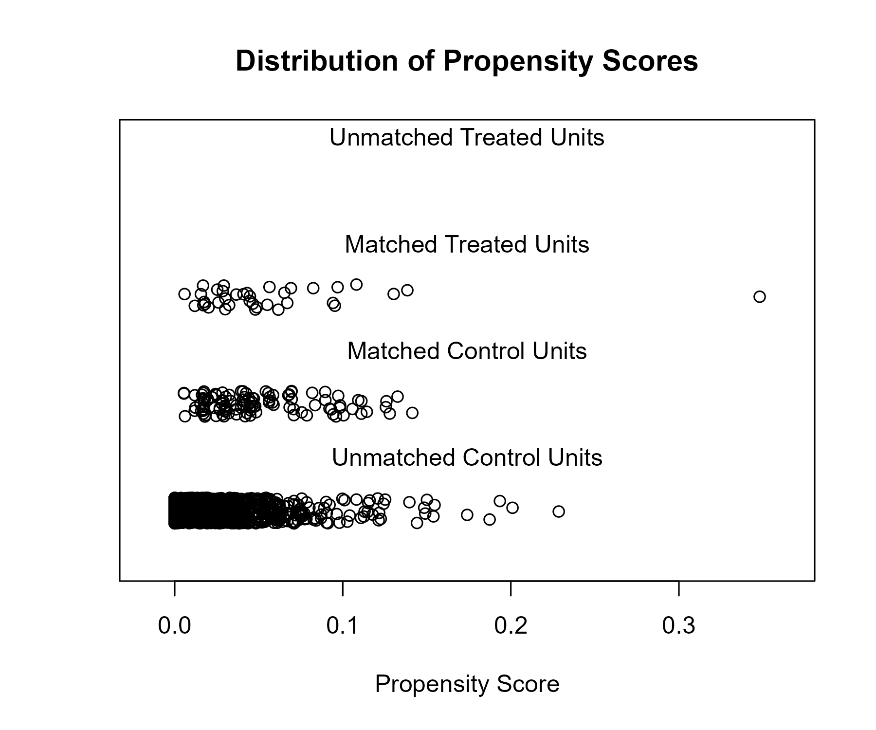

### Covariate balance

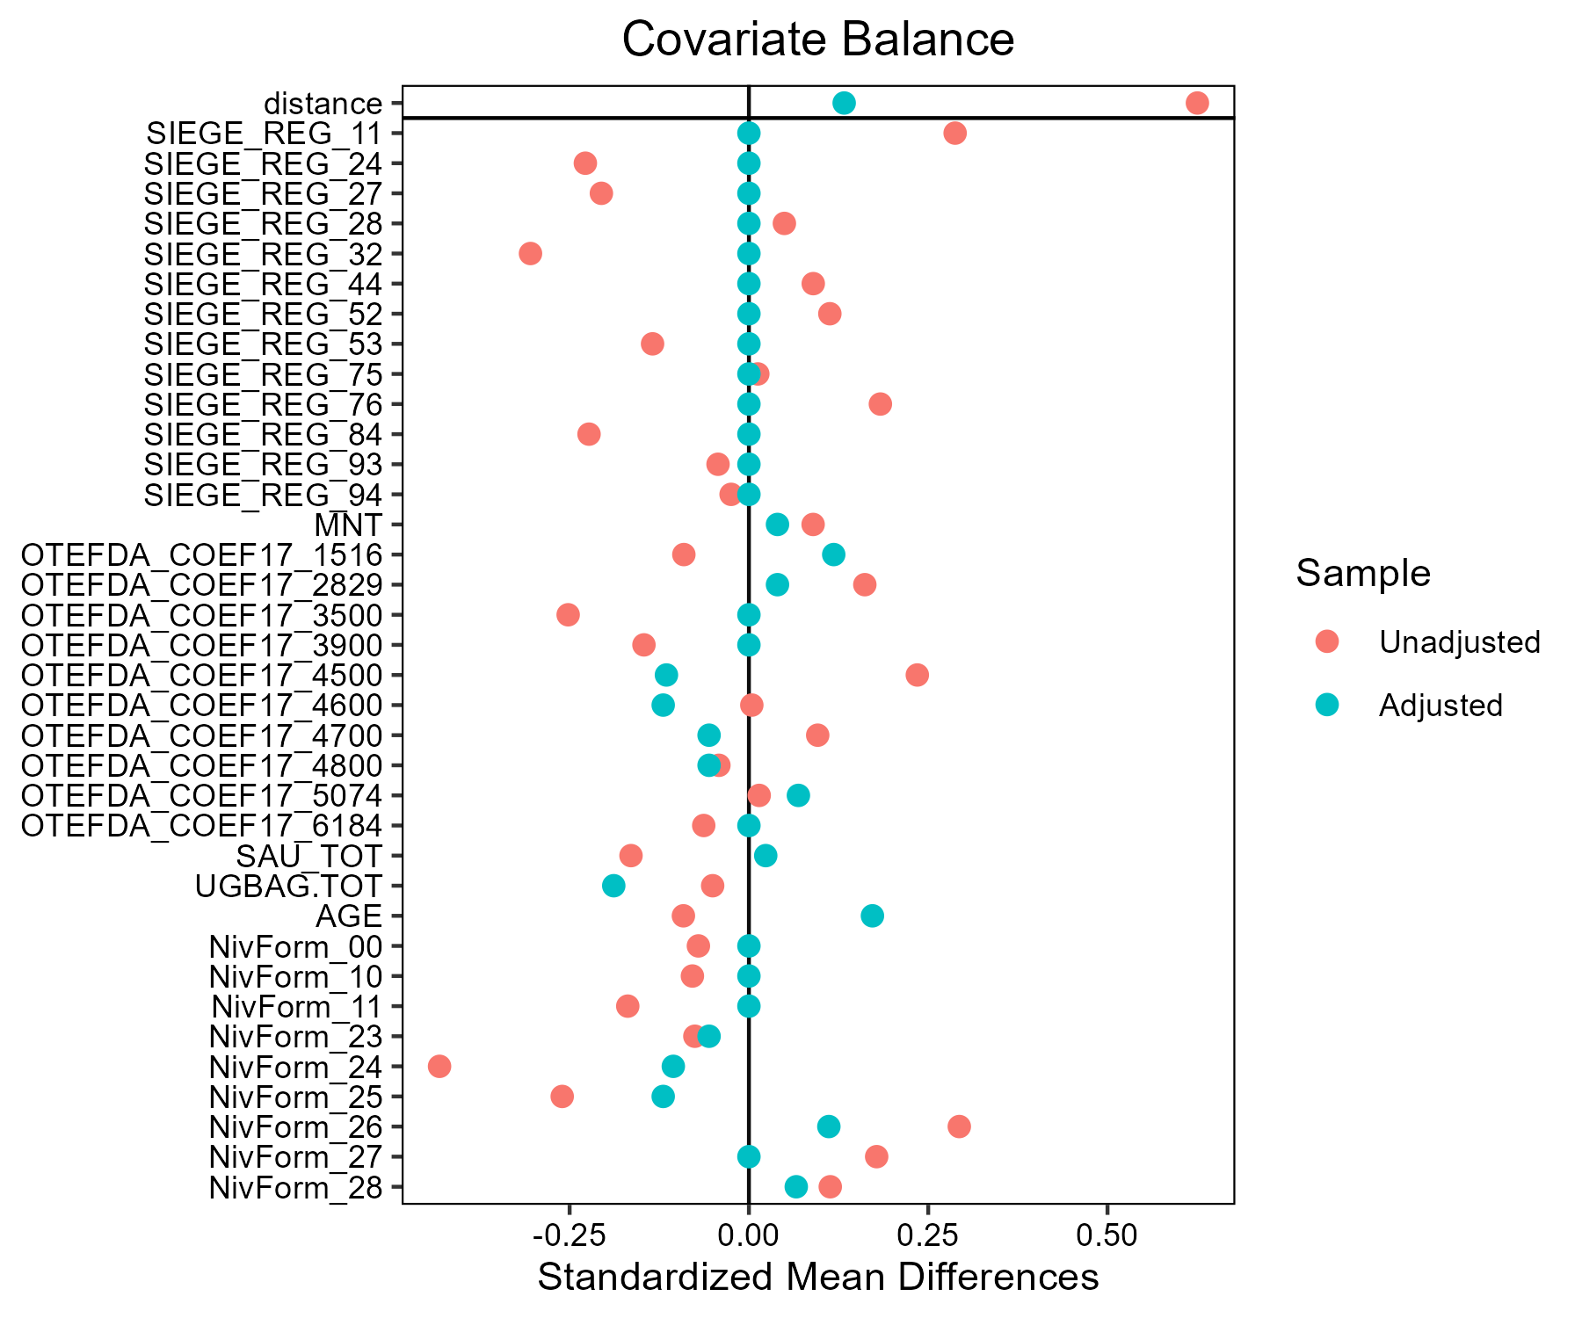

## Melange_cereales_d_ete - AB

### Covariate distribution before matching

|  |  | Melange_cereales_d_ete - AB (N=53) / Mean | Melange_cereales_d_ete - AB (N=53) / Std. Dev. | Melange_cereales_d_ete - Conventionnel (N=128) / Mean | Melange_cereales_d_ete - Conventionnel (N=128) / Std. Dev. | Diff. in Means | Std. Error |
| --- | --- | --- | --- | --- | --- | --- | --- |
| SAU_TOT |  | 121.2 | 86.0 | 137.9 | 69.9 | 16.7 | 13.3 |
| UGBAG.TOT |  | 80.6 | 61.1 | 111.6 | 68.9 | 30.9 | 10.4 |
| AGE |  | 45.6 | 9.8 | 47.6 | 10.1 | 2.0 | 1.6 |
|  |  | N | Pct. | N | Pct. |  |  |
| SIEGE_REG | 11 | 1 | 1.9 | 1 | 0.8 |  |  |
|  | 24 | 0 | 0.0 | 3 | 2.3 |  |  |
|  | 27 | 2 | 3.8 | 5 | 3.9 |  |  |
|  | 28 | 7 | 13.2 | 6 | 4.7 |  |  |
|  | 32 | 2 | 3.8 | 1 | 0.8 |  |  |
|  | 44 | 6 | 11.3 | 4 | 3.1 |  |  |
|  | 52 | 7 | 13.2 | 7 | 5.5 |  |  |
|  | 53 | 5 | 9.4 | 4 | 3.1 |  |  |
|  | 75 | 6 | 11.3 | 40 | 31.2 |  |  |
|  | 76 | 12 | 22.6 | 29 | 22.7 |  |  |
|  | 84 | 5 | 9.4 | 26 | 20.3 |  |  |
|  | 93 | 0 | 0.0 | 2 | 1.6 |  |  |
| MNT | FALSE | 44 | 83.0 | 90 | 70.3 |  |  |
|  | TRUE | 9 | 17.0 | 38 | 29.7 |  |  |
| OTEFDA_COEF17 | 1516 | 5 | 9.4 | 5 | 3.9 |  |  |
|  | 3500 | 0 | 0.0 | 1 | 0.8 |  |  |
|  | 4500 | 13 | 24.5 | 18 | 14.1 |  |  |
|  | 4600 | 9 | 17.0 | 42 | 32.8 |  |  |
|  | 4700 | 0 | 0.0 | 10 | 7.8 |  |  |
|  | 4800 | 10 | 18.9 | 32 | 25.0 |  |  |
|  | 5074 | 3 | 5.7 | 7 | 5.5 |  |  |
|  | 6184 | 13 | 24.5 | 13 | 10.2 |  |  |
| NivForm | 10 | 0 | 0.0 | 1 | 0.8 |  |  |
|  | 11 | 2 | 3.8 | 3 | 2.3 |  |  |
|  | 23 | 0 | 0.0 | 4 | 3.1 |  |  |
|  | 24 | 9 | 17.0 | 39 | 30.5 |  |  |
|  | 25 | 1 | 1.9 | 20 | 15.6 |  |  |
|  | 26 | 17 | 32.1 | 34 | 26.6 |  |  |
|  | 27 | 15 | 28.3 | 25 | 19.5 |  |  |
|  | 28 | 9 | 17.0 | 2 | 1.6 |  |  |

### Covariate distribution after matching

|  |  | Melange_cereales_d_ete - AB (N=48) / Mean | Melange_cereales_d_ete - AB (N=48) / Std. Dev. | Melange_cereales_d_ete - Conventionnel (N=90) / Mean | Melange_cereales_d_ete - Conventionnel (N=90) / Std. Dev. | Diff. in Means | Std. Error |
| --- | --- | --- | --- | --- | --- | --- | --- |
| SAU_TOT |  | 111.1 | 55.9 | 129.8 | 71.2 | 18.7 | 11.0 |
| UGBAG.TOT |  | 75.6 | 54.4 | 102.9 | 68.9 | 27.2 | 10.7 |
| AGE |  | 45.1 | 10.1 | 46.5 | 10.0 | 1.4 | 1.8 |
|  |  | N | Pct. | N | Pct. |  |  |
| SIEGE_REG | 11 | 1 | 2.1 | 1 | 1.1 |  |  |
|  | 27 | 2 | 4.2 | 5 | 5.6 |  |  |
|  | 28 | 6 | 12.5 | 6 | 6.7 |  |  |
|  | 32 | 1 | 2.1 | 1 | 1.1 |  |  |
|  | 44 | 4 | 8.3 | 4 | 4.4 |  |  |
|  | 52 | 7 | 14.6 | 7 | 7.8 |  |  |
|  | 53 | 4 | 8.3 | 4 | 4.4 |  |  |
|  | 75 | 6 | 12.5 | 18 | 20.0 |  |  |
|  | 76 | 12 | 25.0 | 29 | 32.2 |  |  |
|  | 84 | 5 | 10.4 | 15 | 16.7 |  |  |
| MNT | FALSE | 39 | 81.2 | 62 | 68.9 |  |  |
|  | TRUE | 9 | 18.8 | 28 | 31.1 |  |  |
| OTEFDA_COEF17 | 1516 | 5 | 10.4 | 4 | 4.4 |  |  |
|  | 3500 | 0 | 0.0 | 1 | 1.1 |  |  |
|  | 4500 | 12 | 25.0 | 16 | 17.8 |  |  |
|  | 4600 | 8 | 16.7 | 23 | 25.6 |  |  |
|  | 4700 | 0 | 0.0 | 5 | 5.6 |  |  |
|  | 4800 | 10 | 20.8 | 24 | 26.7 |  |  |
|  | 5074 | 2 | 4.2 | 5 | 5.6 |  |  |
|  | 6184 | 11 | 22.9 | 12 | 13.3 |  |  |
| NivForm | 11 | 2 | 4.2 | 2 | 2.2 |  |  |
|  | 24 | 7 | 14.6 | 24 | 26.7 |  |  |
|  | 25 | 1 | 2.1 | 14 | 15.6 |  |  |
|  | 26 | 16 | 33.3 | 29 | 32.2 |  |  |
|  | 27 | 13 | 27.1 | 19 | 21.1 |  |  |
|  | 28 | 9 | 18.8 | 2 | 2.2 |  |  |

### Matching model coefficients

| . | Estimate | Std. Error | t value | Pr(&gt;|t|) |
| --- | --- | --- | --- | --- |
| (Intercept) | -17.0320533919025 | 6963.90914769582 | -0.0024457604243068 | 0.998051795628307 |
| SIEGE_REG24 | -16.730407344893 | 3101.2503121327 | -0.00539472975768528 | 0.995702769893376 |
| SIEGE_REG27 | 3.53523547991005 | 2.51626812554608 | 1.40495181893338 | 0.162089483240329 |
| SIEGE_REG28 | 4.22255700888495 | 2.33792357806313 | 1.80611421541125 | 0.0728920741202814 |
| SIEGE_REG32 | 3.18095368626556 | 2.50465161012378 | 1.27001842228603 | 0.20603164300743 |
| SIEGE_REG44 | 3.72839698473704 | 2.40968944629925 | 1.54725207037074 | 0.123895767030106 |
| SIEGE_REG52 | 5.28879250783562 | 2.39402229035163 | 2.20916594183374 | 0.0286691976451291 |
| SIEGE_REG53 | 5.26549520997257 | 2.47630738255086 | 2.12634959903425 | 0.0351000332249657 |
| SIEGE_REG75 | 1.51183540860272 | 2.2061781547738 | 0.685273492229701 | 0.494221998142167 |
| SIEGE_REG76 | 1.91707447070807 | 2.10149335258154 | 0.912243889971422 | 0.363094472852547 |
| SIEGE_REG84 | 2.06296080198379 | 2.10649994246926 | 0.979331050712288 | 0.328982870258003 |
| SIEGE_REG93 | -14.7921576210494 | 4484.73608203733 | -0.00329833402689989 | 0.997372668464543 |
| MNTTRUE | 0.440334393135357 | 0.762737222827955 | 0.577308121272429 | 0.564591093966552 |
| OTEFDA_COEF173500 | -16.9760970770193 | 6963.90894986356 | -0.0024377253061805 | 0.998058196100259 |
| OTEFDA_COEF174500 | -0.38888909986545 | 1.39552397422967 | -0.278668877817106 | 0.780880211682961 |
| OTEFDA_COEF174600 | -0.945504463604005 | 1.44789148947592 | -0.653021632129518 | 0.514735363741261 |
| OTEFDA_COEF174700 | -17.486584693519 | 1878.95765501799 | -0.0093065347411204 | 0.992586851014906 |
| OTEFDA_COEF174800 | -0.257366868884265 | 1.38652924465319 | -0.185619502709183 | 0.85299226483848 |
| OTEFDA_COEF175074 | -3.16017871533251 | 1.65522788493701 | -1.90921065557857 | 0.0581316595915722 |
| OTEFDA_COEF176184 | 0.0531407376271373 | 1.24717502525056 | 0.0426088853218185 | 0.966069602785379 |
| SAU_TOT | 0.007546312071358 | 0.00595251379939593 | 1.26775213391758 | 0.206837878164907 |
| UGBAG.TOT | -0.0214159401154118 | 0.00903361985240938 | -2.37069308486563 | 0.0190171953215162 |
| AGE | -0.0232115901684303 | 0.0301276966637443 | -0.770440250627028 | 0.442242524365812 |
| NivForm11 | 16.9436083244439 | 6963.90871420019 | 0.0024330600844744 | 0.998061912239919 |
| NivForm23 | -0.733475606046176 | 7549.24189749157 | -9.71588427031186e-05 | 0.99992260669938 |
| NivForm24 | 15.6124748613255 | 6963.9086642242 | 0.0022419126404589 | 0.998214173120187 |
| NivForm25 | 13.3108796555475 | 6963.9088311639 | 0.00191140923556904 | 0.998477439880705 |
| NivForm26 | 16.3313793295279 | 6963.90868029695 | 0.00234514553238391 | 0.998131941664226 |
| NivForm27 | 16.1777224452154 | 6963.90869796326 | 0.00232308077932539 | 0.998149517618603 |
| NivForm28 | 18.6735017059293 | 6963.90872121911 | 0.00268146847603428 | 0.997864039545147 |

### Propensity score distribution

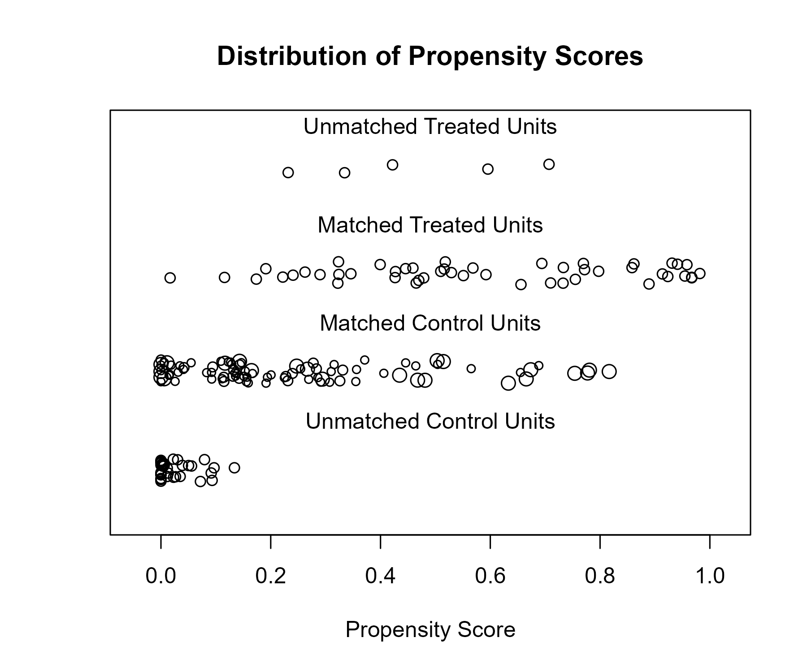

### Covariate balance

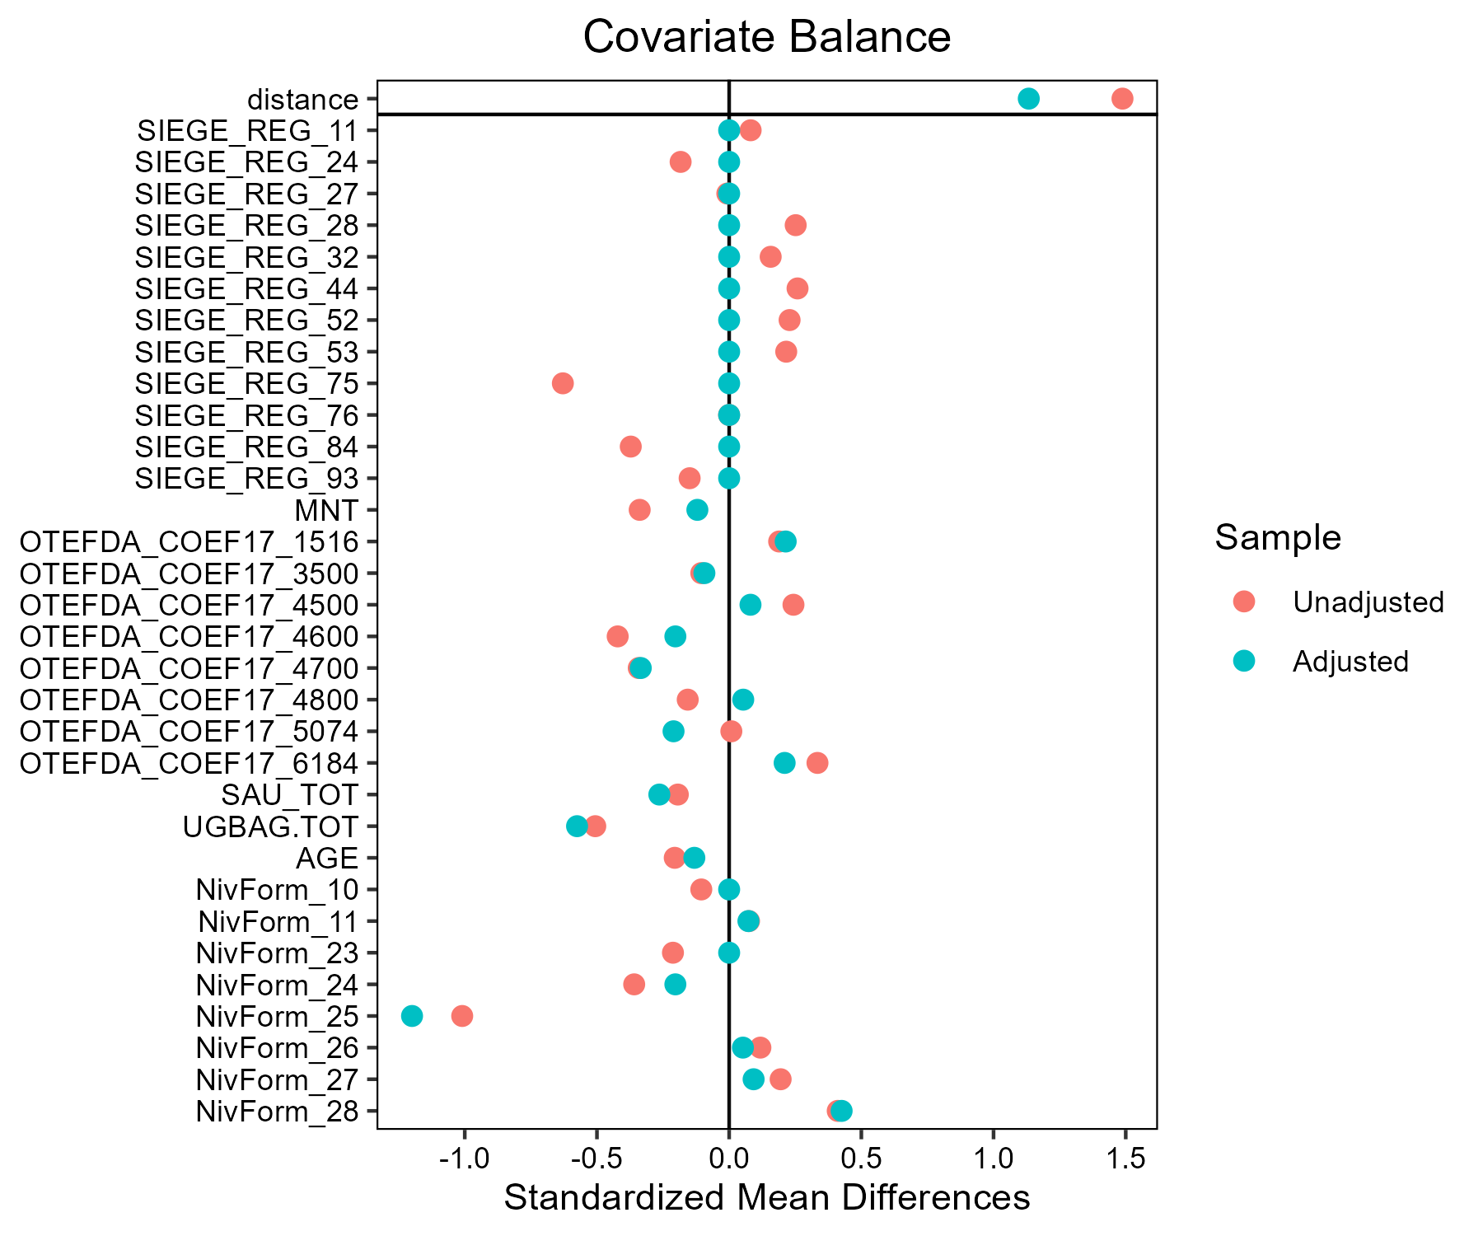

## Orge_d_hiver_et_escourgeon - AB

### Covariate distribution before matching

|  |  | Orge_d_hiver_et_escourgeon - AB (N=37) / Mean | Orge_d_hiver_et_escourgeon - AB (N=37) / Std. Dev. | Orge_d_hiver_et_escourgeon - Conventionnel (N=2088) / Mean | Orge_d_hiver_et_escourgeon - Conventionnel (N=2088) / Std. Dev. | Diff. in Means | Std. Error |
| --- | --- | --- | --- | --- | --- | --- | --- |
| SAU_TOT |  | 135.2 | 122.0 | 146.2 | 90.1 | 11.0 | 20.2 |
| UGBAG.TOT |  | 63.7 | 65.3 | 72.7 | 83.3 | 9.0 | 10.9 |
| AGE |  | 47.4 | 10.7 | 49.0 | 10.3 | 1.6 | 1.8 |
|  |  | N | Pct. | N | Pct. |  |  |
| SIEGE_REG | 11 | 0 | 0.0 | 81 | 3.9 |  |  |
|  | 24 | 1 | 2.7 | 158 | 7.6 |  |  |
|  | 27 | 0 | 0.0 | 223 | 10.7 |  |  |
|  | 28 | 4 | 10.8 | 134 | 6.4 |  |  |
|  | 32 | 2 | 5.4 | 276 | 13.2 |  |  |
|  | 44 | 6 | 16.2 | 339 | 16.2 |  |  |
|  | 52 | 2 | 5.4 | 109 | 5.2 |  |  |
|  | 53 | 3 | 8.1 | 141 | 6.8 |  |  |
|  | 75 | 2 | 5.4 | 158 | 7.6 |  |  |
|  | 76 | 11 | 29.7 | 213 | 10.2 |  |  |
|  | 84 | 6 | 16.2 | 225 | 10.8 |  |  |
|  | 93 | 0 | 0.0 | 31 | 1.5 |  |  |
| MNT | FALSE | 28 | 75.7 | 1860 | 89.1 |  |  |
|  | TRUE | 9 | 24.3 | 228 | 10.9 |  |  |
| OTEFDA_COEF17 | 1516 | 7 | 18.9 | 636 | 30.5 |  |  |
|  | 2829 | 2 | 5.4 | 22 | 1.1 |  |  |
|  | 3500 | 0 | 0.0 | 65 | 3.1 |  |  |
|  | 3900 | 0 | 0.0 | 25 | 1.2 |  |  |
|  | 4500 | 6 | 16.2 | 339 | 16.2 |  |  |
|  | 4600 | 2 | 5.4 | 184 | 8.8 |  |  |
|  | 4700 | 0 | 0.0 | 94 | 4.5 |  |  |
|  | 4800 | 8 | 21.6 | 148 | 7.1 |  |  |
|  | 5074 | 5 | 13.5 | 208 | 10.0 |  |  |
|  | 6184 | 7 | 18.9 | 367 | 17.6 |  |  |
| NivForm | 00 | 0 | 0.0 | 7 | 0.3 |  |  |
|  | 10 | 0 | 0.0 | 9 | 0.4 |  |  |
|  | 11 | 0 | 0.0 | 53 | 2.5 |  |  |
|  | 23 | 1 | 2.7 | 81 | 3.9 |  |  |
|  | 24 | 7 | 18.9 | 580 | 27.8 |  |  |
|  | 25 | 4 | 10.8 | 253 | 12.1 |  |  |
|  | 26 | 9 | 24.3 | 514 | 24.6 |  |  |
|  | 27 | 12 | 32.4 | 497 | 23.8 |  |  |
|  | 28 | 4 | 10.8 | 94 | 4.5 |  |  |

### Covariate distribution after matching

|  |  | Orge_d_hiver_et_escourgeon - AB (N=37) / Mean | Orge_d_hiver_et_escourgeon - AB (N=37) / Std. Dev. | Orge_d_hiver_et_escourgeon - Conventionnel (N=111) / Mean | Orge_d_hiver_et_escourgeon - Conventionnel (N=111) / Std. Dev. | Diff. in Means | Std. Error |
| --- | --- | --- | --- | --- | --- | --- | --- |
| SAU_TOT |  | 135.2 | 122.0 | 131.1 | 97.7 | -4.0 | 22.1 |
| UGBAG.TOT |  | 63.7 | 65.3 | 61.5 | 66.4 | -2.1 | 12.5 |
| AGE |  | 47.4 | 10.7 | 47.0 | 10.0 | -0.4 | 2.0 |
|  |  | N | Pct. | N | Pct. |  |  |
| SIEGE_REG | 24 | 1 | 2.7 | 3 | 2.7 |  |  |
|  | 28 | 4 | 10.8 | 12 | 10.8 |  |  |
|  | 32 | 2 | 5.4 | 6 | 5.4 |  |  |
|  | 44 | 6 | 16.2 | 18 | 16.2 |  |  |
|  | 52 | 2 | 5.4 | 6 | 5.4 |  |  |
|  | 53 | 3 | 8.1 | 9 | 8.1 |  |  |
|  | 75 | 2 | 5.4 | 6 | 5.4 |  |  |
|  | 76 | 11 | 29.7 | 33 | 29.7 |  |  |
|  | 84 | 6 | 16.2 | 18 | 16.2 |  |  |
| MNT | FALSE | 28 | 75.7 | 87 | 78.4 |  |  |
|  | TRUE | 9 | 24.3 | 24 | 21.6 |  |  |
| OTEFDA_COEF17 | 1516 | 7 | 18.9 | 23 | 20.7 |  |  |
|  | 2829 | 2 | 5.4 | 6 | 5.4 |  |  |
|  | 4500 | 6 | 16.2 | 25 | 22.5 |  |  |
|  | 4600 | 2 | 5.4 | 6 | 5.4 |  |  |
|  | 4800 | 8 | 21.6 | 15 | 13.5 |  |  |
|  | 5074 | 5 | 13.5 | 14 | 12.6 |  |  |
|  | 6184 | 7 | 18.9 | 22 | 19.8 |  |  |
| NivForm | 23 | 1 | 2.7 | 2 | 1.8 |  |  |
|  | 24 | 7 | 18.9 | 20 | 18.0 |  |  |
|  | 25 | 4 | 10.8 | 13 | 11.7 |  |  |
|  | 26 | 9 | 24.3 | 26 | 23.4 |  |  |
|  | 27 | 12 | 32.4 | 38 | 34.2 |  |  |
|  | 28 | 4 | 10.8 | 12 | 10.8 |  |  |

### Matching model coefficients

| . | Estimate | Std. Error | t value | Pr(&gt;|t|) |
| --- | --- | --- | --- | --- |
| (Intercept) | -37.4470899139066 | 6025.08813251102 | -0.00621519371838634 | 0.995041617407712 |
| SIEGE_REG24 | 15.3794957258971 | 1714.41151313134 | 0.00897071421190279 | 0.992843356965815 |
| SIEGE_REG27 | 0.358771888310671 | 2009.94295749413 | 0.000178498542445187 | 0.999857595788342 |
| SIEGE_REG28 | 17.2635098701205 | 1714.41134662353 | 0.0100696427984569 | 0.991966683381349 |
| SIEGE_REG32 | 15.7466948990834 | 1714.41139622175 | 0.00918489863855678 | 0.992672489983897 |
| SIEGE_REG44 | 16.7607744390841 | 1714.41131669078 | 0.00977640212468751 | 0.99220061610499 |
| SIEGE_REG52 | 16.5807422047975 | 1714.41142495101 | 0.00967139040459401 | 0.992284389360361 |
| SIEGE_REG53 | 16.4435539854585 | 1714.41138526918 | 0.00959137003332296 | 0.992348225787356 |
| SIEGE_REG75 | 16.4075821351428 | 1714.41142053834 | 0.00957038779524152 | 0.992364964422014 |
| SIEGE_REG76 | 17.3751459417064 | 1714.41132391819 | 0.0101347592023578 | 0.991914736868497 |
| SIEGE_REG84 | 16.9981142143582 | 1714.41134129144 | 0.00991484004157005 | 0.99209017718322 |
| SIEGE_REG93 | -0.0465411190656188 | 3224.25588512609 | -1.44346853115223e-05 | 0.999988484163708 |
| MNTTRUE | 0.274628144584451 | 0.527525001037934 | 0.520597401154647 | 0.602702352183591 |
| OTEFDA_COEF172829 | 2.31111618082117 | 0.844984988451464 | 2.73509732410343 | 0.00628880201157092 |
| OTEFDA_COEF173500 | -16.0626482755698 | 1908.46660449769 | -0.00841652048703124 | 0.993285470022463 |
| OTEFDA_COEF173900 | -16.4621824935972 | 3059.79171379092 | -0.00538016441426382 | 0.995707783561671 |
| OTEFDA_COEF174500 | 0.839343332051736 | 0.718419849026765 | 1.16831868327244 | 0.242811363949863 |
| OTEFDA_COEF174600 | 0.356887683672852 | 0.921564928344558 | 0.387262658002776 | 0.698601160190326 |
| OTEFDA_COEF174700 | -15.3525643309054 | 1587.38987587899 | -0.0096715775778803 | 0.992284240042518 |
| OTEFDA_COEF174800 | 1.21598740136363 | 0.718255344944389 | 1.69297368954181 | 0.0906093635786724 |
| OTEFDA_COEF175074 | 0.660331882694763 | 0.628651558899317 | 1.05039409088703 | 0.293658283316847 |
| OTEFDA_COEF176184 | 0.660593932743831 | 0.549043228935171 | 1.2031728977425 | 0.229045561052928 |
| SAU_TOT | 0.00122742926341959 | 0.0022231434412637 | 0.552114290350011 | 0.580929027633872 |
| UGBAG.TOT | -0.00458064495313404 | 0.00363639649632224 | -1.25966597915458 | 0.20793039525425 |
| AGE | 0.00292398011073099 | 0.0176192302630112 | 0.165953907581844 | 0.868209259582641 |
| NivForm10 | 1.12618710864309 | 7444.80902487289 | 0.000151271457048868 | 0.999879317263185 |
| NivForm11 | -0.426705584985434 | 6143.10231450855 | -6.94609275801344e-05 | 0.999944584821018 |
| NivForm23 | 15.7633864430806 | 5776.02634258906 | 0.00272910570487717 | 0.997822751600558 |
| NivForm24 | 15.8538934817078 | 5776.02627643963 | 0.00274477516599531 | 0.997810250720285 |
| NivForm25 | 16.1229582474462 | 5776.02629338316 | 0.00279135818095499 | 0.997773087435702 |
| NivForm26 | 16.1888985175556 | 5776.02628005139 | 0.0028027743872058 | 0.997763979745101 |
| NivForm27 | 16.6718228546248 | 5776.02628084345 | 0.00288638279052122 | 0.997697278132496 |
| NivForm28 | 17.2326094073445 | 5776.02629599817 | 0.00298347142555149 | 0.99761982220016 |

### Propensity score distribution

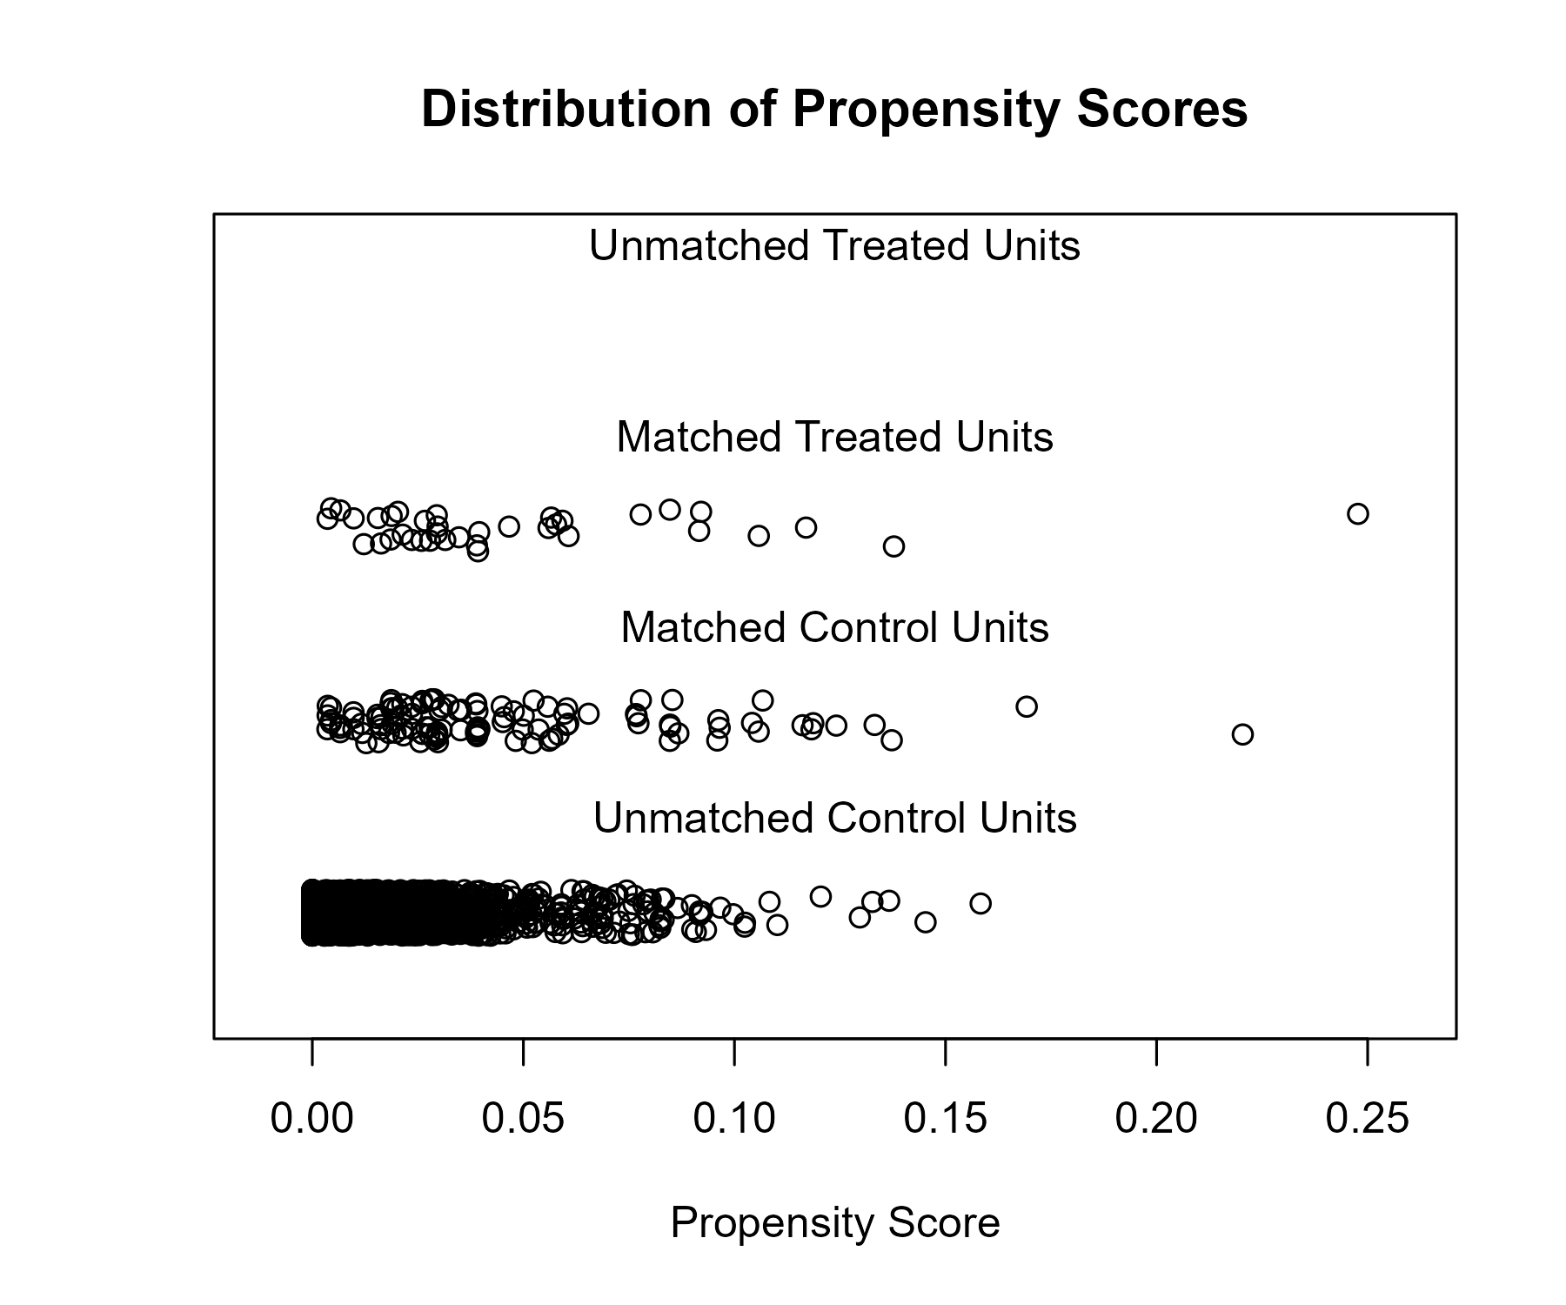

### Covariate balance

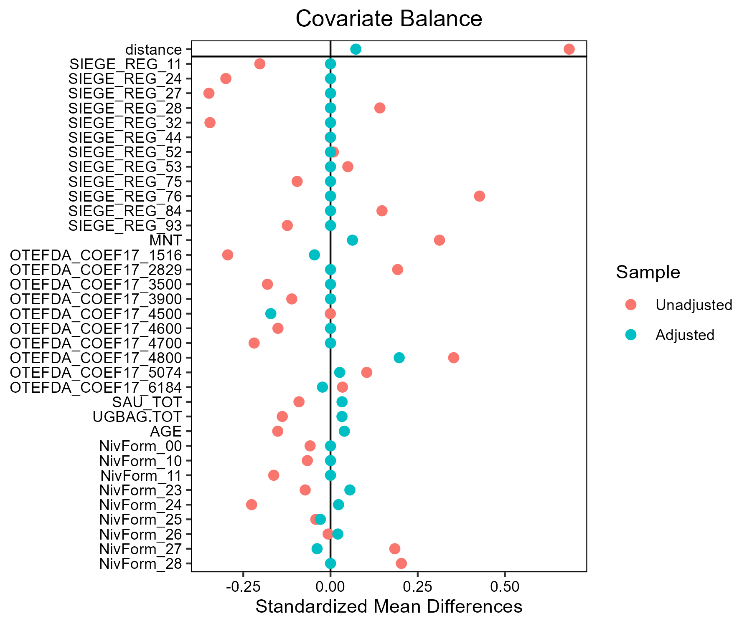

## Orge_de_printemps - AB

### Covariate distribution before matching

|  |  | Orge_de_printemps - AB (N=31) / Mean | Orge_de_printemps - AB (N=31) / Std. Dev. | Orge_de_printemps - Conventionnel (N=1052) / Mean | Orge_de_printemps - Conventionnel (N=1052) / Std. Dev. | Diff. in Means | Std. Error |
| --- | --- | --- | --- | --- | --- | --- | --- |
| SAU_TOT |  | 160.1 | 122.0 | 154.0 | 94.0 | -6.1 | 22.1 |
| UGBAG.TOT |  | 69.8 | 74.9 | 49.1 | 77.2 | -20.7 | 13.7 |
| AGE |  | 52.5 | 8.4 | 50.3 | 10.2 | -2.2 | 1.5 |
|  |  | N | Pct. | N | Pct. |  |  |
| SIEGE_REG | 11 | 4 | 12.9 | 103 | 9.8 |  |  |
|  | 24 | 1 | 3.2 | 114 | 10.8 |  |  |
|  | 27 | 3 | 9.7 | 94 | 8.9 |  |  |
|  | 28 | 2 | 6.5 | 41 | 3.9 |  |  |
|  | 32 | 4 | 12.9 | 125 | 11.9 |  |  |
|  | 44 | 5 | 16.1 | 270 | 25.7 |  |  |
|  | 52 | 1 | 3.2 | 33 | 3.1 |  |  |
|  | 53 | 2 | 6.5 | 52 | 4.9 |  |  |
|  | 75 | 2 | 6.5 | 121 | 11.5 |  |  |
|  | 76 | 4 | 12.9 | 31 | 2.9 |  |  |
|  | 84 | 2 | 6.5 | 42 | 4.0 |  |  |
|  | 93 | 1 | 3.2 | 26 | 2.5 |  |  |
| MNT | FALSE | 29 | 93.5 | 999 | 95.0 |  |  |
|  | TRUE | 2 | 6.5 | 53 | 5.0 |  |  |
| OTEFDA_COEF17 | 1516 | 8 | 25.8 | 504 | 47.9 |  |  |
|  | 2829 | 0 | 0.0 | 8 | 0.8 |  |  |
|  | 3500 | 3 | 9.7 | 65 | 6.2 |  |  |
|  | 3900 | 0 | 0.0 | 7 | 0.7 |  |  |
|  | 4500 | 11 | 35.5 | 105 | 10.0 |  |  |
|  | 4600 | 2 | 6.5 | 51 | 4.8 |  |  |
|  | 4700 | 1 | 3.2 | 34 | 3.2 |  |  |
|  | 4800 | 1 | 3.2 | 47 | 4.5 |  |  |
|  | 5074 | 2 | 6.5 | 66 | 6.3 |  |  |
|  | 6184 | 3 | 9.7 | 165 | 15.7 |  |  |
| NivForm | 00 | 0 | 0.0 | 10 | 1.0 |  |  |
|  | 10 | 0 | 0.0 | 11 | 1.0 |  |  |
|  | 11 | 1 | 3.2 | 31 | 2.9 |  |  |
|  | 23 | 1 | 3.2 | 32 | 3.0 |  |  |
|  | 24 | 6 | 19.4 | 290 | 27.6 |  |  |
|  | 25 | 2 | 6.5 | 93 | 8.8 |  |  |
|  | 26 | 11 | 35.5 | 239 | 22.7 |  |  |
|  | 27 | 5 | 16.1 | 277 | 26.3 |  |  |
|  | 28 | 5 | 16.1 | 69 | 6.6 |  |  |

### Covariate distribution after matching

|  |  | Orge_de_printemps - AB (N=31) / Mean | Orge_de_printemps - AB (N=31) / Std. Dev. | Orge_de_printemps - Conventionnel (N=93) / Mean | Orge_de_printemps - Conventionnel (N=93) / Std. Dev. | Diff. in Means | Std. Error |
| --- | --- | --- | --- | --- | --- | --- | --- |
| SAU_TOT |  | 160.1 | 122.0 | 155.2 | 93.0 | -4.9 | 23.9 |
| UGBAG.TOT |  | 69.8 | 74.9 | 78.6 | 89.0 | 8.9 | 16.3 |
| AGE |  | 52.5 | 8.4 | 52.1 | 9.1 | -0.4 | 1.8 |
|  |  | N | Pct. | N | Pct. |  |  |
| SIEGE_REG | 11 | 4 | 12.9 | 12 | 12.9 |  |  |
|  | 24 | 1 | 3.2 | 3 | 3.2 |  |  |
|  | 27 | 3 | 9.7 | 9 | 9.7 |  |  |
|  | 28 | 2 | 6.5 | 6 | 6.5 |  |  |
|  | 32 | 4 | 12.9 | 12 | 12.9 |  |  |
|  | 44 | 5 | 16.1 | 15 | 16.1 |  |  |
|  | 52 | 1 | 3.2 | 3 | 3.2 |  |  |
|  | 53 | 2 | 6.5 | 6 | 6.5 |  |  |
|  | 75 | 2 | 6.5 | 6 | 6.5 |  |  |
|  | 76 | 4 | 12.9 | 12 | 12.9 |  |  |
|  | 84 | 2 | 6.5 | 6 | 6.5 |  |  |
|  | 93 | 1 | 3.2 | 3 | 3.2 |  |  |
| MNT | FALSE | 29 | 93.5 | 86 | 92.5 |  |  |
|  | TRUE | 2 | 6.5 | 7 | 7.5 |  |  |
| OTEFDA_COEF17 | 1516 | 8 | 25.8 | 25 | 26.9 |  |  |
|  | 3500 | 3 | 9.7 | 4 | 4.3 |  |  |
|  | 4500 | 11 | 35.5 | 30 | 32.3 |  |  |
|  | 4600 | 2 | 6.5 | 6 | 6.5 |  |  |
|  | 4700 | 1 | 3.2 | 6 | 6.5 |  |  |
|  | 4800 | 1 | 3.2 | 6 | 6.5 |  |  |
|  | 5074 | 2 | 6.5 | 7 | 7.5 |  |  |
|  | 6184 | 3 | 9.7 | 9 | 9.7 |  |  |
| NivForm | 11 | 1 | 3.2 | 2 | 2.2 |  |  |
|  | 23 | 1 | 3.2 | 1 | 1.1 |  |  |
|  | 24 | 6 | 19.4 | 23 | 24.7 |  |  |
|  | 25 | 2 | 6.5 | 7 | 7.5 |  |  |
|  | 26 | 11 | 35.5 | 37 | 39.8 |  |  |
|  | 27 | 5 | 16.1 | 12 | 12.9 |  |  |
|  | 28 | 5 | 16.1 | 11 | 11.8 |  |  |

### Matching model coefficients

| . | Estimate | Std. Error | t value | Pr(&gt;|t|) |
| --- | --- | --- | --- | --- |
| (Intercept) | -21.5189966057652 | 1952.83504202833 | -0.011019362179928 | 0.991210092230671 |
| SIEGE_REG24 | -2.05545593530208 | 1.2630917231633 | -1.62732119735088 | 0.103968918270044 |
| SIEGE_REG27 | -1.29750038878505 | 1.00457990018538 | -1.29158505813785 | 0.196785116852949 |
| SIEGE_REG28 | -0.861805212603262 | 1.12487163362596 | -0.766136496682096 | 0.443767284634322 |
| SIEGE_REG32 | -0.482168555438419 | 0.849781667088997 | -0.567402868421638 | 0.570561789565477 |
| SIEGE_REG44 | -1.60821590187653 | 0.898746849679121 | -1.78939809630566 | 0.0738388539362918 |
| SIEGE_REG52 | -1.62389554849655 | 1.38717905923931 | -1.17064595062951 | 0.242006731160559 |
| SIEGE_REG53 | -1.50739768958246 | 1.15215248889611 | -1.30833175652532 | 0.191047126852876 |
| SIEGE_REG75 | -1.84823473838561 | 1.13243884094766 | -1.63208349233143 | 0.102961742147917 |
| SIEGE_REG76 | 0.451545982598305 | 1.06813060339782 | 0.422744167391046 | 0.672568485616216 |
| SIEGE_REG84 | -0.195848357429514 | 1.14874832976707 | -0.170488480683342 | 0.864658837481784 |
| SIEGE_REG93 | -0.533164725972175 | 1.59738729845145 | -0.333772984478492 | 0.738617515573164 |
| MNTTRUE | -0.949068618450625 | 1.08457587279781 | -0.875059682087866 | 0.381741549465431 |
| OTEFDA_COEF172829 | -12.8149982618594 | 2285.68249676736 | -0.00560663971482638 | 0.995527637167392 |
| OTEFDA_COEF173500 | 1.37499802914312 | 1.02500309254465 | 1.34145744451324 | 0.180062035882059 |
| OTEFDA_COEF173900 | -13.1887449757821 | 2431.47518394377 | -0.00542417420620779 | 0.995673186704183 |
| OTEFDA_COEF174500 | 3.26915336467345 | 0.883805505794848 | 3.69895111903987 | 0.00022770916986421 |
| OTEFDA_COEF174600 | 2.11595171705513 | 1.1846260089431 | 1.78617698841759 | 0.0743590821947968 |
| OTEFDA_COEF174700 | 2.14004019567068 | 1.42685215660733 | 1.49983317175559 | 0.133958226636338 |
| OTEFDA_COEF174800 | 1.35999116086149 | 1.44013050264613 | 0.944352722453004 | 0.345206676984936 |
| OTEFDA_COEF175074 | 1.73607470861679 | 1.01848975546154 | 1.70455785078571 | 0.0885727481188793 |
| OTEFDA_COEF176184 | 0.971879988789297 | 0.841299141531735 | 1.15521333710126 | 0.248265890823411 |
| SAU_TOT | 0.00334598953851872 | 0.00274078208393257 | 1.22081560520046 | 0.222429914799545 |
| UGBAG.TOT | -0.00303150786749881 | 0.0044043678862289 | -0.688295788591458 | 0.491418566560314 |
| AGE | 0.0473642828279847 | 0.0240413451358336 | 1.97011783493712 | 0.0490873278199473 |
| NivForm10 | 0.109015080129069 | 2736.49869911102 | 3.98374317387702e-05 | 0.999968221895397 |
| NivForm11 | 14.9246214389944 | 1952.83450656811 | 0.00764254287232088 | 0.993903644139978 |
| NivForm23 | 14.8640716112346 | 1952.83448099197 | 0.00761153684857315 | 0.993928376757962 |
| NivForm24 | 14.2938180434511 | 1952.83423236626 | 0.00731952451802897 | 0.99416130692218 |
| NivForm25 | 14.5050544401231 | 1952.83436961153 | 0.00742769313457366 | 0.994075023747611 |
| NivForm26 | 15.3546660510585 | 1952.83422428222 | 0.00786275960352048 | 0.993727983724638 |
| NivForm27 | 14.7918092956938 | 1952.83427866405 | 0.00757453382363452 | 0.993957893019851 |
| NivForm28 | 16.2525990360989 | 1952.83432647851 | 0.00832256931155381 | 0.993361208023648 |

### Propensity score distribution

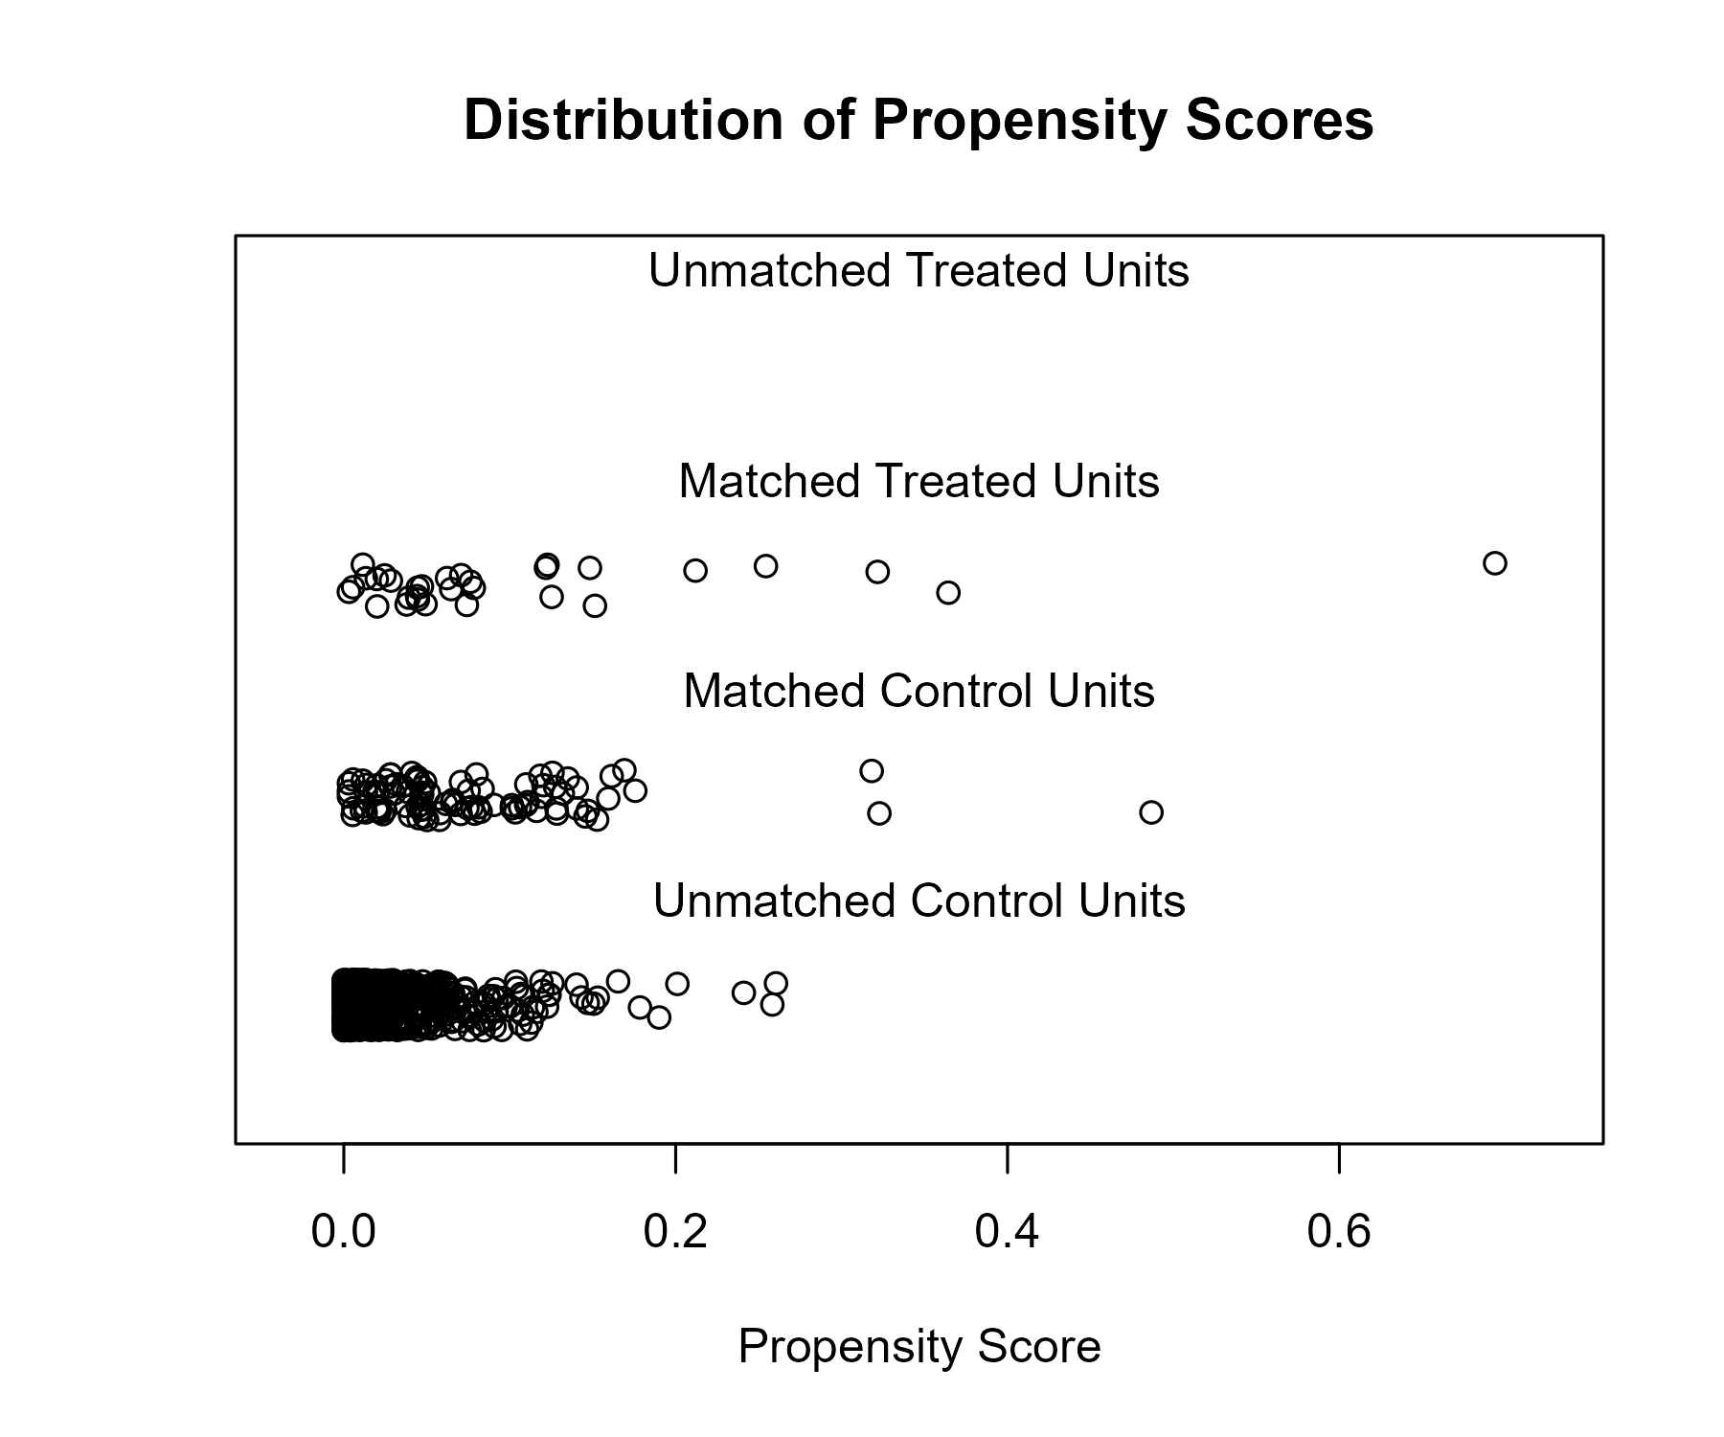

### Covariate balance

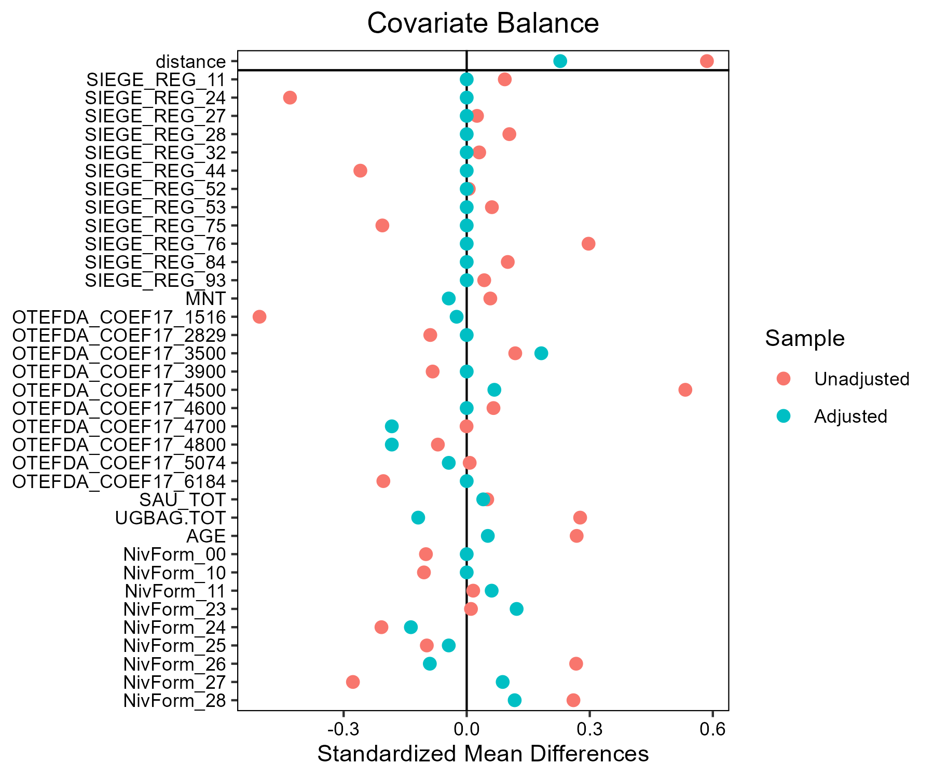

## Tournesol - AB

### Covariate distribution before matching

|  |  | Tournesol - AB (N=30) / Mean | Tournesol - AB (N=30) / Std. Dev. | Tournesol - Conventionnel (N=770) / Mean | Tournesol - Conventionnel (N=770) / Std. Dev. | Diff. in Means | Std. Error |
| --- | --- | --- | --- | --- | --- | --- | --- |
| SAU_TOT |  | 114.6 | 65.1 | 140.3 | 92.3 | 25.7 | 12.3 |
| UGBAG.TOT |  | 25.3 | 52.6 | 29.4 | 58.7 | 4.1 | 9.8 |
| AGE |  | 46.4 | 10.9 | 49.9 | 10.6 | 3.5 | 2.0 |
|  |  | N | Pct. | N | Pct. |  |  |
| SIEGE_REG | 11 | 3 | 10.0 | 11 | 1.4 |  |  |
|  | 24 | 1 | 3.3 | 88 | 11.4 |  |  |
|  | 27 | 1 | 3.3 | 57 | 7.4 |  |  |
|  | 28 | 0 | 0.0 | 2 | 0.3 |  |  |
|  | 32 | 0 | 0.0 | 9 | 1.2 |  |  |
|  | 44 | 3 | 10.0 | 61 | 7.9 |  |  |
|  | 52 | 4 | 13.3 | 44 | 5.7 |  |  |
|  | 75 | 5 | 16.7 | 233 | 30.3 |  |  |
|  | 76 | 9 | 30.0 | 181 | 23.5 |  |  |
|  | 84 | 4 | 13.3 | 68 | 8.8 |  |  |
|  | 93 | 0 | 0.0 | 16 | 2.1 |  |  |
| MNT | FALSE | 28 | 93.3 | 752 | 97.7 |  |  |
|  | TRUE | 2 | 6.7 | 18 | 2.3 |  |  |
| OTEFDA_COEF17 | 1516 | 15 | 50.0 | 346 | 44.9 |  |  |
|  | 2829 | 1 | 3.3 | 15 | 1.9 |  |  |
|  | 3500 | 0 | 0.0 | 84 | 10.9 |  |  |
|  | 3900 | 0 | 0.0 | 30 | 3.9 |  |  |
|  | 4500 | 1 | 3.3 | 26 | 3.4 |  |  |
|  | 4600 | 1 | 3.3 | 15 | 1.9 |  |  |
|  | 4700 | 0 | 0.0 | 3 | 0.4 |  |  |
|  | 4800 | 2 | 6.7 | 31 | 4.0 |  |  |
|  | 5074 | 4 | 13.3 | 65 | 8.4 |  |  |
|  | 6184 | 6 | 20.0 | 155 | 20.1 |  |  |
| NivForm | 00 | 0 | 0.0 | 5 | 0.6 |  |  |
|  | 10 | 0 | 0.0 | 1 | 0.1 |  |  |
|  | 11 | 0 | 0.0 | 27 | 3.5 |  |  |
|  | 23 | 0 | 0.0 | 26 | 3.4 |  |  |
|  | 24 | 5 | 16.7 | 236 | 30.6 |  |  |
|  | 25 | 3 | 10.0 | 87 | 11.3 |  |  |
|  | 26 | 6 | 20.0 | 158 | 20.5 |  |  |
|  | 27 | 12 | 40.0 | 192 | 24.9 |  |  |
|  | 28 | 4 | 13.3 | 38 | 4.9 |  |  |

### Covariate distribution after matching

|  |  | Tournesol - AB (N=30) / Mean | Tournesol - AB (N=30) / Std. Dev. | Tournesol - Conventionnel (N=90) / Mean | Tournesol - Conventionnel (N=90) / Std. Dev. | Diff. in Means | Std. Error |
| --- | --- | --- | --- | --- | --- | --- | --- |
| SAU_TOT |  | 114.6 | 65.1 | 119.8 | 63.2 | 5.2 | 13.6 |
| UGBAG.TOT |  | 25.3 | 52.6 | 29.5 | 49.0 | 4.2 | 10.9 |
| AGE |  | 46.4 | 10.9 | 47.7 | 11.0 | 1.3 | 2.3 |
|  |  | N | Pct. | N | Pct. |  |  |
| SIEGE_REG | 11 | 3 | 10.0 | 9 | 10.0 |  |  |
|  | 24 | 1 | 3.3 | 3 | 3.3 |  |  |
|  | 27 | 1 | 3.3 | 3 | 3.3 |  |  |
|  | 44 | 3 | 10.0 | 9 | 10.0 |  |  |
|  | 52 | 4 | 13.3 | 12 | 13.3 |  |  |
|  | 75 | 5 | 16.7 | 15 | 16.7 |  |  |
|  | 76 | 9 | 30.0 | 27 | 30.0 |  |  |
|  | 84 | 4 | 13.3 | 12 | 13.3 |  |  |
| MNT | FALSE | 28 | 93.3 | 87 | 96.7 |  |  |
|  | TRUE | 2 | 6.7 | 3 | 3.3 |  |  |
| OTEFDA_COEF17 | 1516 | 15 | 50.0 | 51 | 56.7 |  |  |
|  | 2829 | 1 | 3.3 | 1 | 1.1 |  |  |
|  | 4500 | 1 | 3.3 | 6 | 6.7 |  |  |
|  | 4600 | 1 | 3.3 | 3 | 3.3 |  |  |
|  | 4800 | 2 | 6.7 | 5 | 5.6 |  |  |
|  | 5074 | 4 | 13.3 | 8 | 8.9 |  |  |
|  | 6184 | 6 | 20.0 | 16 | 17.8 |  |  |
| NivForm | 24 | 5 | 16.7 | 18 | 20.0 |  |  |
|  | 25 | 3 | 10.0 | 12 | 13.3 |  |  |
|  | 26 | 6 | 20.0 | 22 | 24.4 |  |  |
|  | 27 | 12 | 40.0 | 29 | 32.2 |  |  |
|  | 28 | 4 | 13.3 | 9 | 10.0 |  |  |

### Matching model coefficients

| . | Estimate | Std. Error | t value | Pr(&gt;|t|) |
| --- | --- | --- | --- | --- |
| (Intercept) | -17.5644069208477 | 6388.42670378012 | -0.00274941041594085 | 0.997807004626893 |
| SIEGE_REG24 | -3.24042366223124 | 1.08284189563739 | -2.99251781380683 | 0.00285551038228381 |
| SIEGE_REG27 | -2.34534164315677 | 1.06831311430782 | -2.19536914013863 | 0.0284356255241587 |
| SIEGE_REG28 | -19.5957943864209 | 10027.3662807354 | -0.00195423143403751 | 0.99844125738995 |
| SIEGE_REG32 | -19.2069597219807 | 4811.59201543804 | -0.00399180970879388 | 0.996816041746442 |
| SIEGE_REG44 | -1.63890464033165 | 0.818078584748656 | -2.00335844365757 | 0.0454897234465024 |
| SIEGE_REG52 | -1.08448383807438 | 0.831089154307538 | -1.30489470648666 | 0.192319548913738 |
| SIEGE_REG75 | -2.51459278727654 | 0.797947542978299 | -3.1513259354004 | 0.0016883937974791 |
| SIEGE_REG76 | -1.76488564070061 | 0.738029587416369 | -2.39134808521562 | 0.0170263579390334 |
| SIEGE_REG84 | -1.71307868767844 | 0.847293168253702 | -2.02182520981391 | 0.0435407010923064 |
| SIEGE_REG93 | -19.5204154113937 | 3311.21720191255 | -0.00589523858480765 | 0.99529783833196 |
| MNTTRUE | 1.12578913673996 | 0.870136336126031 | 1.29380775172788 | 0.196120789856097 |
| OTEFDA_COEF172829 | 0.446141713011807 | 0.970405860030471 | 0.45974754624606 | 0.645827553756643 |
| OTEFDA_COEF173500 | -17.4663176049693 | 1511.97612167017 | -0.0115519797929584 | 0.990786058758493 |
| OTEFDA_COEF173900 | -18.1831641160273 | 2555.48033412378 | -0.00711536061272877 | 0.994324659331252 |
| OTEFDA_COEF174500 | 0.371387521656342 | 1.11111933503774 | 0.334246295555399 | 0.738284964373123 |
| OTEFDA_COEF174600 | 0.559991862622907 | 1.10200815187513 | 0.508155825952874 | 0.611489986487264 |
| OTEFDA_COEF174700 | -17.2410569593393 | 8383.87870455461 | -0.0020564535302703 | 0.998359722667401 |
| OTEFDA_COEF174800 | 0.301523384866038 | 0.895325682280548 | 0.336775087360397 | 0.736378459487551 |
| OTEFDA_COEF175074 | -0.152898629317326 | 0.575153943320914 | -0.265839487137123 | 0.790434177378792 |
| OTEFDA_COEF176184 | -0.0438503553551719 | 0.472499534619824 | -0.092805076285322 | 0.926082621370501 |
| SAU_TOT | -0.00768626918327048 | 0.00279471381853652 | -2.75028846685113 | 0.00609437139743786 |
| UGBAG.TOT | 7.46453031701783e-05 | 0.00517831098419999 | 0.0144149904086362 | 0.988502643771924 |
| AGE | -0.0114834634130042 | 0.017970184062166 | -0.639028702949195 | 0.522994796002498 |
| NivForm10 | 18.0207733130909 | 16068.1655705141 | 0.00112152026527284 | 0.999105447726265 |
| NivForm11 | 0.487526354054863 | 6890.06159678567 | 7.07579093751937e-05 | 0.99994356173142 |
| NivForm23 | 0.698003403610633 | 6918.79682339129 | 0.000100885084708775 | 0.999919531547047 |
| NivForm24 | 17.2349805218696 | 6388.42658040034 | 0.00269784434476345 | 0.997848134855217 |
| NivForm25 | 17.69020032463 | 6388.42659228717 | 0.00276910129107339 | 0.997791298754941 |
| NivForm26 | 17.9300657338922 | 6388.42658462273 | 0.00280664816232697 | 0.997761350552983 |
| NivForm27 | 18.5755399853068 | 6388.4265817368 | 0.00290768622721759 | 0.997680760408503 |
| NivForm28 | 18.5365367930777 | 6388.42660302791 | 0.0029015809282824 | 0.997685630126234 |

### Propensity score distribution

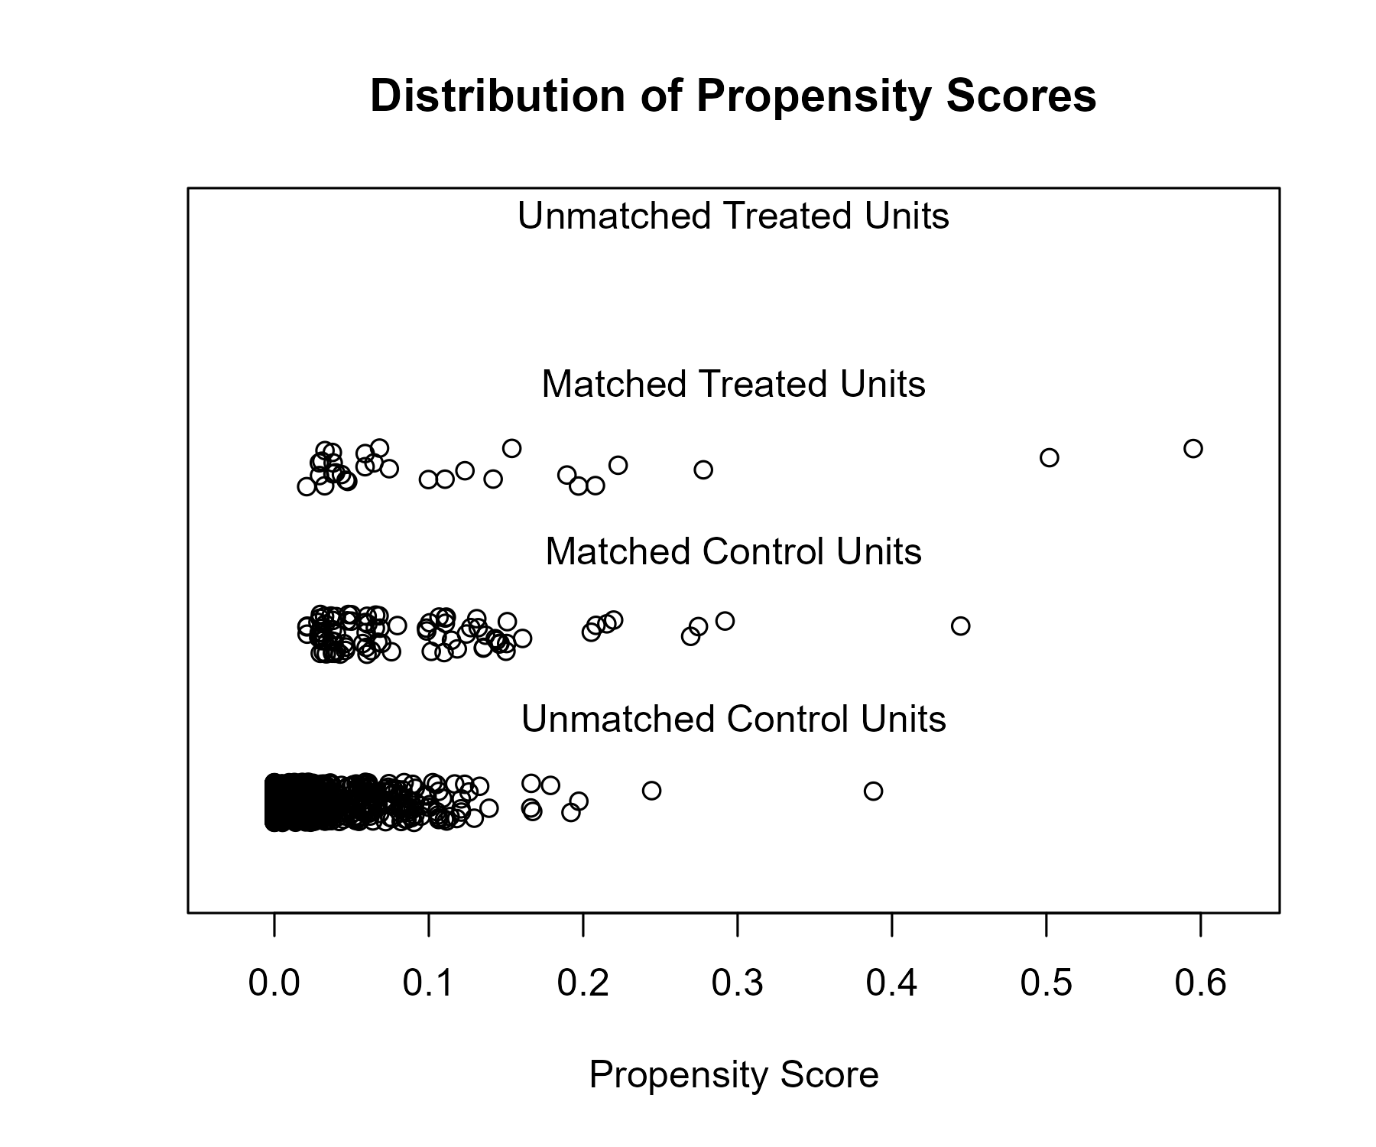

### Covariate balance

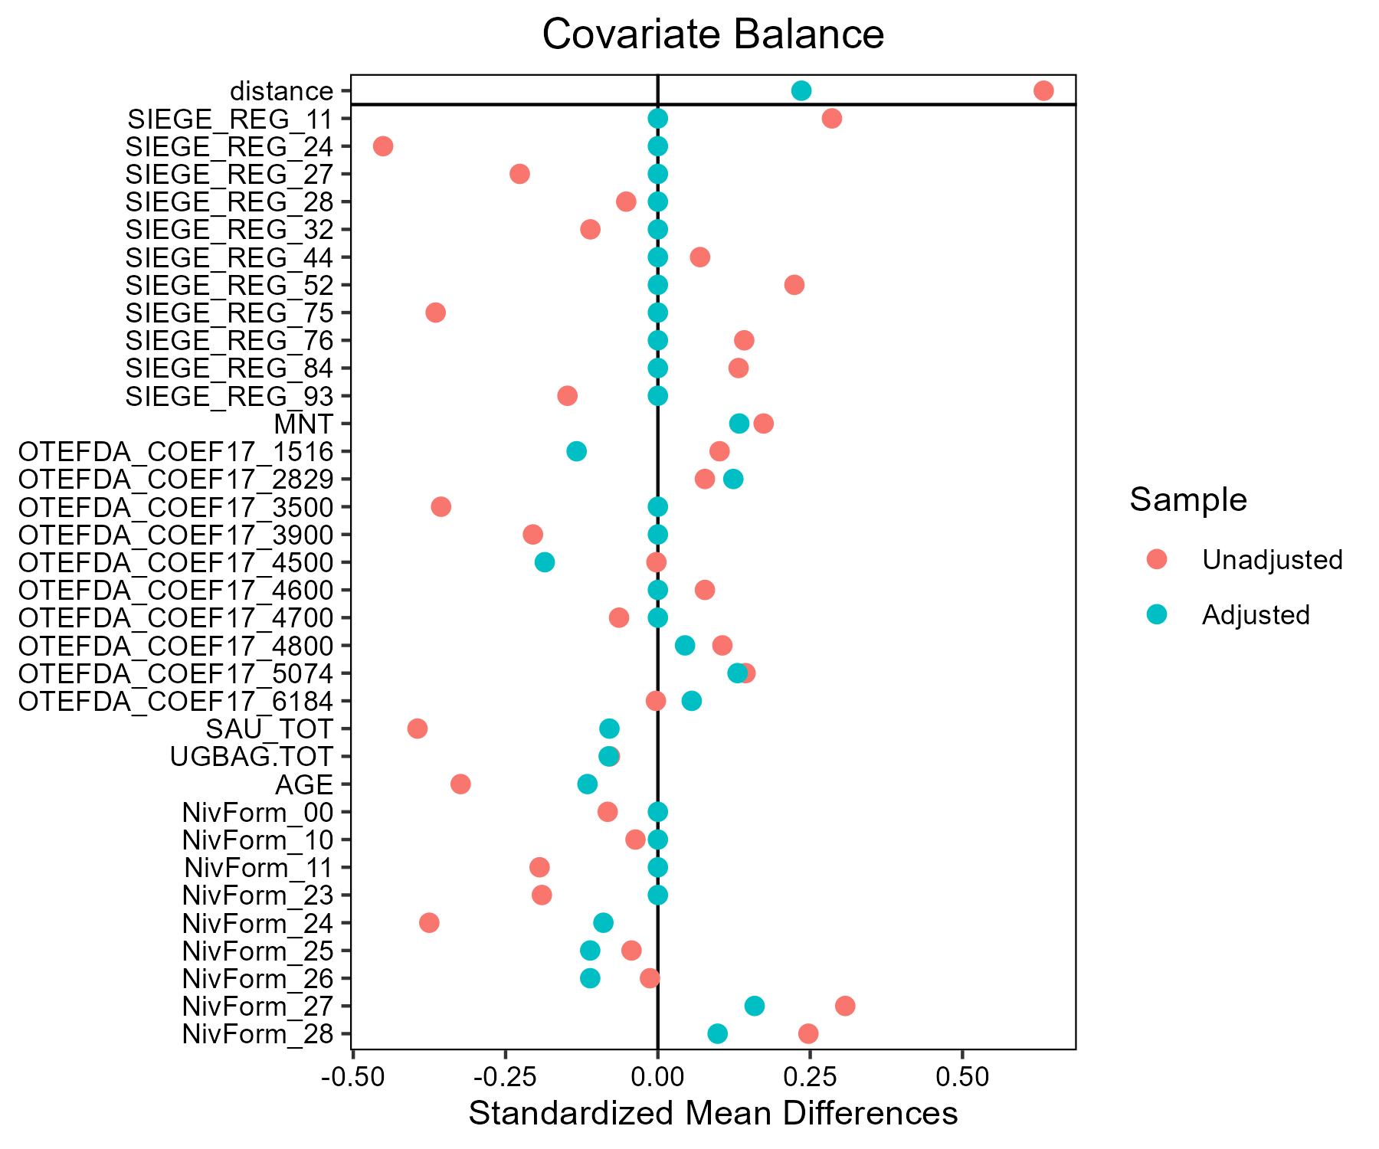

## Triticale - AB

### Covariate distribution before matching

|  |  | Triticale - AB (N=47) / Mean | Triticale - AB (N=47) / Std. Dev. | Triticale - Conventionnel (N=775) / Mean | Triticale - Conventionnel (N=775) / Std. Dev. | Diff. in Means | Std. Error |
| --- | --- | --- | --- | --- | --- | --- | --- |
| SAU_TOT |  | 132.0 | 64.7 | 141.6 | 84.4 | 9.6 | 9.9 |
| UGBAG.TOT |  | 62.6 | 74.7 | 112.8 | 81.5 | 50.2 | 11.3 |
| AGE |  | 48.0 | 10.6 | 48.4 | 10.0 | 0.4 | 1.6 |
|  |  | N | Pct. | N | Pct. |  |  |
| SIEGE_REG | 11 | 6 | 12.8 | 2 | 0.3 |  |  |
|  | 24 | 1 | 2.1 | 55 | 7.1 |  |  |
|  | 27 | 6 | 12.8 | 95 | 12.3 |  |  |
|  | 28 | 1 | 2.1 | 16 | 2.1 |  |  |
|  | 32 | 3 | 6.4 | 6 | 0.8 |  |  |
|  | 44 | 10 | 21.3 | 63 | 8.1 |  |  |
|  | 52 | 2 | 4.3 | 55 | 7.1 |  |  |
|  | 53 | 2 | 4.3 | 35 | 4.5 |  |  |
|  | 75 | 5 | 10.6 | 177 | 22.8 |  |  |
|  | 76 | 3 | 6.4 | 88 | 11.4 |  |  |
|  | 84 | 8 | 17.0 | 162 | 20.9 |  |  |
|  | 93 | 0 | 0.0 | 21 | 2.7 |  |  |
| MNT | FALSE | 37 | 78.7 | 548 | 70.7 |  |  |
|  | TRUE | 10 | 21.3 | 227 | 29.3 |  |  |
| OTEFDA_COEF17 | 1516 | 14 | 29.8 | 36 | 4.6 |  |  |
|  | 2829 | 1 | 2.1 | 2 | 0.3 |  |  |
|  | 3500 | 1 | 2.1 | 11 | 1.4 |  |  |
|  | 3900 | 0 | 0.0 | 8 | 1.0 |  |  |
|  | 4500 | 11 | 23.4 | 158 | 20.4 |  |  |
|  | 4600 | 4 | 8.5 | 240 | 31.0 |  |  |
|  | 4700 | 3 | 6.4 | 66 | 8.5 |  |  |
|  | 4800 | 5 | 10.6 | 99 | 12.8 |  |  |
|  | 5074 | 4 | 8.5 | 67 | 8.6 |  |  |
|  | 6184 | 4 | 8.5 | 88 | 11.4 |  |  |
| NivForm | 00 | 0 | 0.0 | 2 | 0.3 |  |  |
|  | 10 | 0 | 0.0 | 1 | 0.1 |  |  |
|  | 11 | 0 | 0.0 | 14 | 1.8 |  |  |
|  | 23 | 0 | 0.0 | 40 | 5.2 |  |  |
|  | 24 | 7 | 14.9 | 246 | 31.7 |  |  |
|  | 25 | 3 | 6.4 | 107 | 13.8 |  |  |
|  | 26 | 13 | 27.7 | 208 | 26.8 |  |  |
|  | 27 | 13 | 27.7 | 146 | 18.8 |  |  |
|  | 28 | 11 | 23.4 | 11 | 1.4 |  |  |

### Covariate distribution after matching

|  |  | Triticale - AB (N=43) / Mean | Triticale - AB (N=43) / Std. Dev. | Triticale - Conventionnel (N=122) / Mean | Triticale - Conventionnel (N=122) / Std. Dev. | Diff. in Means | Std. Error |
| --- | --- | --- | --- | --- | --- | --- | --- |
| SAU_TOT |  | 130.5 | 58.7 | 125.3 | 75.2 | -5.1 | 11.2 |
| UGBAG.TOT |  | 68.5 | 75.5 | 80.5 | 61.1 | 12.0 | 12.8 |
| AGE |  | 48.2 | 10.6 | 47.2 | 10.2 | -1.0 | 1.9 |
|  |  | N | Pct. | N | Pct. |  |  |
| SIEGE_REG | 11 | 2 | 4.7 | 2 | 1.6 |  |  |
|  | 24 | 1 | 2.3 | 3 | 2.5 |  |  |
|  | 27 | 6 | 14.0 | 18 | 14.8 |  |  |
|  | 28 | 1 | 2.3 | 3 | 2.5 |  |  |
|  | 32 | 3 | 7.0 | 6 | 4.9 |  |  |
|  | 44 | 10 | 23.3 | 30 | 24.6 |  |  |
|  | 52 | 2 | 4.7 | 6 | 4.9 |  |  |
|  | 53 | 2 | 4.7 | 6 | 4.9 |  |  |
|  | 75 | 5 | 11.6 | 15 | 12.3 |  |  |
|  | 76 | 3 | 7.0 | 9 | 7.4 |  |  |
|  | 84 | 8 | 18.6 | 24 | 19.7 |  |  |
| MNT | FALSE | 33 | 76.7 | 85 | 69.7 |  |  |
|  | TRUE | 10 | 23.3 | 37 | 30.3 |  |  |
| OTEFDA_COEF17 | 1516 | 11 | 25.6 | 12 | 9.8 |  |  |
|  | 2829 | 0 | 0.0 | 1 | 0.8 |  |  |
|  | 3500 | 1 | 2.3 | 2 | 1.6 |  |  |
|  | 4500 | 11 | 25.6 | 34 | 27.9 |  |  |
|  | 4600 | 4 | 9.3 | 17 | 13.9 |  |  |
|  | 4700 | 3 | 7.0 | 12 | 9.8 |  |  |
|  | 4800 | 5 | 11.6 | 21 | 17.2 |  |  |
|  | 5074 | 4 | 9.3 | 11 | 9.0 |  |  |
|  | 6184 | 4 | 9.3 | 12 | 9.8 |  |  |
| NivForm | 24 | 7 | 16.3 | 24 | 19.7 |  |  |
|  | 25 | 2 | 4.7 | 4 | 3.3 |  |  |
|  | 26 | 13 | 30.2 | 47 | 38.5 |  |  |
|  | 27 | 13 | 30.2 | 44 | 36.1 |  |  |
|  | 28 | 8 | 18.6 | 3 | 2.5 |  |  |

### Matching model coefficients

| . | Estimate | Std. Error | t value | Pr(&gt;|t|) |
| --- | --- | --- | --- | --- |
| (Intercept) | -17.0445413614425 | 6584.3870143577 | -0.00258862993992845 | 0.997935228787206 |
| SIEGE_REG24 | -3.46610721624907 | 1.31300060245805 | -2.6398367295188 | 0.00845841289897306 |
| SIEGE_REG27 | -1.11012240729446 | 1.05037989051229 | -1.0568770568837 | 0.290891184530608 |
| SIEGE_REG28 | -1.40132262526146 | 1.34387894458007 | -1.04274468389661 | 0.297385946027485 |
| SIEGE_REG32 | 0.0234130900331801 | 1.15878625705765 | 0.0202048392363832 | 0.983885075842769 |
| SIEGE_REG44 | -0.523139763171053 | 1.01089121616068 | -0.517503520465747 | 0.604949766036566 |
| SIEGE_REG52 | -2.26206597218411 | 1.14941486781555 | -1.96801523585923 | 0.049416089403133 |
| SIEGE_REG53 | -1.87816191936363 | 1.18475519193443 | -1.58527426775571 | 0.113304720735794 |
| SIEGE_REG75 | -2.11258796784605 | 1.04303399588852 | -2.0254258022016 | 0.0431598388341172 |
| SIEGE_REG76 | -2.44120295783877 | 1.1373925955952 | -2.14631514860643 | 0.0321521841351879 |
| SIEGE_REG84 | -1.88240398855764 | 1.07819644931718 | -1.7458821996212 | 0.0812206401107529 |
| SIEGE_REG93 | -18.5969593115765 | 1936.97955902449 | -0.00960100958470739 | 0.992342047379786 |
| MNTTRUE | 0.363111351979105 | 0.560822184071861 | 0.647462533209238 | 0.517520972339811 |
| OTEFDA_COEF172829 | -0.365387180745776 | 1.98734137098941 | -0.183857280927969 | 0.8541726584295 |
| OTEFDA_COEF173500 | -0.847457967635876 | 1.28859922879694 | -0.657658291808138 | 0.510949543921248 |
| OTEFDA_COEF173900 | -17.2862275530218 | 3099.23113876288 | -0.00557758578791318 | 0.995551163383679 |
| OTEFDA_COEF174500 | -0.396267495120801 | 0.684208016614606 | -0.579162309558274 | 0.562644968125112 |
| OTEFDA_COEF174600 | -1.24333250423135 | 0.789841868849298 | -1.57415370502292 | 0.115852793729891 |
| OTEFDA_COEF174700 | -0.153365932823798 | 0.893036289570149 | -0.171735387032948 | 0.863689600648545 |
| OTEFDA_COEF174800 | -0.245957353506795 | 0.731155615074484 | -0.336395356112718 | 0.736662197418148 |
| OTEFDA_COEF175074 | -0.809149500314298 | 0.661710291064649 | -1.22281534871164 | 0.2217645700959 |
| OTEFDA_COEF176184 | -1.29362838238844 | 0.656187614831594 | -1.97143065969089 | 0.0490236637155556 |
| SAU_TOT | 0.00177276288682197 | 0.00270394706612369 | 0.655620411002854 | 0.512259508685789 |
| UGBAG.TOT | -0.00950112886878569 | 0.00427996413128881 | -2.21990852664568 | 0.0267084869603242 |
| AGE | 0.0182968441386954 | 0.0177337219219445 | 1.03175431639391 | 0.302503380479155 |
| NivForm10 | -1.62464543047698 | 11430.06649559 | -0.000142137880921673 | 0.999886626308595 |
| NivForm11 | -0.776381926926056 | 7005.10457929215 | -0.000110830883127873 | 0.999911597764952 |
| NivForm23 | -0.31611393099867 | 6733.46489357419 | -4.69466962396048e-05 | 0.999962553822855 |
| NivForm24 | 15.3508078970021 | 6584.38682039417 | 0.0023313952104781 | 0.998140406761635 |
| NivForm25 | 15.5329013890517 | 6584.38684727606 | 0.00235905054629006 | 0.998118348047485 |
| NivForm26 | 16.3144961138239 | 6584.38682223934 | 0.00247775480910695 | 0.998023666031643 |
| NivForm27 | 16.6405081342788 | 6584.38683025101 | 0.00252726769603305 | 0.997984173103049 |
| NivForm28 | 18.3321607236146 | 6584.38684205112 | 0.00278418646464336 | 0.997779247250981 |

### Propensity score distribution

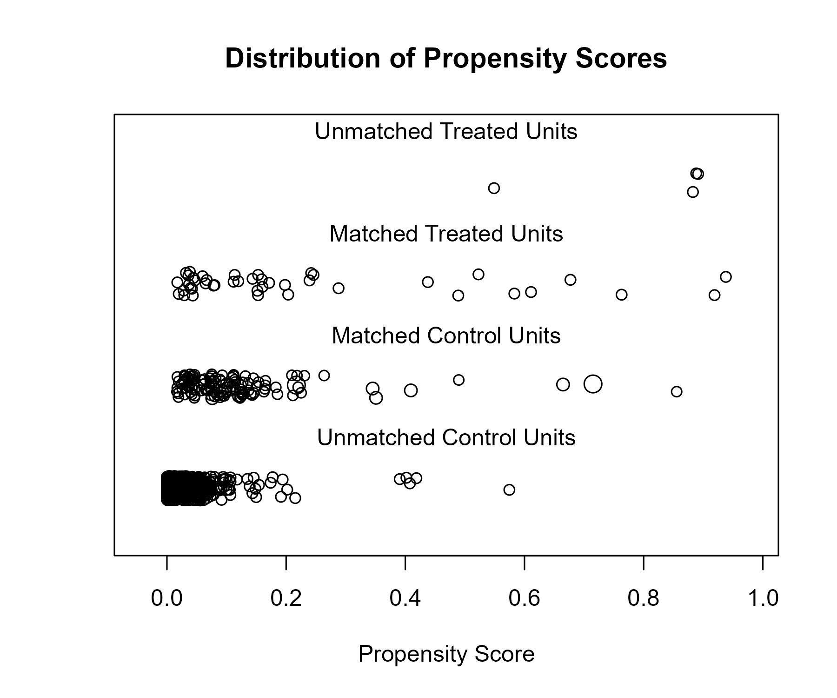

### Covariate balance

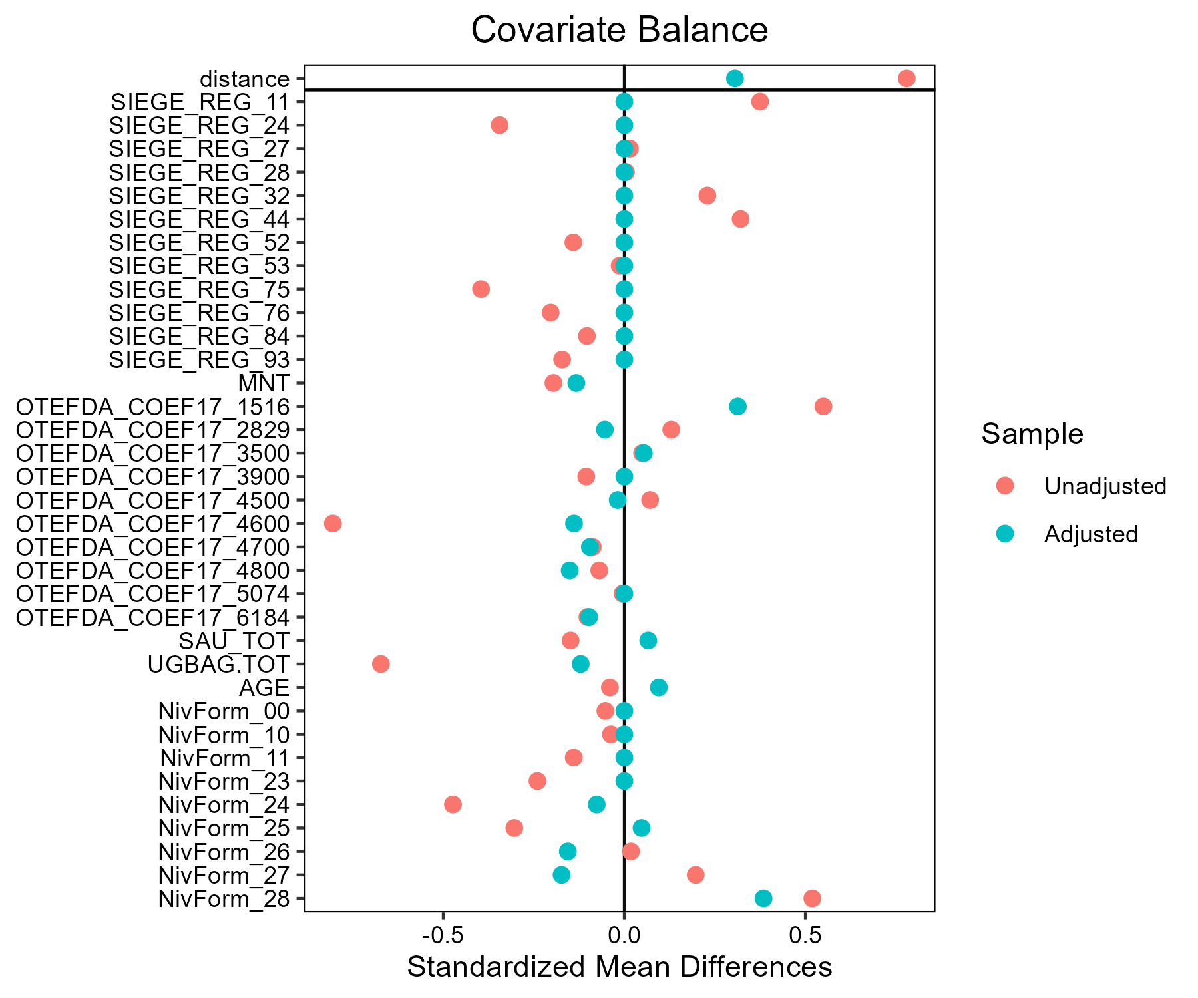

## Number of matches

| match | FQS | nobs |
| --- | --- | --- |
| Autres_cereales__AB | AB | 41 |
| Autres_cereales__AB | Conventionnel | 103 |
| Ble_tendre__AB | AB | 93 |
| Ble_tendre__AB | Conventionnel | 279 |
| Ble_tendre__LR | Conventionnel | 300 |
| Ble_tendre__LR | LR | 100 |
| Lait__AB | AB | 88 |
| Lait__AB | Conventionnel | 264 |
| Lait__Beurre de Charentes-Poitou | Beurre de Charentes-Poitou | 59 |
| Lait__Beurre de Charentes-Poitou | Conventionnel | 104 |
| Lait__Bleu d'Auvergne - Cantal | Bleu d'Auvergne - Cantal | 54 |
| Lait__Bleu d'Auvergne - Cantal | Conventionnel | 112 |
| Lait__Comte - Morbier | Comte - Morbier | 64 |
| Lait__Comte - Morbier | Conventionnel | 74 |
| Lait__Fromages de Savoie | Conventionnel | 99 |
| Lait__Fromages de Savoie | Fromages de Savoie | 33 |
| Lait__Munster | Conventionnel | 114 |
| Lait__Munster | Munster | 38 |
| Mais_fourrage__AB | AB | 44 |
| Mais_fourrage__AB | Conventionnel | 132 |
| Mais_grain__AB | AB | 37 |
| Mais_grain__AB | Conventionnel | 111 |
| Melange_cereales_d_ete__AB | AB | 48 |
| Melange_cereales_d_ete__AB | Conventionnel | 90 |
| Orge_d_hiver_et_escourgeon__AB | AB | 37 |
| Orge_d_hiver_et_escourgeon__AB | Conventionnel | 111 |
| Orge_de_printemps__AB | AB | 31 |
| Orge_de_printemps__AB | Conventionnel | 93 |
| Tournesol__AB | AB | 30 |
| Tournesol__AB | Conventionnel | 90 |
| Triticale__AB | AB | 43 |
| Triticale__AB | Conventionnel | 122 |